

**Lab No: 5 Date: 2081/**

**Title: Write a recursive program to calculate the factorial and Fibonacci sequence for user input value.**

* Factorial

**factorial**, in [mathematics](https://www.britannica.com/science/mathematics), the product of all positive [integers](https://www.britannica.com/science/integer) less than or equal to a given [positive integer](https://www.britannica.com/science/natural-number) and [denoted](https://www.britannica.com/dictionary/denoted) by that [integer](https://www.britannica.com/science/integer) and an exclamation point. Thus, factorial seven is written 7! meaning 1 × 2 × 3 × 4 × 5 × 6 × 7. Factorial zero is defined as equal to 1. Factorials are commonly encountered in the evaluation of [permutations and combinations](https://www.britannica.com/science/permutation) and in the coefficients of terms of binomial expansions (see [binomial theorem](https://www.britannica.com/science/binomial-theorem)). Factorials have been generalized to include nonintegral values (see [gamma function](https://www.britannica.com/science/gamma-function)).

* Fibonacci

In mathematics, the Fibonacci sequence is a [sequence](https://en.wikipedia.org/wiki/Integer_sequence) in which each term is the sum of the two terms that precede it.  . Many writers begin the sequence with 0 and 1, although some authors start it from 1 and 1and some (as did Fibonacci) from 1 and 2. Starting from 0 and 1, the sequence begins

0, 1, 1, 2, 3, 5, 8, 13, 21, 34, 55, 89, 144, ... (sequence [A000045](https://oeis.org/A000045) in the [OEIS](https://en.wikipedia.org/wiki/On-Line_Encyclopedia_of_Integer_Sequences))

Fibonacci numbers appear unexpectedly often in mathematics, so much so that there is an entire journal dedicated to their study, the [Fibonacci Quarterly](https://en.wikipedia.org/wiki/Fibonacci_Quarterly). Applications of Fibonacci numbers include computer algorithms such as the [Fibonacci search technique](https://en.wikipedia.org/wiki/Fibonacci_search_technique) and the [Fibonacci heap](https://en.wikipedia.org/wiki/Fibonacci_heap) [data structure](https://en.wikipedia.org/wiki/Data_structure), and [graphs](https://en.wikipedia.org/wiki/Graph_(discrete_mathematics)) called [Fibonacci cubes](https://en.wikipedia.org/wiki/Fibonacci_cube) used for interconnecting parallel and distributed systems.

**IDE: Visual studio Code**

**Language: C**

**Source code(for factorial):**

#include <stdio.h>

int fact(int n)

{

    if (n == 0 || n == 1)

    {

        return 1;

    }

    else

        return n * fact(n - 1);

}

void main()

{

    int num, result;

    printf("Enter any number: ");

    scanf("%d", &num);

    result = fact(num);

    printf("The factorial of %d is %d", num, result);

}

**Output:**

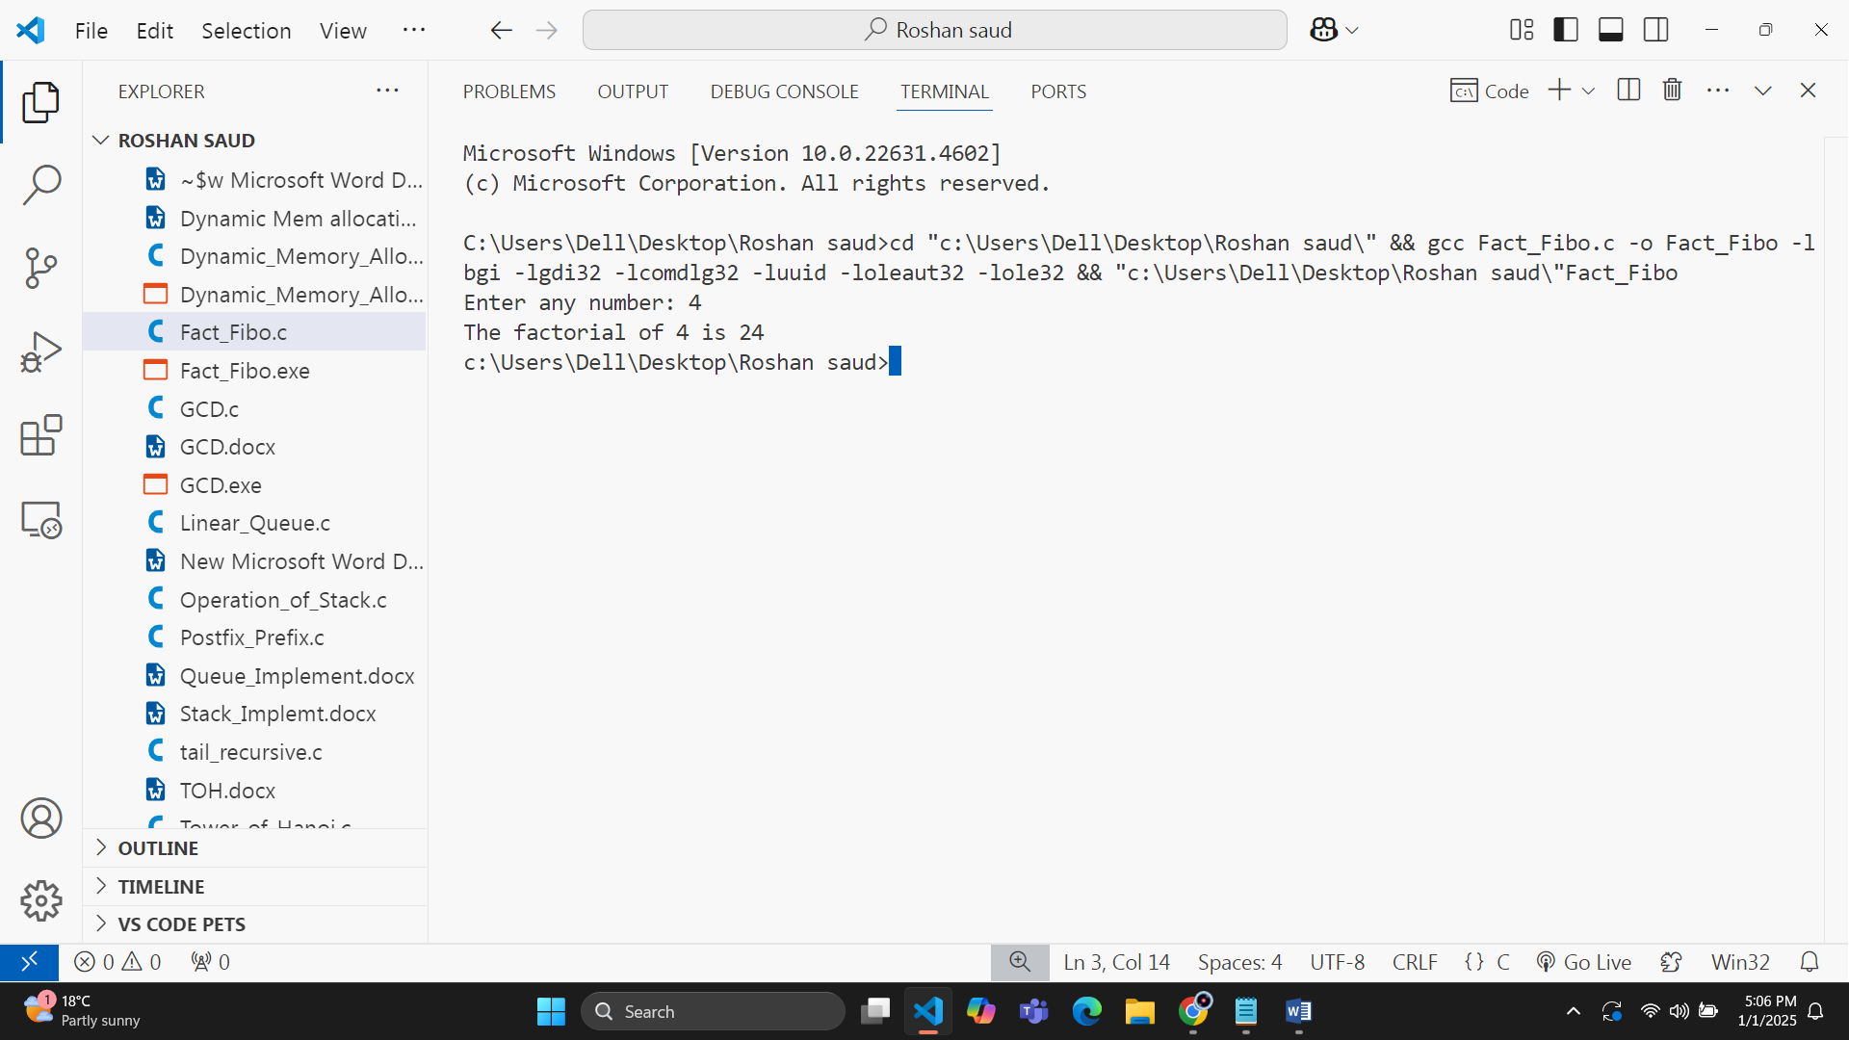

**Source code(for Fibonacci):**

#include <stdio.h>

int fibo(int n)

{

    if (n == 0)

    {

        return 0;

    }

    else if (n == 1)

    {

        return 1;

    }

    else

        return (fibo(n - 1) + fibo(n - 2));

}

void main()

{

    int num, i;

    printf("Enter any number: ");

    scanf("%d", &num);

    for (i = 0; i < num; i++)

    {

        printf("%d,", fibo(i));

    }

}

