

**Lab No: 3 Date: 2081/**

**Title: Write a program to evaluate the user input postfix or prefix expression.**

* **Infix notation:** X + Y

Operators are written in-between their operands. This is the usual way we write expressions. An expression such as A * ( B + C ) / D is usually taken to mean something like: "First add B and C together, then multiply the result by A, then divide by D to give the final answer. "Infix notation needs extra information to make the order of evaluation of the operators clear: rules built into the language about operator precedence and associativity, and brackets ( ) to allow users to override these rules.

* **Postfix notation** (also known as "Reverse Polish notation"): X Y +

Operators are written after their operands. The infix expression given above is equivalent to A B C + * D / The order of evaluation of operators is always left-to-right, and brackets cannot be used to change this order. Because the "+" is to the left of the "*" in the example above, the addition must be performed before the multiplication. Operators act on values immediately to the left of them. For example, the "+" above uses the "B" and "C". We can add (totally unnecessary) brackets to make this explicit:( (A (B C +) *) D /)

* **Prefix notation** (also known as "Polish notation"): + X Y

Operators are written before their operands. The expressions given above are equivalent to / * A + B C DAs for Postfix, operators are evaluated left-to-right and brackets are superfluous. Operators act on the two nearest values on the right. I have again added (totally unnecessary) brackets to make this clear:(/ (* A (+ B C) ) D)

**IDE: Visual Studio Code**

**Language: C**

**Source code (for postfix):**

#include <stdio.h>

#include <math.h>

int stack[50], top = -1;

void sum();

void sub();

void mult();

void div();

void power();

int main()

{

    char st[50];

    int i;

    printf("Enter the postfix expression:\n");

    scanf("%[^\n]s", st);

    // Here, to take space as input we use '%[^\n]s'

    for (i = 0; st[i] != '\0'; i++)

    {

        if (st[i] != ' ')

        {

            switch (st[i])

            {

            case '+':

                sum();

                break;

            case '-':

                sub();

                break;

            case '*':

                mult();

                break;

            case '/':

                div();

                break;

            case '^':

                power();

                break;

            default:

                top++;

                stack[top] = st[i] - 48;

                /*since, st[i] contain characters so, we subtract

                them with 48 so that (char: '0','1','2',...) changed

                to their interger form */

            }

        }

    }

    printf("\nThe result is %d\n", stack[top]);

}

void sum()

{

    int res, op1, op2;

    op2 = stack[top];

    top--;

    op1 = stack[top];

    top--;

    res = op1 + op2;

    top++;

    stack[top] = res;

}

void sub()

{

    int res, op1, op2;

    op2 = stack[top];

    top--;

    op1 = stack[top];

    top--;

    res = op1 - op2;

    top++;

    stack[top] = res;

}

void mult()

{

    int res, op1, op2;

    op2 = stack[top];

    top--;

    op1 = stack[top];

    top--;

    res = op1 * op2;

    top++;

    stack[top] = res;

}

void div()

{

    int res, op1, op2;

    op2 = stack[top];

    top--;

    op1 = stack[top];

    top--;

    res = op1 / op2;

    top++;

    stack[top] = res;

}

void power()

{

    int op1, op2, i;

    op2 = stack[top];

    top--;

    op1 = stack[top];

    top--;

    stack[top++] = pow(op1, op2);

}

**Output:**

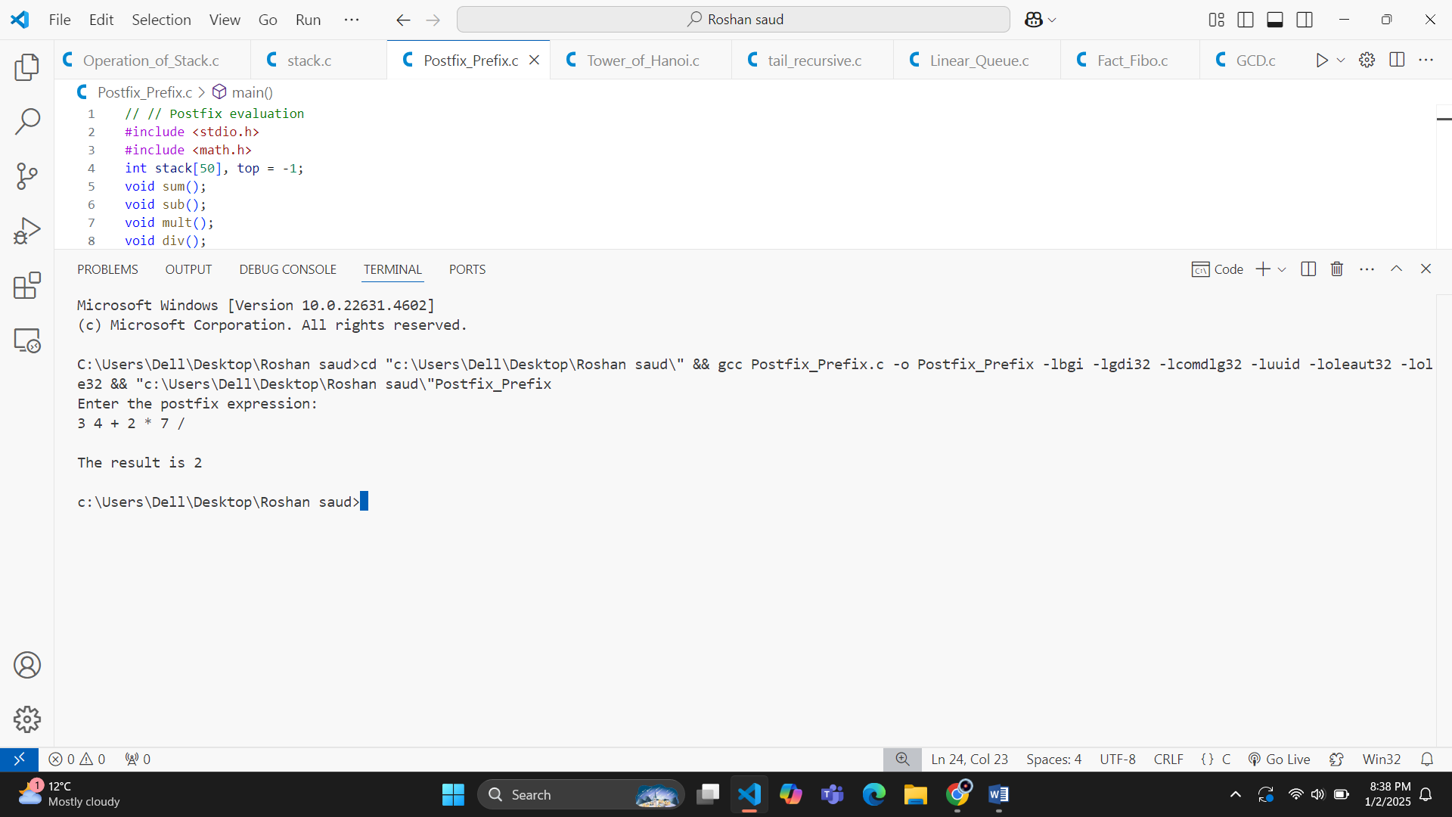

**Source code(for prefix):**

#include <stdio.h>

#include <math.h>

#include <string.h>

int stack[50], top = -1;

void sum();

void sub();

void mult();

void div();

void power();

void reverse(char str[]);

int main()

{

    char st[50];

    int i;

    printf("Enter the prefix expression:\n");

    scanf("%[^\n]s", st);

    // Reverse the input string to process prefix from right to left

    strrev(st);

    for (i = 0; st[i] != '\0'; i++)

    {

        if (st[i] != ' ') // Skip spaces

        {

                switch (st[i])

                {

                case '+':

                    sum();

                    break;

                case '-':

                    sub();

                    break;

                case '*':

                    mult();

                    break;

                case '/':

                    div();

                    break;

                case '^':

                    power();

                    break;

                default:

                   top++;

                 stack[top] = st[i] - 48;

            }

        }

    }

    printf("\nThe result is %d\n", stack[top]);

    return 0;

}

void sum()

{

    int op1 = stack[top--];

    int op2 = stack[top--];

    stack[++top] = op1 + op2;

}

void sub()

{

    int op1 = stack[top--];

    int op2 = stack[top--];

    stack[++top] = op1 - op2;

}

void mult()

{

    int op1 = stack[top--];

    int op2 = stack[top--];

    stack[++top] = op1 * op2;

}

void div()

{

    int op1 = stack[top--];

    int op2 = stack[top--];

    stack[++top] = op1 / op2;

}

void power()

{

    int op1 = stack[top--];

    int op2 = stack[top--];

    stack[++top] = pow(op1, op2);

}

