Source code:
#function for printing the solution
def print_solution(board):
n= len(board)
for row in range(n):
for col in range(n):
print("Q" if board[row]== col else ".", end= "")
print("\n "+ "=" * (3*n) + "\n") #==============
#check if queen attack each other
def is_safe(board, row, col):
#check for row, column and diagonal conflict
for r in range(row):
if board[r]== col or abs(board[r]-col)==abs(r-row):
return False
return True
#Place the queens backtracking
def solve_n_queen(board, row,n,solution):
#place queen row by row backtrack if the position is not safe
if row == n:
solution.append(board[:]) #[:]= array slicing to save the solution
return
for col in range(n):
if is_safe(board,row,col):
board[row] = col
solve_n_queen(board,row+1,n,solution)
board[row]= -1 #barcktrack
#main function
def n_queens(n):
board =[-1]*n #-1 represents there is no queen
solution= []
solve_n_queen(board,0,n,solution)
return solution
if __name__ == "__main__":
N = 4
print(f"\n Solving {N} Queen problem \n")
result = n_queens(N)
print(f"Total soltuion found: {len(result)}\n")
for i, sol in enumerate(result, 1):
print(f"Solution{i}:")
print_solution(sol)

Output:
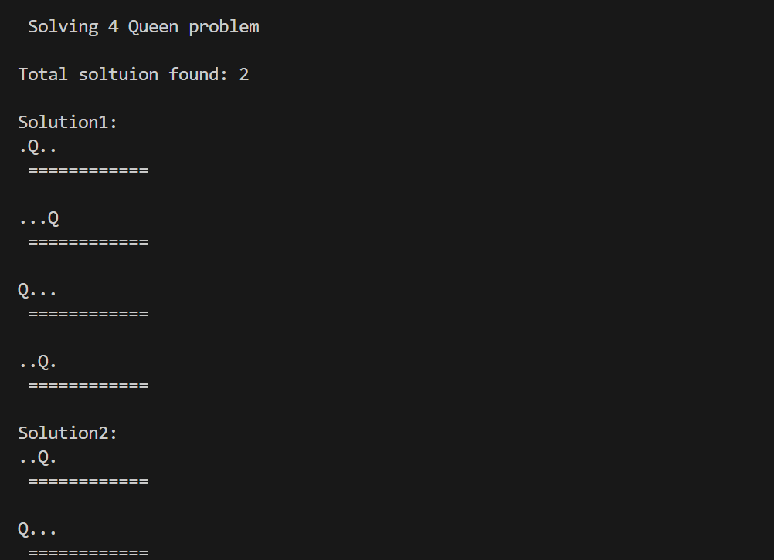
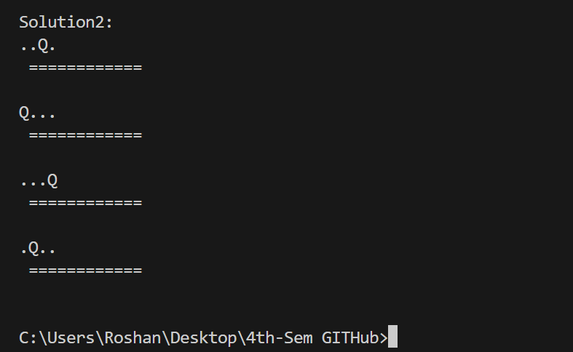

Source code:
% -- Family facts --
% Parent relationship
parent(dasharath,ram).
parent(dasharath,laxman).
parent(dasharath,bharat).
parent(dasharath,shatrughan).
% marriage
marriage(ram,sita).
% gender
male(ram).
male(dasharath).
male(laxman).
male(shatrughan).
female(sita).
% -- rules --
father(X,Y) :- parent(X,Y),male(X).
mother(X,Y) :- parent(X,Y),female(X).
sibling(X,Y) :- parent(P,X),parent(P,Y), X \= Y.
husband(X,Y) :- marriage(X,Y), male(X).
wife(X,Y) :- marriage(X,Y), female(X).

Output:
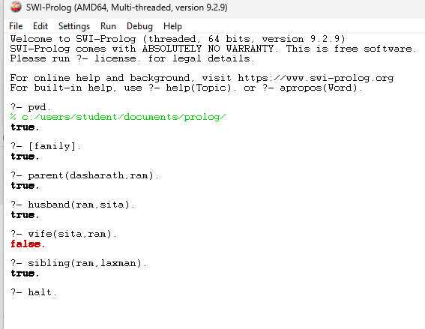

Source code:
:- use_module(library(clpfd)).
solve_compact([S,E,N,D,M,O,R,Y]) :-
Vars = [S,E,N,D,M,O,R,Y],
Vars ins 0..9,
all_different(Vars),
S #\= 0,
M #\= 0,
1000*S + 100*E + 10*N + D
+ 1000*M + 100*O + 10*R + E
#= 10000*M + 1000*O + 100*N + 10*E + Y,
labeling([ff], Vars).

solve_carry([S,E,N,D,M,O,R,Y]) :-
Digits = [S,E,N,D,M,O,R,Y],
Carries = [C1,C2,C3,C4],
Digits ins 0..9,
Carries ins 0..1,
all_different(Digits),
S #\= 0,
M #\= 0,
D + E #= Y + 10*C1,
N + R + C1 #= E + 10*C2,
E + O + C2 #= N + 10*C3,
S + M + C3 #= O + 10*C4,
C4 #= M,
labeling([ff], Digits).

print_solution([S,E,N,D,M,O,R,Y]) :-
SEND is 1000*S + 100*E + 10*N + D,
MORE is 1000*M + 100*O + 10*R + E,
MONEY is 10000*M + 1000*O + 100*N + 10*E + Y,
nl,
format("S = ~d, E = ~d, N = ~d, D = ~d~n", [S,E,N,D]),
format("M = ~d, O = ~d, R = ~d, Y = ~d~n", [M,O,R,Y]),
nl,
format("SEND = ~d~n", [SEND]), #d= datatype
format("MORE = ~d~n", [MORE]),
format("MONEY = ~d~n", [MONEY]),
nl.

Output:
