Lab Work 6: Bus and Ring Topology Connection
Objective:
To design and configure a network in Cisco Packet Tracer that connects a Bus topology and a Star topology using a router. Each network uses a different subnet. IP addresses are manually assigned using CLI, and connectivity is tested across both networks using ping.

Apparatus/Software Required
- Cisco Packet Tracer
- 5 PCs (2 in Bus, 3 in Star)
- 5 Switches (2 for Bus, 3 for Star)
- 1 Router
- Copper Straight-Through Cables

Network Topology Diagram
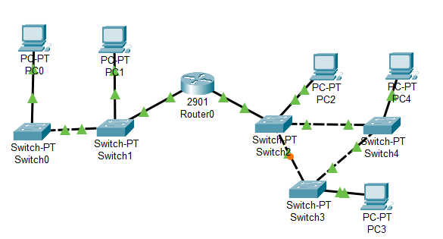
Fig: Bus and Ring connection
Corrected IP Addressing Scheme
Device | Interface/PC | IP Address | Subnet Mask | Default Gateway
PC0 (Bus) | FastEthernet 0 | 192.127.7.2 | 255.255.255.0 | 192.127.7.1
PC1 (Bus) | FastEthernet 0 | 192.127.7.3 | 255.255.255.0 | 192.127.7.1
PC2 (Ring) | FastEthernet 0 | 192.127.8.2 | 255.255.255.0 | 192.127.8.1
PC3 (Ring) | FastEthernet 0 | 192.127.8.3 | 255.255.255.0 | 192.127.8.1
PC4 (Ring) | FastEthernet 0 | 192.127.8.4 | 255.255.255.0 | 192.127.8.1
Router Fa0/0 | Bus side | 192.127.7.1 | 255.255.255.0 | —
Router Fa0/1 | Star side | 192.127.8.1 | 255.255.255.0 | —
Procedure
Step 1: Device Placement & Cabling
- Place PCs, Switches, Router.
- Bus side: PC0 → SW0 → SW1 → Router Fa0/0.
- Ring side: PCs each to SWs, SWs connected → Router Fa0/1.
- Use straight-through cables (except router-to-switch, which also works with straight-through in PT).

Step 2: Assign IP Addresses to PCs (CLI Mode)
PC0> ipconfig 192.127.7.2 255.255.255.0 192.127.7.1
PC1> ipconfig 192.127.7.3 255.255.255.0 192.127.7.1
PC2> ipconfig 192.127.8.2 255.255.255.0 192.127.8.1
PC3> ipconfig 192.127.8.3 255.255.255.0 192.127.8.1
PC4> ipconfig 192.127.8.4 255.255.255.0 192.127.8.1
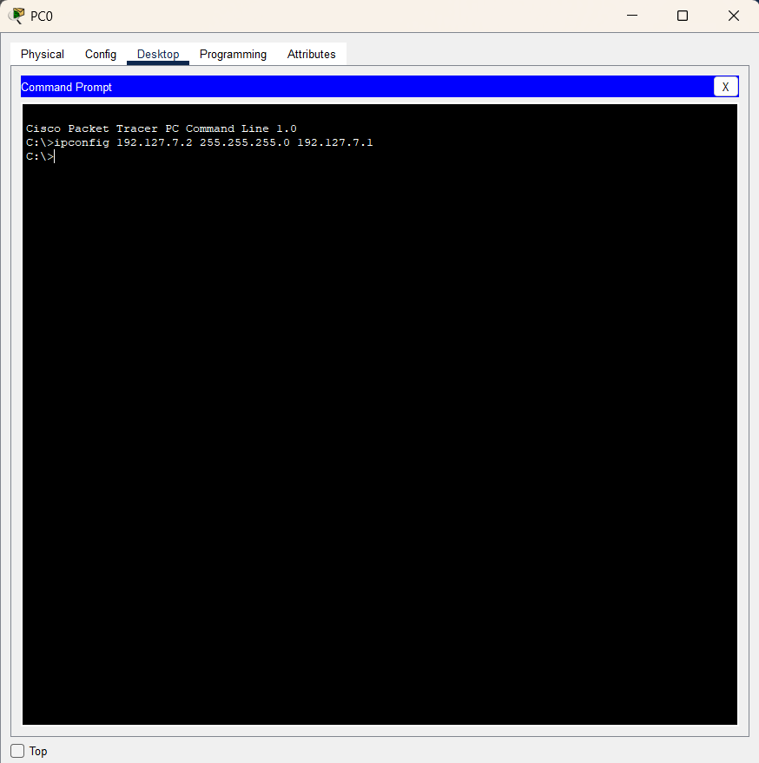
Step 3: Configure Router Interfaces
Router> enable
Router# configure terminal

Router(config)# interface gigabitEthernet 0/0
Router(config-if)# ip address 192.127.7.1 255.255.255.0
Router(config-if)# no shutdown
Router(config-if)# exit

Router(config)# interface gigabitEthernet 0/1
Router(config-if)# ip address 192.127.8.1 255.255.255.0
Router(config-if)# no shutdown
Router(config-if)# exit

Router(config)# end
Router# write memory
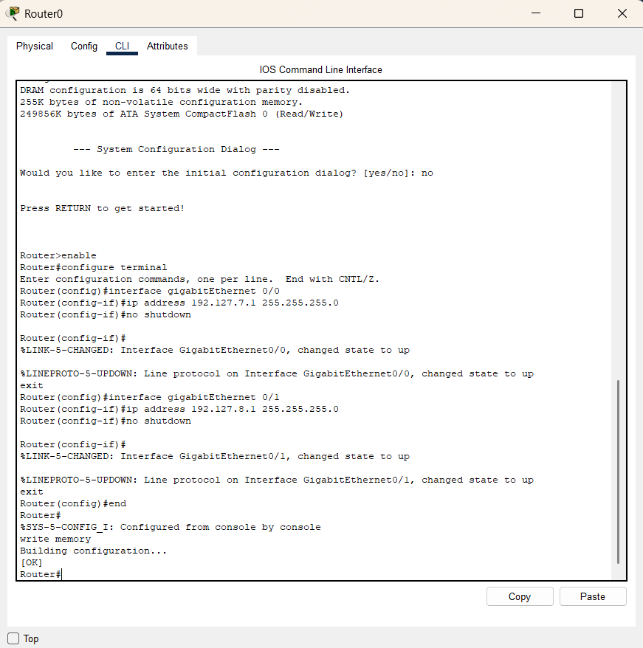
Step 4: Test Connectivity
- From PC0 (Bus) to PC3(Ring)
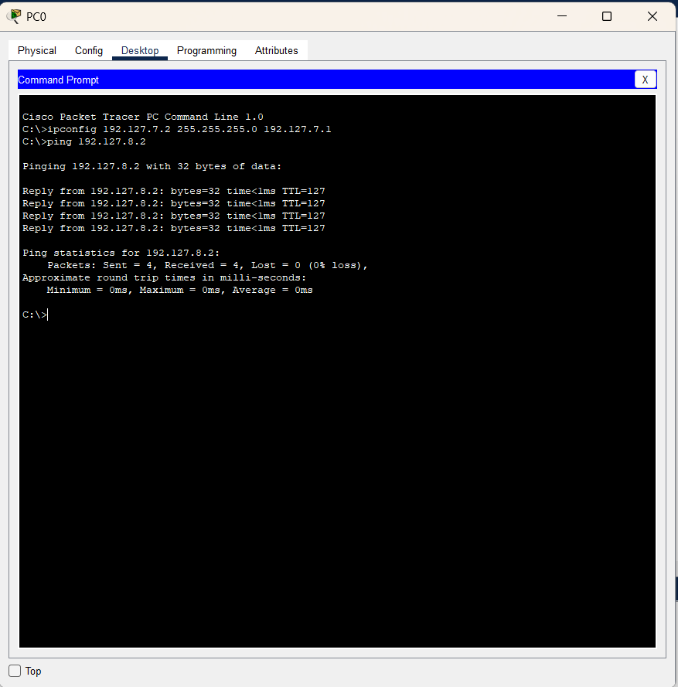
- From PC4(Ring) to PC1(Bus):
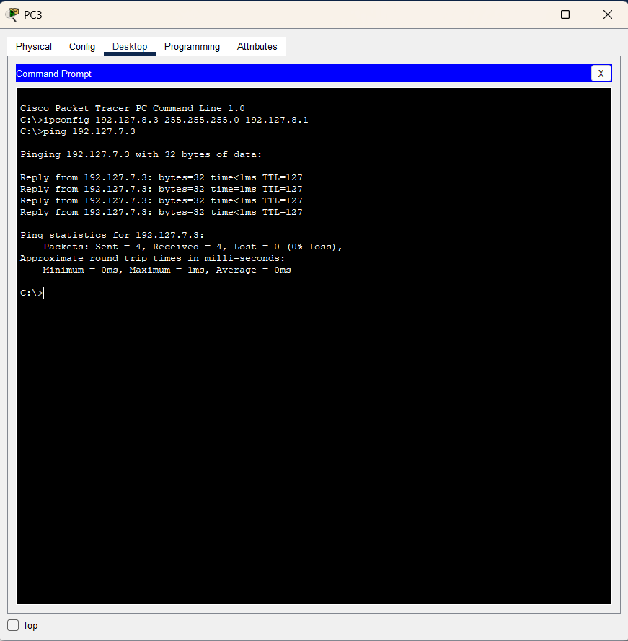
Observations
- Each subnet communicates via its own router interface.
- Router provides inter-network communication between Bus and Ring topologies.
- Cross-network ping works after fixing subnet separation.

Result
Bus and Ring topologies were successfully designed and interconnected with correct addressing. Communication across both networks was verified with ping.

Conclusion
The lab demonstrates how to connect different topologies using a router with separate subnets. Correct IP addressing and gateway assignment are essential for ensuring successful connectivity.

