Lab Title: Simulate a network with two routers and configure RIP (Routing Information Protocol). Verify routing tables and connectivity.
Objective
To simulate a two-router network, configure RIP for dynamic routing, and verify routing tables and connectivity.
- Apparatus/software required:
- cisco packet tracer
- 4 pc
- 2 PT-Switch
- 2 PT-Router
Network Topology Diagram
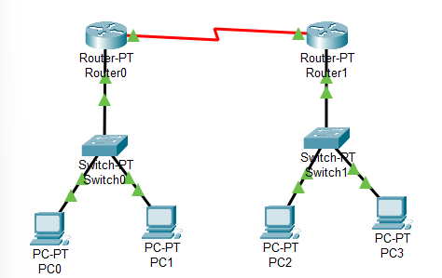
Fig: Two-Router RIP Network Topology

IP Addressing Scheme
S.NO | Device | IP Address | Subnet Mask | Default Gateway
1 | PC0 | 192.168.27.2 | 255.255.255.0 | 192.168.27.1
2 | PC1 | 192.168.27.3 | 255.255.255.0 | 192.168.27.1
3 | PC2 | 192.168.28.2 | 255.255.255.0 | 192.168.28.1
4 | PC3 | 192.168.28.3 | 255.255.255.0 | 192.168.28.1
For Router
S.NO | Device | Interface | Ipv4 Address | Subnet Mask
1 | Router 0 | FastEthernet0/0  Serial 2/0 | 192.168.27.1  10.0.0.1 | 255.255.255.0  255.0.0.0
2 | Router 1 | FastEthernet0/0  Serial 2/0 | 192.168.28.1  10.0.0.2 | 255.255.255.0  255.0.0.0
Procedure
Step 1: Device Placement and cabling
- Place 4 PC’S, 2 switch, and a router in the workspace.
- Then, create a network topology as shown above.
- Use an Automatic connecting cables to connect the devices with others.
Step 2: IP address Assignment on PCs
- Click on each PC →Desktop → IP configuration.
- Enter the IP address, subnet mask, and default gateway as per the table above. For ex:
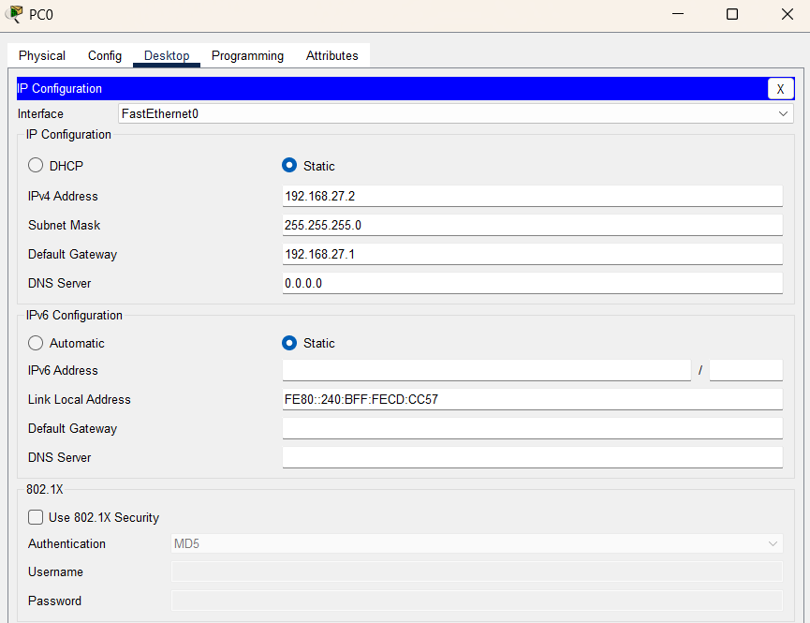

Step 3: configure Router Interface
- Click the Router →Config→FastEhernet0/0
- Configure the IP Address in FastEthernet and serial ports according to the table
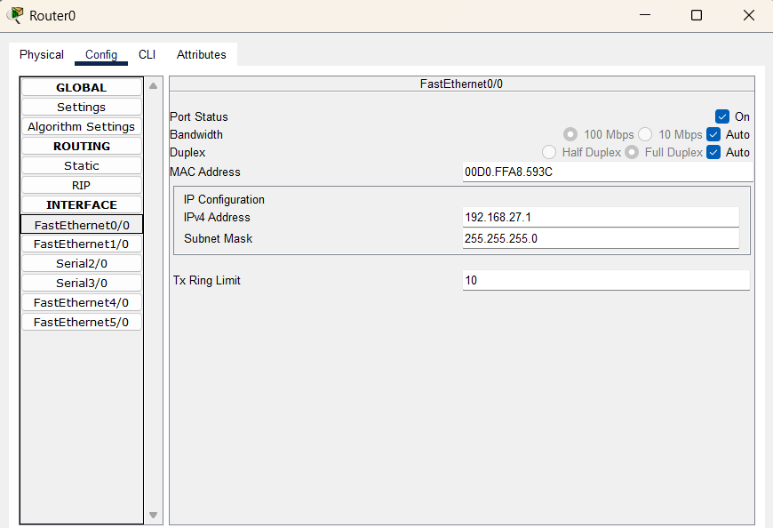

Step 4:
To assign RIP routes to the particular router
- First click on router 0 →CLI
- Then type the command and IP information given
- RIP Routes for Router0 is given below
Router(config)#
Router (config)#router rip
Router (config-router)#version 2
Router (config-router)#network 10.0.0.0
Router (config-router)#network 192.168.27.0
Similary, do the same for router1
Router1
Router> enable
Router# configure terminal
Router(config)# router rip
Router(config-router)# version 2
Router(config-router)# network 10.0.0.0
Router(config-router)# network 192.168.28.0
Router(config-router)# exit
Router(config)# exit
Router#

Step 5: Test connectivity
- Open the Command prompt on each pc
- Use the ping command to test the connectivity
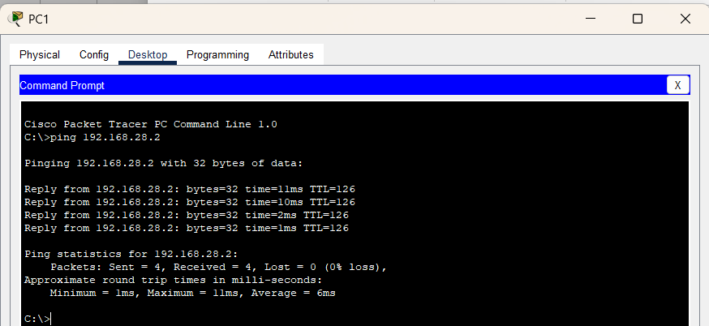
Observation
RIP was successfully configured on both routers. Routing tables were automatically updated with routes learned from each other, and ping tests confirmed connectivity between devices on different networks.
Result
The network was able to exchange routing information dynamically, and end-to-end communication between the networks was established without manual route entries.
Conclusion
The lab demonstrated that RIP efficiently updates routing tables and enables seamless connectivity between networks. The objective of verifying routing tables and network communication was successfully achieved.

