Lab Title: Simulate a network with three routers and configure RIP (Routing Information Protocol). Verify routing tables and connectivity.
Objective
To simulate a three-router network, configure RIP for dynamic routing, and verify routing tables and connectivity across all LANs.
Apparatus/software required:
- Cisco Packet Tracer
- 6 PCs
- 3 PT-Switches
- 3 PT-Routers
Network Topology Diagram
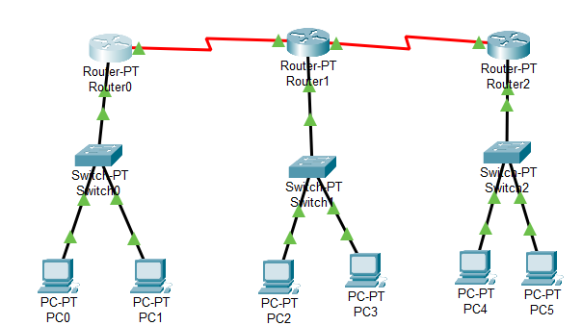
Fig: Three-Router RIP Network Topology

IP Addressing Scheme
For PCs
S.NO | Device | IP Address | Subnet Mask | Default Gateway
1 | PC0 | 192.168.27.2 | 255.255.255.0 | 192.168.27.1
2 | PC1 | 192.168.27.3 | 255.255.255.0 | 192.168.27.1
3 | PC2 | 192.168.28.2 | 255.255.255.0 | 192.168.28.1
4 | PC3 | 192.168.28.3 | 255.255.255.0 | 192.168.28.1
5 | PC4 | 192.168.29.2 | 255.255.255.0 | 192.168.29.1
6 | PC5 | 192.168.29.3 | 255.255.255.0 | 192.168.29.1

For Routers
S.NO | Router | Interface | IPv4 Address | Subnet Mask
1 | Router0 | FastEthernet0/0 | 192.168.27.1 | 255.255.255.0
 |  | Serial2/0 | 10.0.0.1 | 255.0.0.0
2 | Router1 | FastEthernet0/0 | 192.168.28.1 | 255.255.255.0
 |  | Serial2/0 | 10.0.0.2 | 255.0.0.0
 |  | Serial2/1 | 11.0.0.1 | 255.0.0.0
3 | Router2 | FastEthernet0/0 | 192.168.29.1 | 255.255.255.0
 |  | Serial2/0 | 11.0.0.2 | 255.0.0.0

Procedure
Step 1: Device Placement and Cabling
- Place 6 PCs, 3 switches, 3 routers.
- PCs → Switch → Router.
- Connect R0–R1 and R1–R2 via serial links.
- Use auto cabling.
Step 2: Assign IP Addresses on PCs
Enter IP, subnet mask, and default gateway as per the table above, for ex:
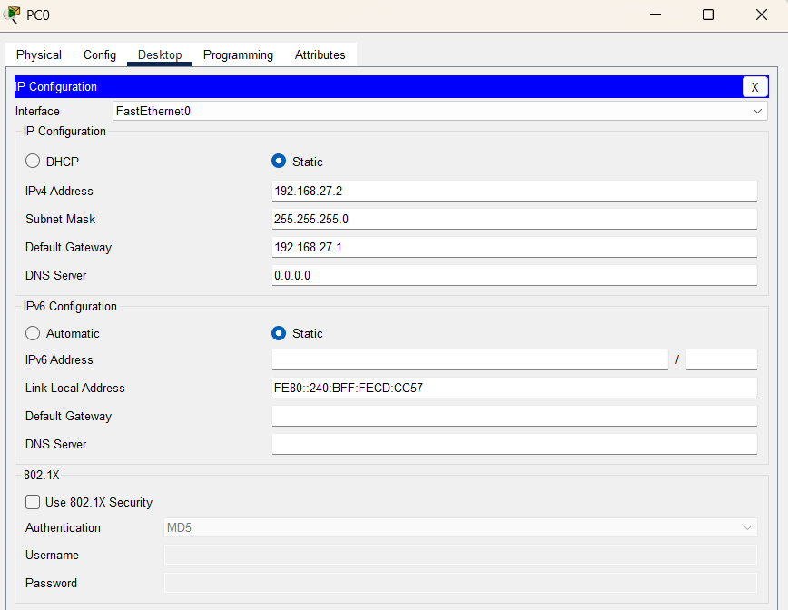
Step 3: Configure Router Interfaces
- On each Router → Config → FastEthernet0/0 → assign IP.
- On Serial ports, assign IPs and turn ports ON.
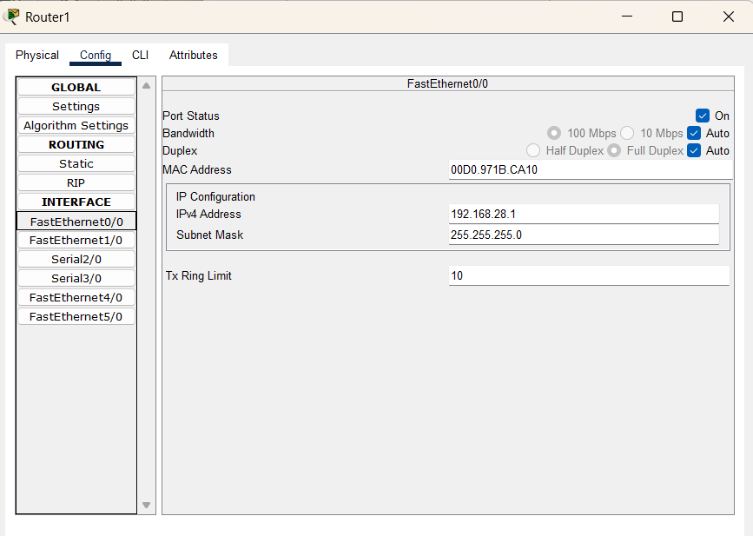
Step 4: Configure RIP on Routers
- On Router0:
Router> enable
Router# configure terminal
Router(config)# router rip
Router(config-router)# version 2
Router(config-router)# network 10.0.0.0
Router(config-router)# network 192.168.27.0
- On Router1:
Router> enable
Router# configure terminal
Router(config)# router rip
Router(config-router)# version 2
Router(config-router)# network 10.0.0.0
Router(config-router)# network 10.0.1.0
Router(config-router)# network 192.168.28.0
- On Router2:
Router> enable
Router# configure terminal
Router(config)# router rip
Router(config-router)# version 2
Router(config-router)# network 10.0.1.0
Router(config-router)# network 192.168.29.0
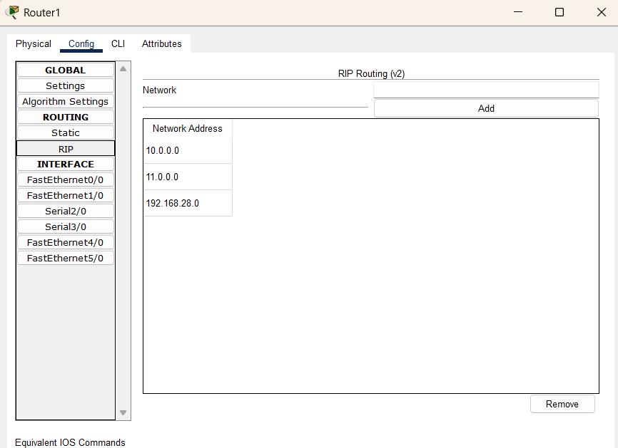
Step 5: Verify Routing Tables and Test Connectivity
PC2>Ping 192.168.27.2
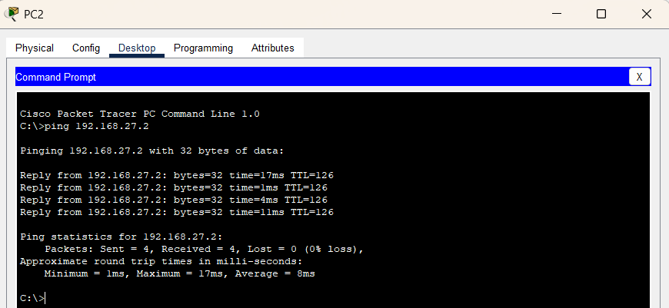
PC5>Ping 192.168.28.2
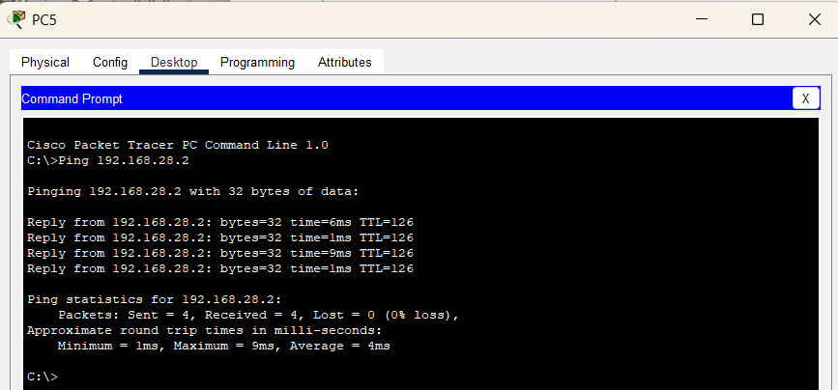
Observation
RIP configured on all routers; routing tables updated; ping successful.
Result
Dynamic routing enabled full LAN-to-LAN communication without static routes.
Conclusion
RIP efficiently updated routes across three routers, ensuring seamless connectivity.

