Lab Title: Use FTP server in Packet Tracer to upload and download files between server and client.

Objective
To configure an FTP server in Cisco Packet Tracer, connect it to client PCs, and demonstrate file upload and download using the FTP protocol across different subnets.

Apparatus / Software Required
- Cisco Packet Tracer
- 1 Router (R0)
- 1 Switch (S0)
- 1 FTP Server
- 2 PCs (PC0 and PC1)

Network Topology Diagram
The topology of the network is shown below:
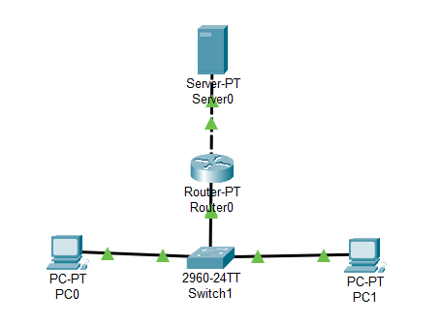
Fig: FTP Server and Client Configuration in Cisco Packet Tracer

IP Addressing Scheme
- Router Interfaces
Interface | Connected To | IP Address | Subnet Mask
Fa0/0 | Server | 192.168.27.1 | 255.255.255.0
Fa0/1 | Switch/PCs | 192.168.28.1 | 255.255.255.0

- Server
Device | IP Address | Subnet Mask | Default Gateway
FTP Server | 192.168.27.2 | 255.255.255.0 | 192.168.27.1

- PCs
Device | IP Address | Subnet Mask | Default Gateway
PC0 | 192.168.28.3 | 255.255.255.0 | 192.168.28.1
PC1 | 192.168.28.4 | 255.255.255.0 | 192.168.28.1

Procedure
Step 1: Device Placement and Cabling
- Place 1 router, 1 switch, 1 server, and 2 PCs in the workspace.
- Connect Router Fa0/0 → Server, Router Fa0/1 → Switch, and Switch → PC1 & PC2.
Step 2: Assign IP Addresses
- Configure IPs on Router, Server, and PCs as per the table above, for ex:

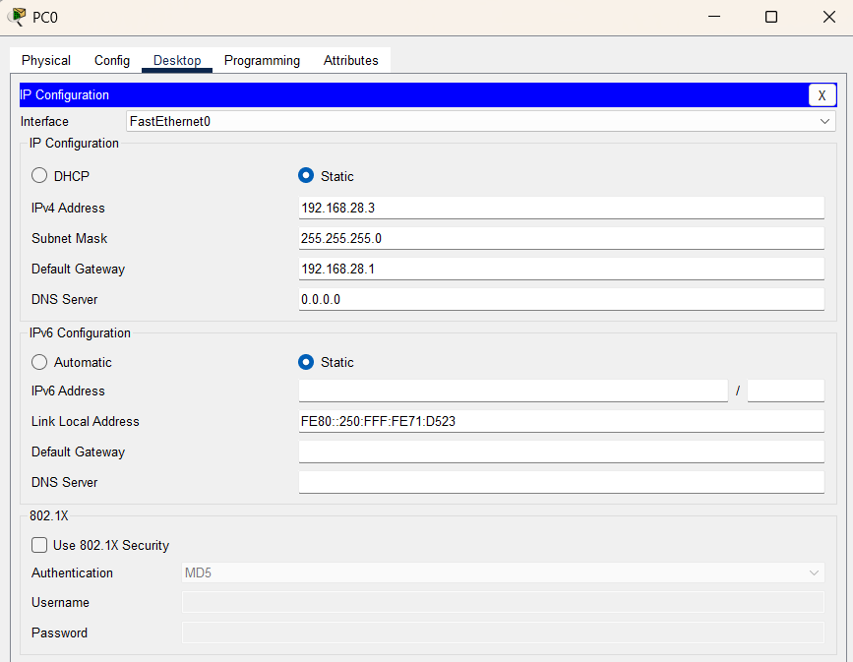
- Turn router ports ON.
Step 3: Configure the FTP Server
- Open FTP Server → Services → FTP → Turn ON.
- Create user account: Username: Roshan, Password: 123.
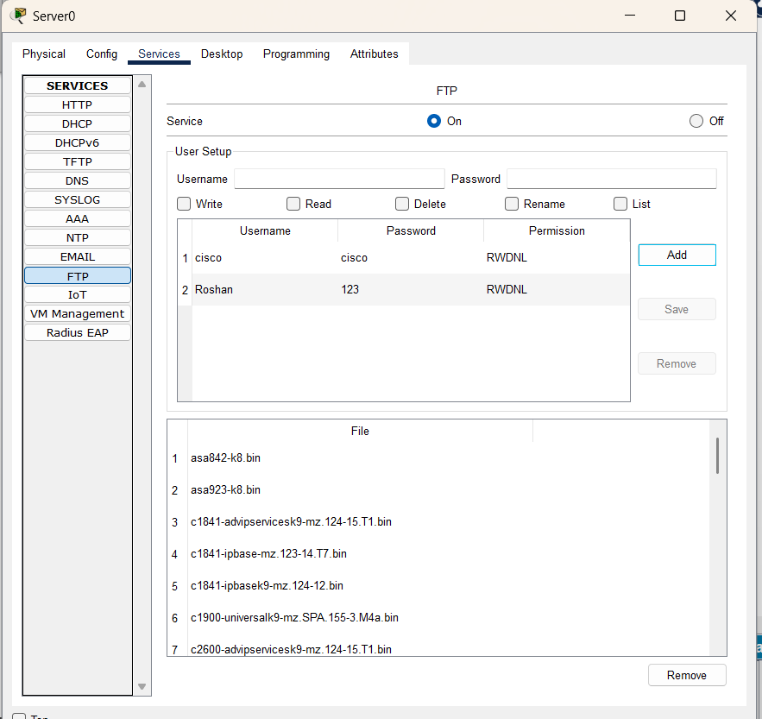
Step 4: Create Test File on PC1
- Open ‘Text Editor’ on PC1 and write "Testing FTP."
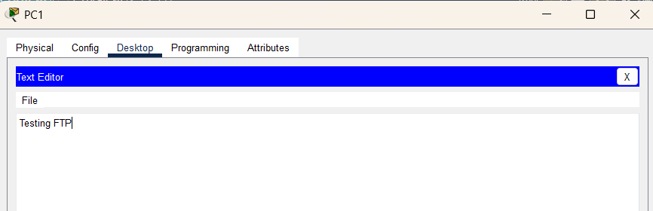
- Save it as testfile.txt.

Step 5: Upload File from PC0 to Server
- On PC0 command prompt:
ftp 192.168.27.2
Username: Roshan
Password: 123
put Testing.txt
dir
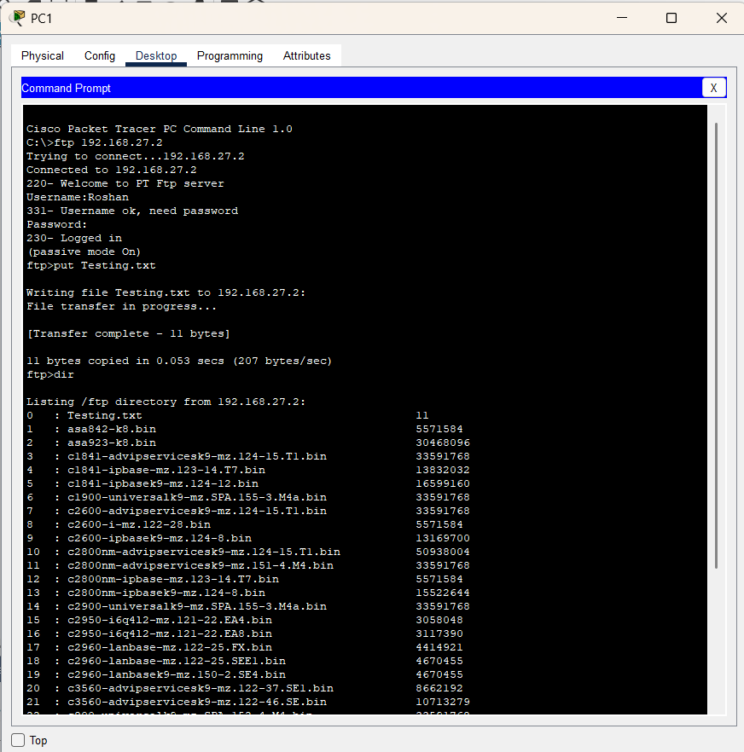
Step 6: Download File from PC0
- On PC0 command prompt:
ftp 192.168.27.2
Username: Roshan
Password: 123
dir
get Testing.txt
Step 7: Verify
- Upload success → File visible on server.
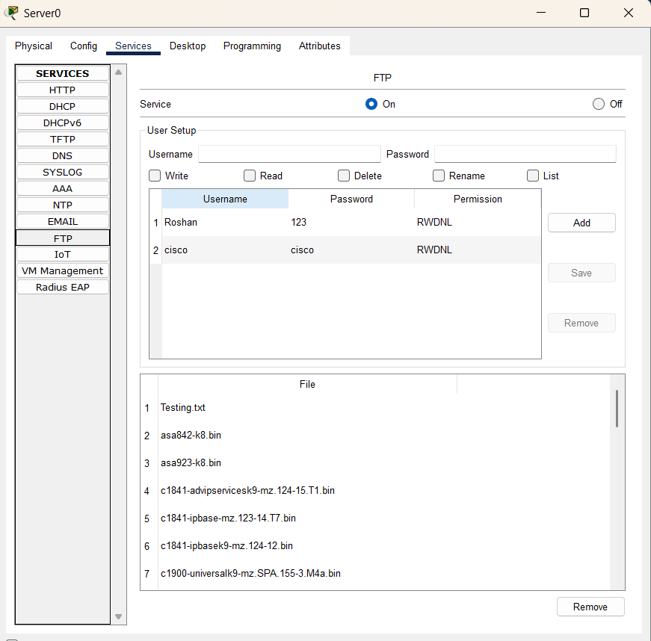
- Download success → File available on PC0.
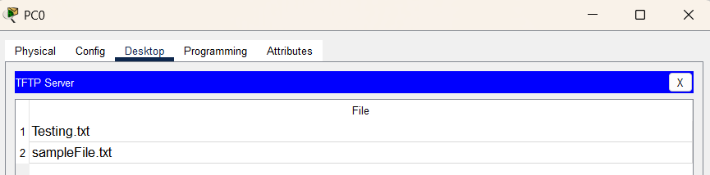

Observation
Router correctly routed. FTP service functioned across subnets. File created on PC1 was successfully uploaded to the FTP server and then downloaded to PC2.

Result
FTP communication was successfully established between the client PCs and the server. File upload from one client and download to another verified proper working of the FTP service.

Conclusion
This lab demonstrated that FTP services can be used in Packet Tracer for file sharing across networks. The objective of uploading and downloading files between clients and server was successfully achieved.

