Lab Title
In Cisco Packet Tracer, set up and configure a DNS server and a Web server. Host a sample HTML page on the Web server and access it from client PCs using a web browser via the domain name.

Objective
To set up a Web and DNS server in Packet Tracer so a client can open a webpage using a domain name instead of an IP.

Apparatus / Software Required
- 1 PC (Client)
- 1 Switch (PT-Switch)
- 1 Web Server (Server0)
- 1 DNS Server

Network topology Diagram
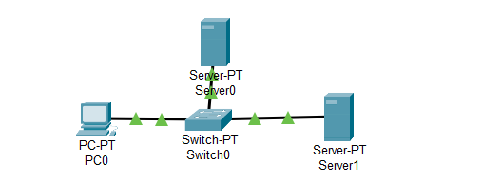
IP Addressing Table
Device | IPv4 Address | Subnet Mask | Default Gateway | DNS Server
PC0 | 192.168.27.11 | 255.255.255.0 | 192.168.27.1 | 192.168.27.13
Server0 (Web) | 192.168.27.12 | 255.255.255.0 | 192.168.27.1 | —
Server1 (DNS) | 192.168.27.13 | 255.255.255.0 | 192.168.27.1 | 192.168.27.13

Procedure
Step 1: Connections:
- PC ↔ Switch ↔ Servers
Step 2: Configure IP Addresses
- Assign IP address, subnet mask, gateway, and DNS on PC0 as per the table.
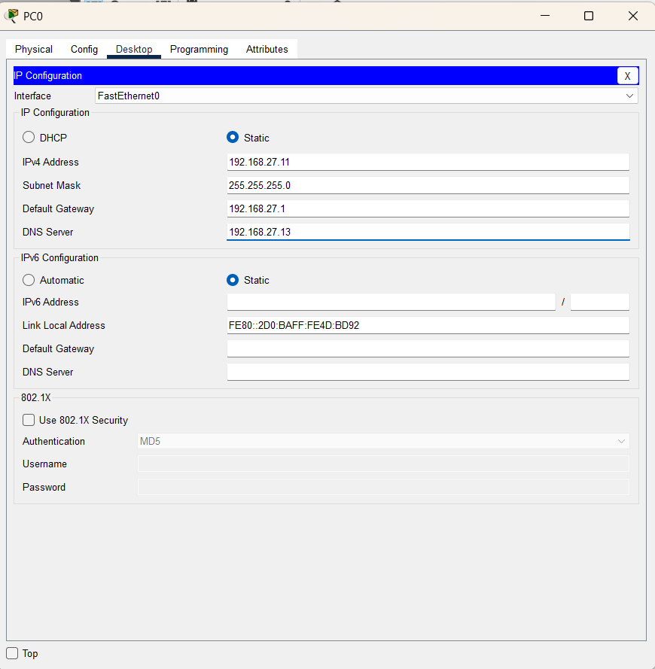

Step 3: Configure Web Server (Server0)
- Open Services → HTTP on Server0.
- Ensure HTTP service is turned ON.
- Edit the index.html file to include a sample webpage.
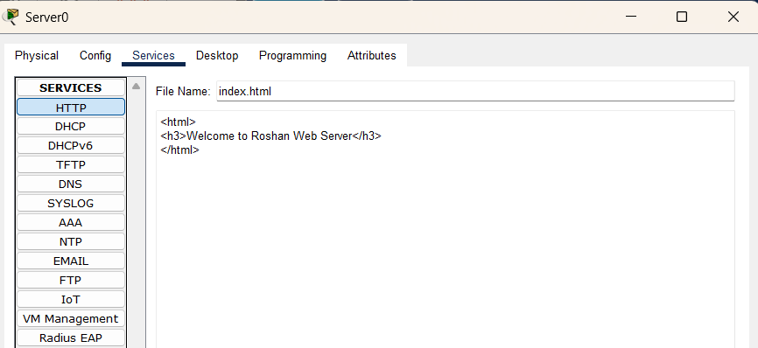
Step 4: Configure DNS Server (Server1)
- Open Services → DNS on Server1.
- Turn DNS service ON.
- Add a DNS record:
  - Name: cisco.com
  - Address: 192.168.27.12
- Save the record.
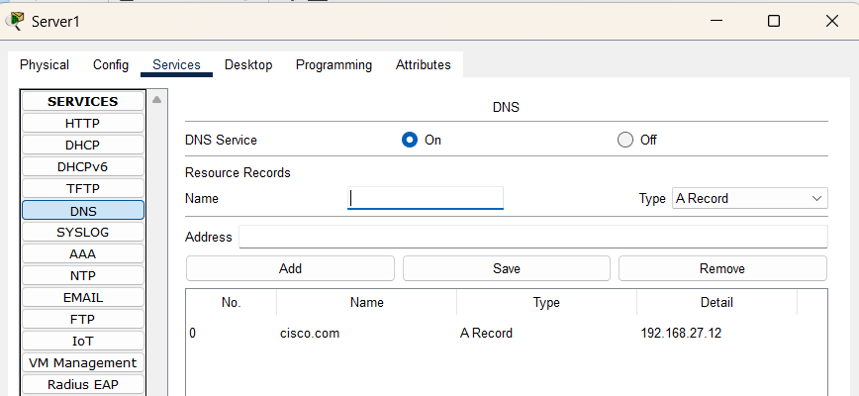

Step 5: Verification
- Open the Web Browser on PC0.
- Test access by typing the Web Server IP: 192.168.27.12. The page should load.
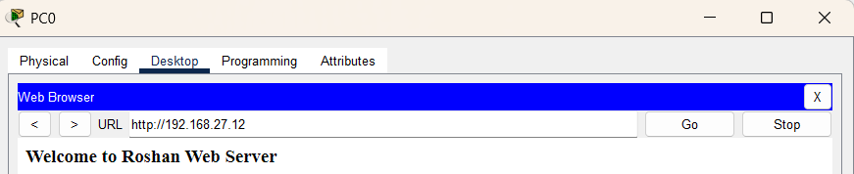
- Then type the domain name: cisco.com. The page should also load, showing DNS resolution is working.
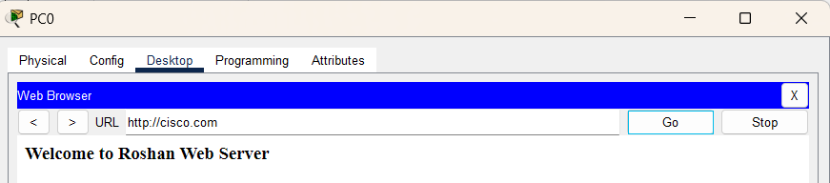
Observations
- PC accessed the page via both IP and domain name.
- DNS resolved cisco.com to the Web server’s IP.

Result
DNS and Web servers were configured successfully, and the client accessed the hosted page using the domain name.

Conclusion
DNS simplified access to the web server by resolving the domain name to its IP, showing how domain-based browsing works in real networks

