Lab Title: Configure a Mail Server and Simulate Sending/Receiving Emails Between Two Users on Different PCs
Objective
To configure a Mail Server in Cisco Packet Tracer and demonstrate email communication between two users on separate PCs.
Apparatus / Software Required
- 1 Mail Server
- 1 Switch (PT-Switch)
- 2 PCs (PC1, PC2)
- Cisco Packet Tracer
Network Topology Diagram
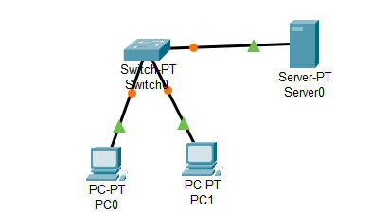
IP Addressing Table
Device | IPv4 Address | Subnet Mask | Default Gateway | DNS Server
Server (Mail) | 192.168.27.2 | 255.255.255.0 | 192.168.27.1 | —
PC1 (Roshan) | 192.168.27.3 | 255.255.255.0 | 192.168.27.1 | 192.168.27.2
PC2 (Bob) | 192.168.27.4 | 255.255.255.0 | 192.168.27.1 | 192.168.27.2
Procedure
Step 1: Connections
- Server ↔ Switch
- PC1 ↔ Switch
- PC2 ↔ Switch
Step 2: Assign IP Addresses
- Configure the IP address, subnet mask, and gateway for the server and PCs as per the table. For example, Mail server:
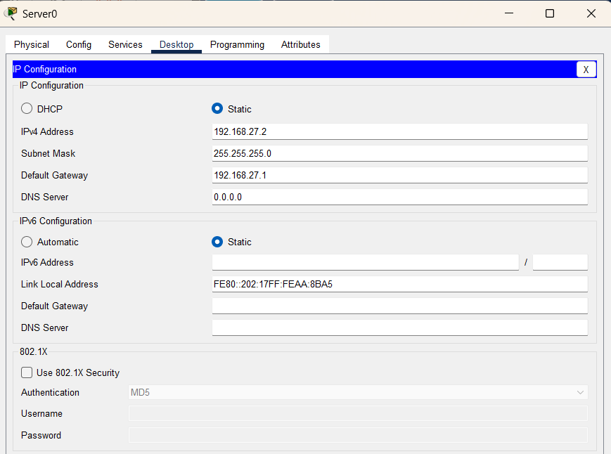
Step 3: Configure Mail Server
- Open Server → Services → Email.
- Turn Email Service ON.
- Domain Name: mail.com, Click on set.
- Add user accounts:
  - Username: Roshan | Password: 123
  - Username: Bob | Password: 123
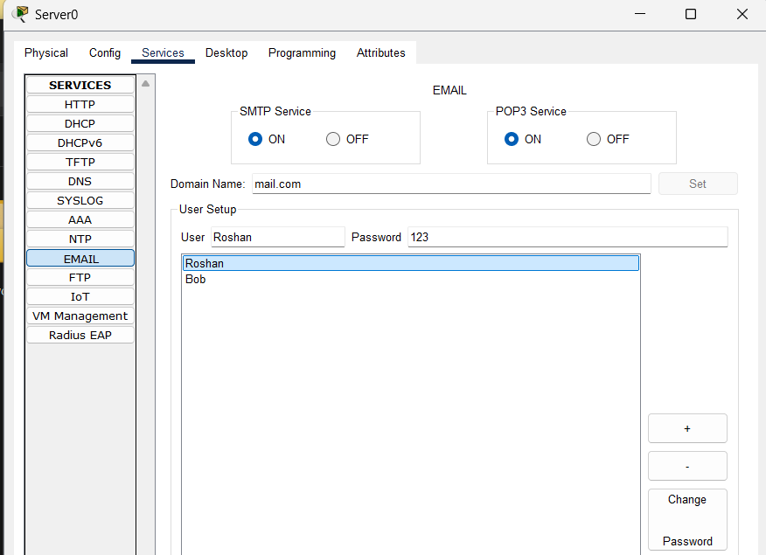
Step 4: Configure Email on PCs
- PC1:
  - Display Name: Roshan
  - Email: Roshan@mail.com
  - Incoming Mail Server: 192.168.27.2
  - Outgoing Mail Server: 192.168.27.2
  - Username: Roshan
  - Password: 123
- PC2:
  - Display Name: Bob
  - Email: Bob@mail.com
  - Incoming Mail Server: 192.168.27.2
  - Outgoing Mail Server: 192.168.27.2
  - Username: Bob
  - Password: 123
Step 5: Send Email
- On PC1:
  - Open Email application.
  - Compose a message:
    - To: Bob@mail.com
    - Subject: Test Mail
    - Body: Hello Bob, this is Roshan.
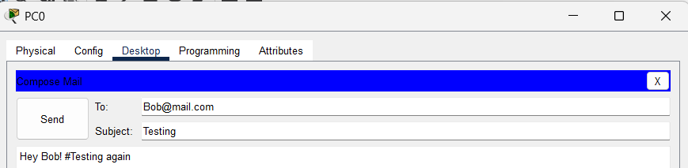
  - Click Send
Step 6: Receive Email
- On PC2:
  - Open Email application.
  - Click Receive.
  - Roshan’s message will appear in the inbox.
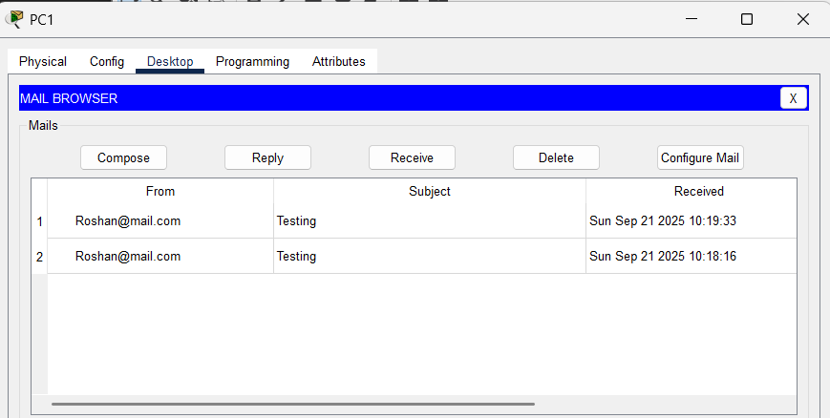
Step 7: Reply
- On PC2:
  - Reply: Hi Roshan, I received your mail.
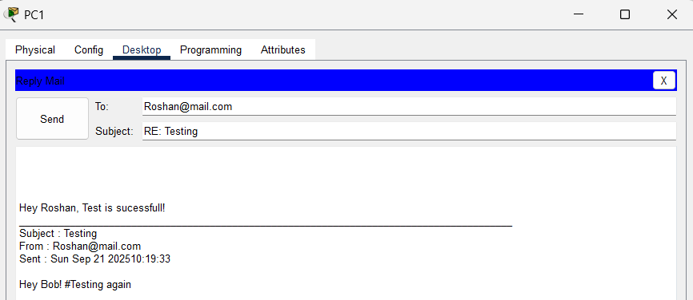
- On PC1:
  - Click Receive to view Bob’s reply.
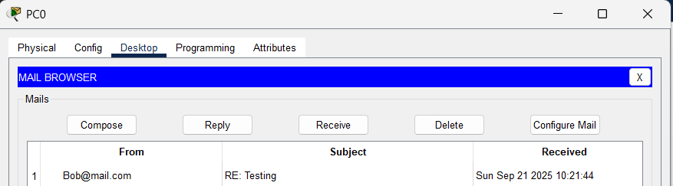
Observations
- The Mail Server allowed successful email exchange between Roshan and Bob.
- PC1 sent a message that PC2 received, and PC2’s reply was received back by PC1.
- End-to-end communication within the LAN was validated.
Result
The Mail Server was configured successfully in Packet Tracer, enabling Roshan and Bob to exchange emails using their configured accounts.
Conclusion
The simulation demonstrated how a Mail Server handles email services within a LAN. By configuring accounts and using the email application, users can send and receive emails, replicating real-world communication systems.

