Lab Title: Configure a Basic Firewall in Cisco Packet Tracer to Control and Filter Traffic Between Two Networks
Objective:
Configure a firewall on a server in Cisco Packet Tracer to block ping requests while allowing web traffic, demonstrating basic traffic control.
Apparatus / Software Required
- 1 PT-Server (Server0)
- 1 PT-Switch
- 3 PCs (PC0, PC1, PC2)
- Cisco Packet Tracer software
Network Topology Diagram
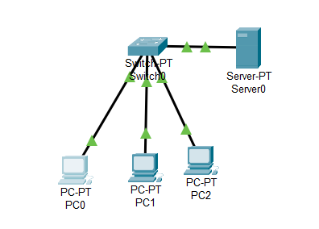
IP Addressing Table:
S.NO | Device | IPv4 Address | Subnet Mask
1 | Server | 192.168.27.1 | 255.255.255.0
2 | PC0 | 192.168.27.2 | 255.255.255.0
3 | PC1 | 192.168.27.3 | 255.255.255.0
4 | PC2 | 192.168.27.4 | 255.255.255.0
Procedure
Step 1: Build connection
- Place 1 switch, 3 PC’s and 1 Server
- Connect PC’s to switch and Server to switch
Step 2: Configure IP Addresses
Configure each PC and the server with IPv4 addresses according to the table.
For example, PC0:
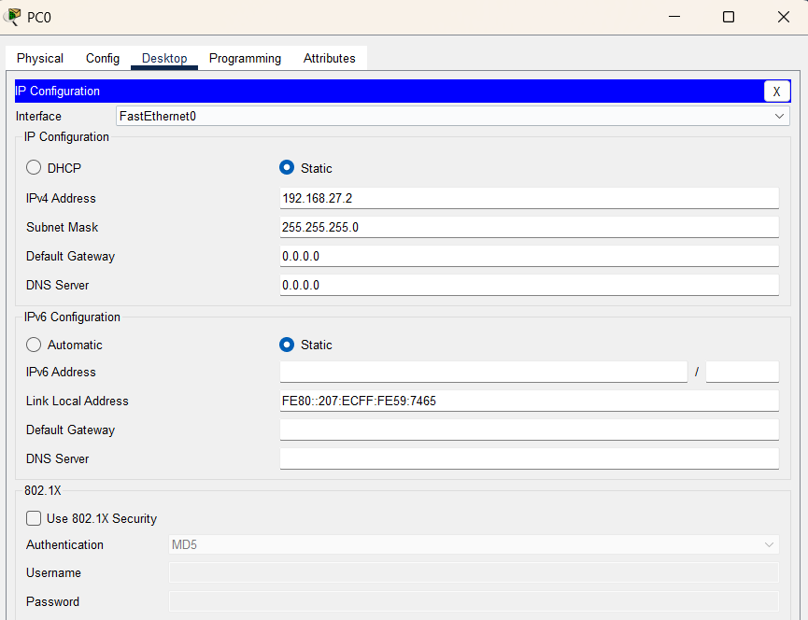
Step 3: Configure Firewall on Server
- Click on Server0 → Desktop → Firewall (IPv4)
- Turn Firewall Services ON
- Configure the following rules:
- Deny ‘ICMP’ protocol
  - Remote IP: 0.0.0.0
  - Remote Wildcard Mask: 255.255.255.255
- Allow ‘IP’ protocol
  - Remote IP: 0.0.0.0
  - Remote Wildcard Mask: 255.255.255.255

- Add the rules in sequence (first Deny ICMP, then Allow IP).
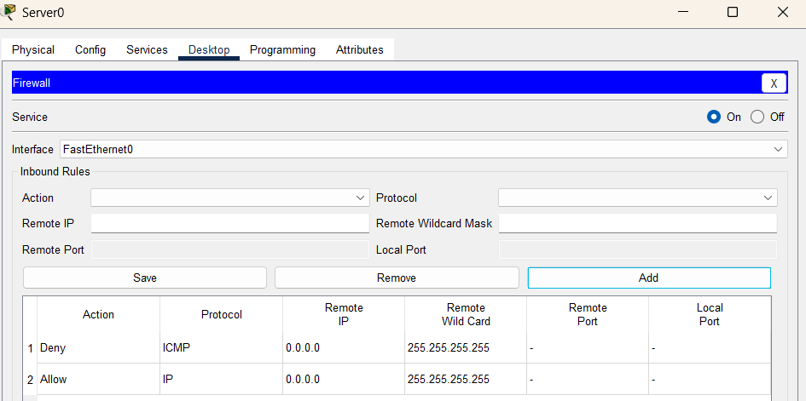
Step 4: Verify the Network
Test with Ping Command:
- Go to PC2 → Desktop → Command Prompt
- PC2> ping 192.168.27.1
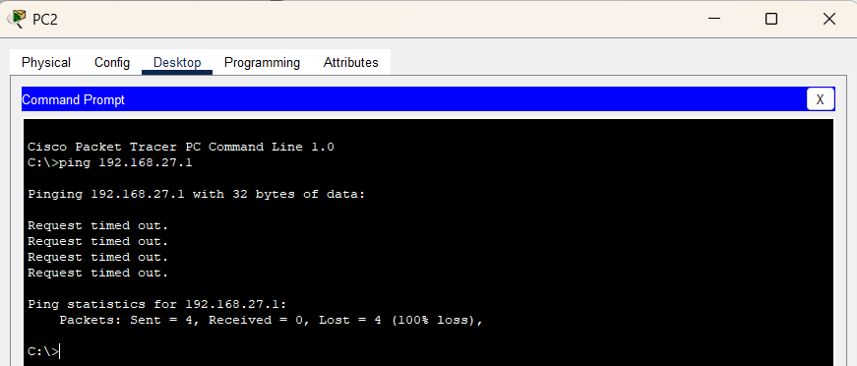
Test with Web Browser:
- On PC2 → Desktop → Web Browser
- Enter 192.168.27.1 in the URL bar.
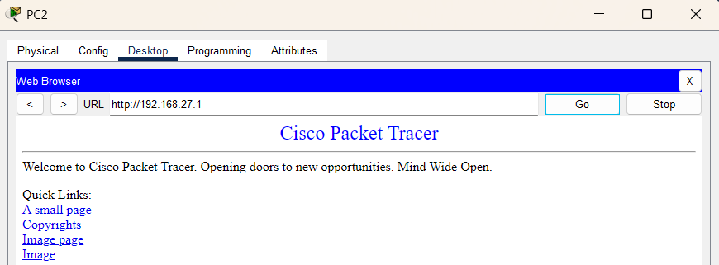
Observations
- Pings from PCs to the Server are blocked by the firewall.
- Web browsing works successfully despite ICMP being blocked.
- This demonstrates selective traffic filtering using firewall rules.

Result
A basic firewall was successfully configured in Cisco Packet Tracer to block ICMP traffic while allowing HTTP access.
Conclusion:
The lab showed that a firewall can control network traffic by blocking pings and allowing web browsing, highlighting its role in network security.

