Lab Title: Design and configure a small LAN using Packet Tracer with at least 4 PCs, a switch, and a router. Assign IP addresses manually and test connectivity using ping.
Objective
To design and configure a small Local Area Network (LAN) consisting of 4 PCs, a switch, and a router. Assign IP addresses manually and test the connectivity using the ping command.
Apparatus / Software Required
• Cisco Packet Tracer
• 4 PCs
• 1 Switch
• 1 Router
• Copper Straight-Through Cables
Network Topology Diagram:
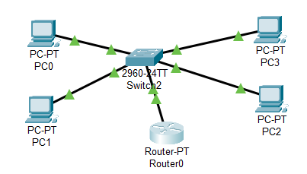
(Place 4 PCs connected to the Switch; Switch connected to Router FastEthernet0/0)
IP Addressing Scheme:
Device | Interface | IP Address | Subnet Mask | Default Gateway
PC0 | Fa0 | 192.127.7.10 | 255.255.255.0 | 192.127.7.1
PC1 | Fa0 | 192.127.7.11 | 255.255.255.0 | 192.127.7.1
PC2 | Fa0 | 192.127.7.12 | 255.255.255.0 | 192.127.7.1
PC3 | Fa0 | 192.127.7.13 | 255.255.255.0 | 192.127.7.1
Router | Fa0/0 | 192.127.7.1 | 255.255.255.0 | —
Where, Fa0: FastEthernet0
Procedure
Step 1: Device Placement and Cabling
• Place 4 PCs, a Switch, and a Router in the Packet Tracer workspace.
• Use Copper Straight-Through Cables to connect:
- PC’s to Switch
- Switch to Router Fa0/0
Step 2: IP Address Assignment on PCs
• Click on each PC → Desktop → IP Configuration.
• Enter the IP address, subnet mask, and default gateway as per the table above.
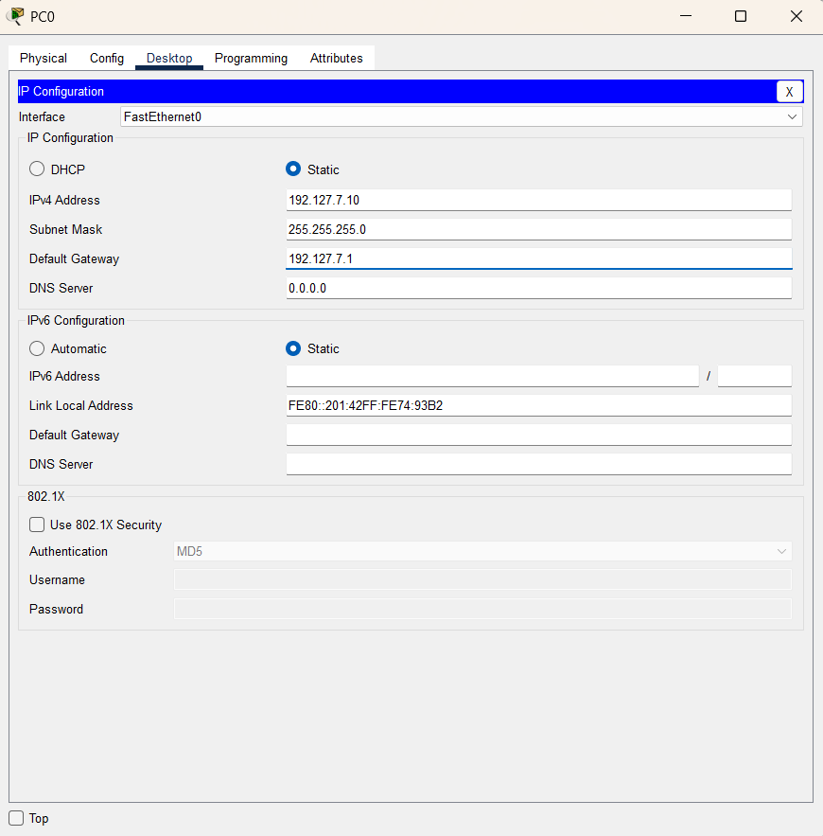
Step 3: Configure Router Interface
• Click the Router → Config → FastEthernet0/0
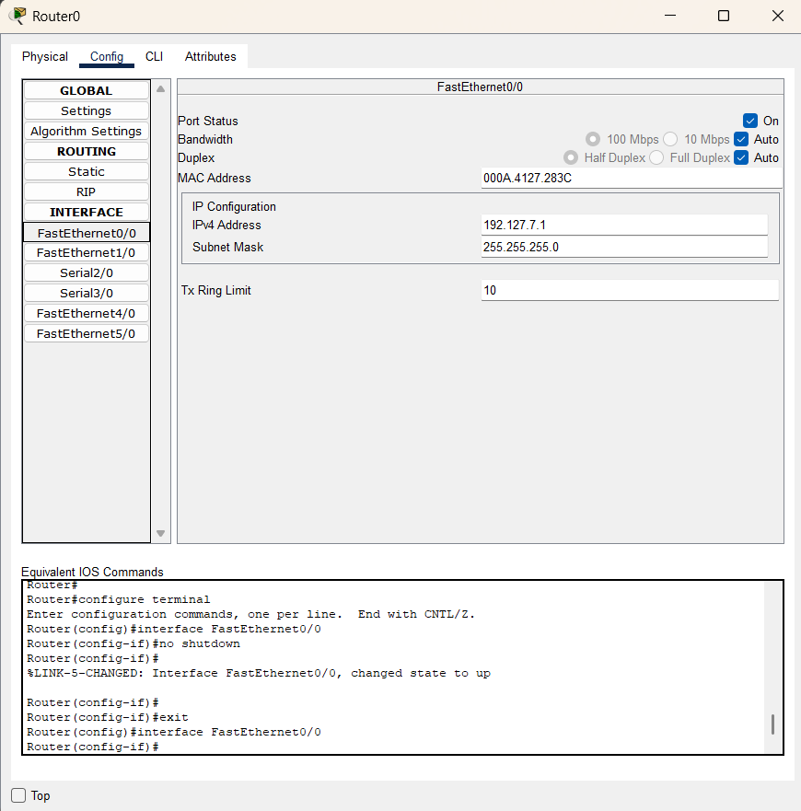

Step 4: Test Connectivity
• Open Command Prompt on each PC
• Use the ping command to test connectivity:
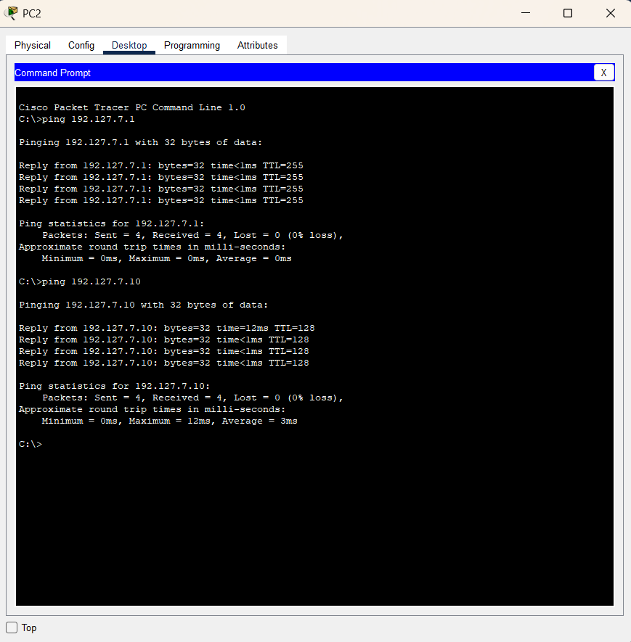
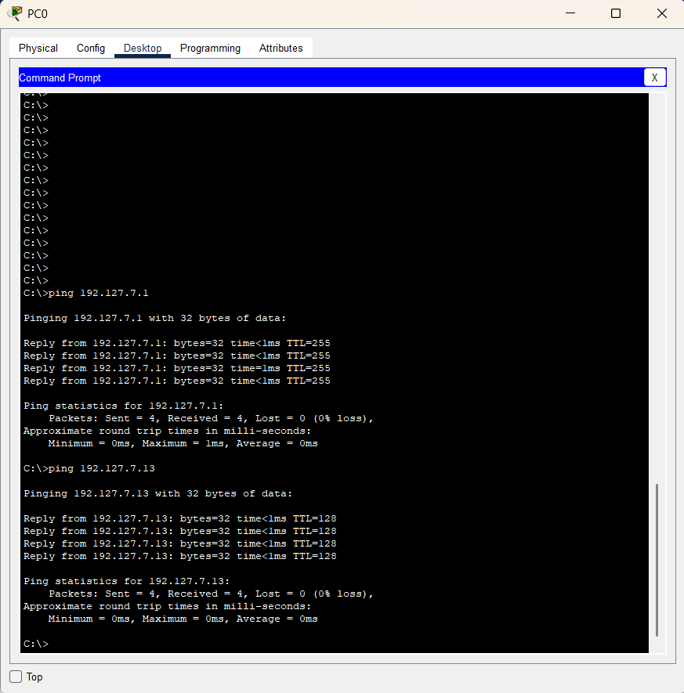

Observation
Each PC successfully sends and receives ping responses to/from:
• The Router (192.127.7.1)
• Other PCs on the same network (192.127.7.10 - 13)
Result
A small LAN with 4 PCs, a switch, and a router was successfully designed and configured. Manual IP addressing (all within 192.127.7.0/24) was applied, and connectivity was verified using the ping command.
Conclusion:
This lab demonstrated setting up a basic LAN with static IPs and testing communication, forming a foundation for more complex network topologies.

