Lab Title: To simulate and configure different network topologies (Star, Ring, Bus, Mesh, and Hybrid) using Cisco Packet Tracer.
Objectives
- To understand the design and working of basic network topologies.
- To configure IP addresses for devices using 192.127.7.0/24.
- To test connectivity with the ping command.
Apparatus / Software Required
- Cisco Packet Tracer
- PCs (minimum 4–6 for each topology)
- Switches, Hubs, Routers (as required)
- Copper Straight-Through and Cross-Over Cables

(a) Star Topology
In a Star topology, all devices are connected to a central device (switch/hub).
Devices Used
- 1 Switch
- 4 PCs

Network topology Diagram
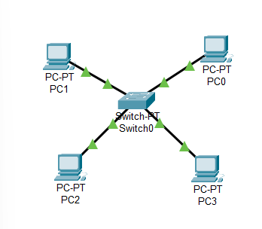
Fig: Star Topology

IP Addressing Scheme
Device | Interface | IP Address | Subnet Mask | Default Gateway
PC0 | Fa0 | 192.127.7.10 | 255.255.255.0 | 192.127.7.1
PC1 | Fa0 | 192.127.7.11 | 255.255.255.0 | 192.127.7.1
PC2 | Fa0 | 192.127.7.12 | 255.255.255.0 | 192.127.7.1
PC3 | Fa0 | 192.127.7.13 | 255.255.255.0 | 192.127.7.1
Router | Fa0/0 | 192.127.7.1 | 255.255.255.0 | —

Procedure
Step 1: Connect four PCs to a switch with straight-through cables, and link the switch to a router
Step 2: Configure IP addresses as per the table.
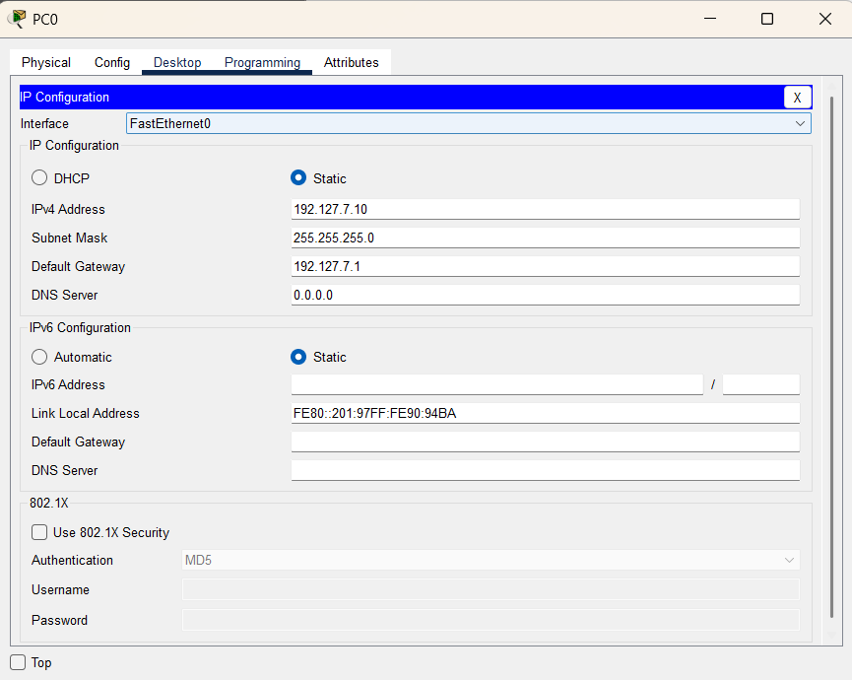

Step 3: Test Connectivity
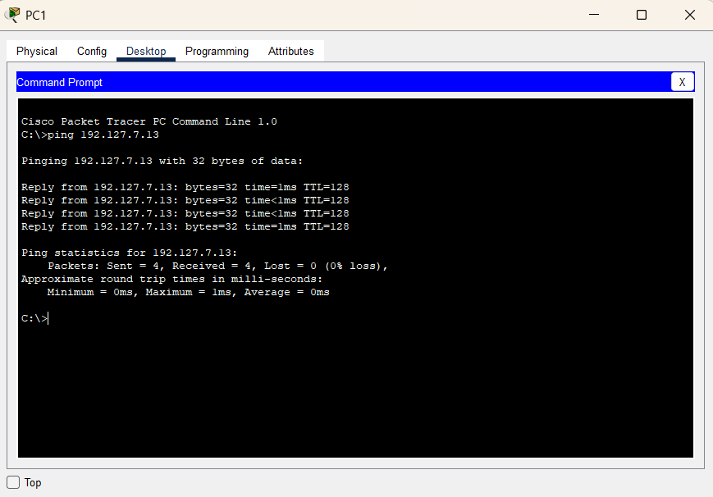
(b) Ring Topology
In this Ring topology, 4 switches are connected in a closed loop (each switch connected to two other switches). Each switch has 1 PC connected to it, so the PCs communicate through the ring of switches.
Devices Used
- 4 Switches
- 4 PCs
- Copper Straight-Through cables (PC → Switch)
- Copper Cross-Over cables (Switch → Switch in ring)

Network Topology Diagram
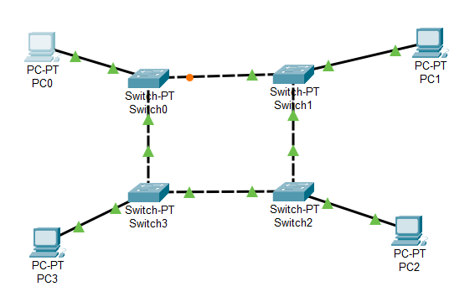
Fig: Ring Topology

IP Addressing Scheme
Device | Connected Switch | IP Address | Subnet Mask | Default Gateway
PC0 | Switch0 | 192.127.7.20 | 255.255.255.0 | 192.127.7.1
PC1 | Switch1 | 192.127.7.21 | 255.255.255.0 | 192.127.7.1
PC2 | Switch2 | 192.127.7.22 | 255.255.255.0 | 192.127.7.1
PC3 | Switch3 | 192.127.7.23 | 255.255.255.0 | 192.127.7.1

Procedure
Step1: Place Devices
  - Place 4 PCs and 4 Switches in Packet Tracer.
  - Connect each PC to its switch using a straight-through cable.
  - Connect the switches in a ring:
    - Switch0 ↔ Switch1
    - Switch1 ↔ Switch2
    - Switch2 ↔ Switch3
    - Switch3 ↔ Switch0

Step 2: Assign IP Addresses
  - On each PC → Desktop → IP Configuration → enter the values from the table.
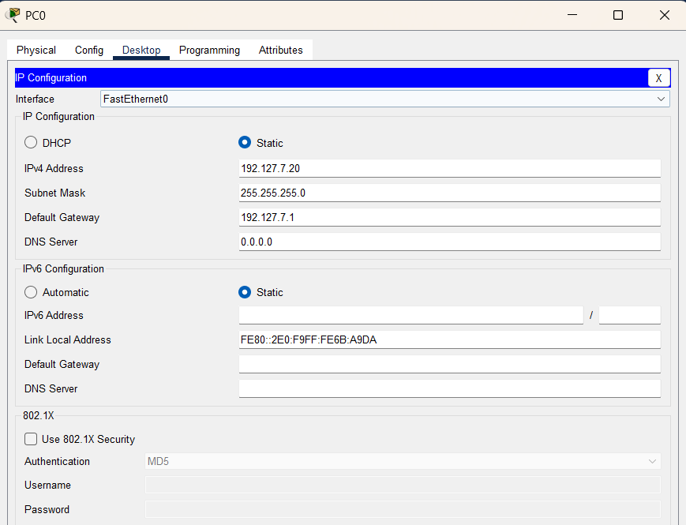
Step 3: Test Connectivity
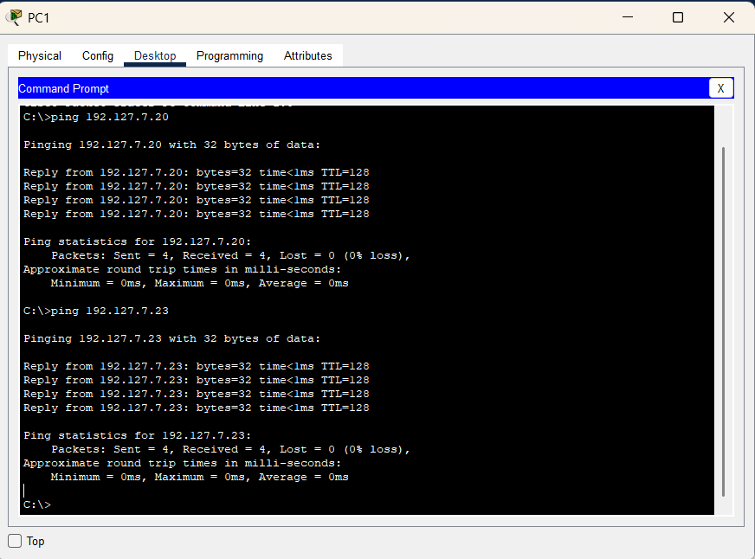
(c) Bus Topology
In this Bus topology, 5 switches are connected in a line (simulating a single shared communication medium). Each switch has 1 PC connected to it.
Devices Used
- 5 Switches
- 5 PCs
- Copper Straight-Through cables (PC → Switch)
- Copper Cross-Over cables (Switch → Switch in line)
Network Topology Diagram
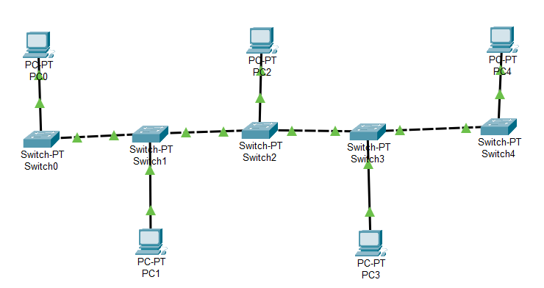
Fig: Bus Topology

IP Addressing Scheme
Device | Connected Switch | IP Address | Subnet Mask | Default Gateway
PC0 | Switch0 | 192.127.7.30 | 255.255.255.0 | 192.127.7.1
PC1 | Switch1 | 192.127.7.31 | 255.255.255.0 | 192.127.7.1
PC2 | Switch2 | 192.127.7.32 | 255.255.255.0 | 192.127.7.1
PC3 | Switch3 | 192.127.7.33 | 255.255.255.0 | 192.127.7.1
PC4 | Switch4 | 192.127.7.34 | 255.255.255.0 | 192.127.7.1

Procedure
Step 1: Place 5 switches and 5 PCs, connect PCs to switches with straight-through cables, and connect switches in a line with cross-over cables.
Step 2: Assign IP addresses to all PCs as per the table.
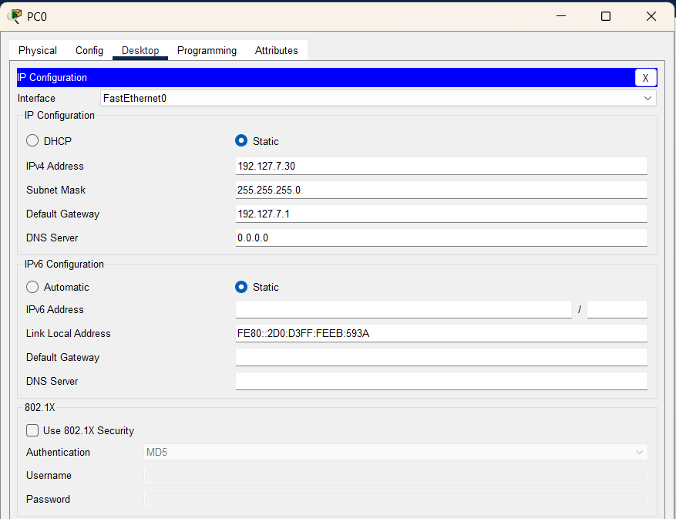
Step 3: Test connectivity
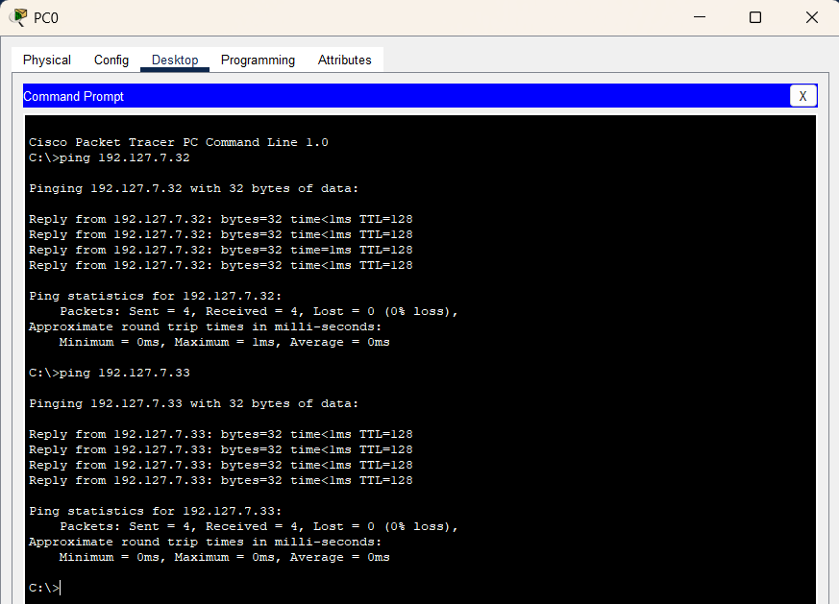

Observation
- All PCs could communicate successfully along the bus.
- STP prevented any accidental loops when switches were connected in line.

(d) Mesh Topology
In this Mesh topology, 4 switches are fully interconnected with every other switch, and each switch has 1 PC connected to it. This ensures maximum redundancy.
Devices Used
- 4 Switches
- 4 PCs
- Copper Straight-Through cables (PC → Switch)
- Copper Cross-Over cables (Switch → Switch fully connected)

Network Topology Diagram
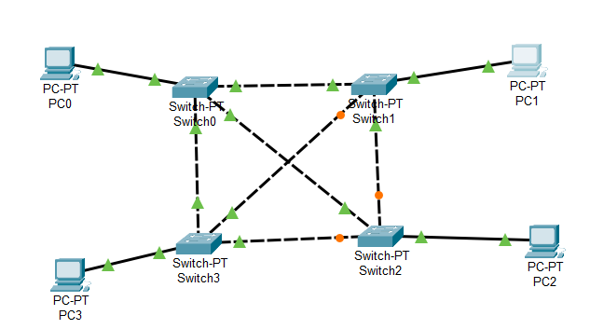
Fig: Mesh Topology

IP Addressing Scheme
Device | Connected Switch | IP Address | Subnet Mask | Default Gateway
PC0 | Switch0 | 192.127.7.40 | 255.255.255.0 | 192.127.7.1
PC1 | Switch1 | 192.127.7.41 | 255.255.255.0 | 192.127.7.1
PC2 | Switch2 | 192.127.7.42 | 255.255.255.0 | 192.127.7.1
PC3 | Switch3 | 192.127.7.43 | 255.255.255.0 | 192.127.7.1

Procedure
Step 1: Place 4 switches and 4 PCs, connect PCs to switches with straight-through cables, and interconnect switches with cross-over cables.
Step 2: Assign IP addresses as per the table.
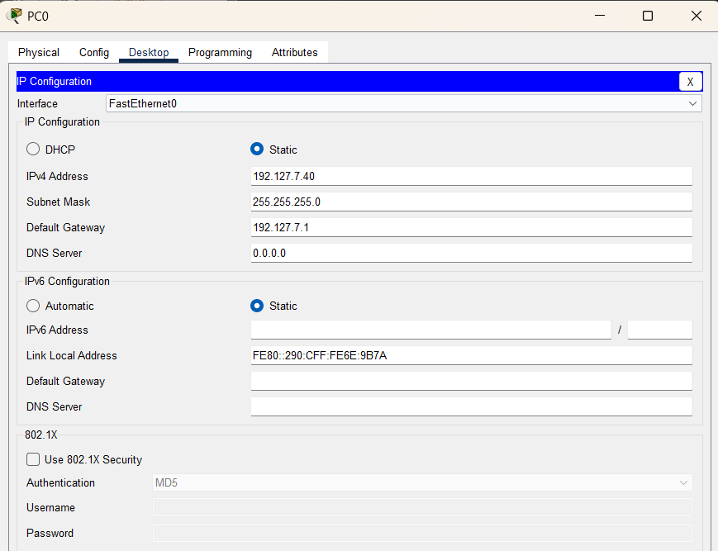
Step 3: Test connectivity
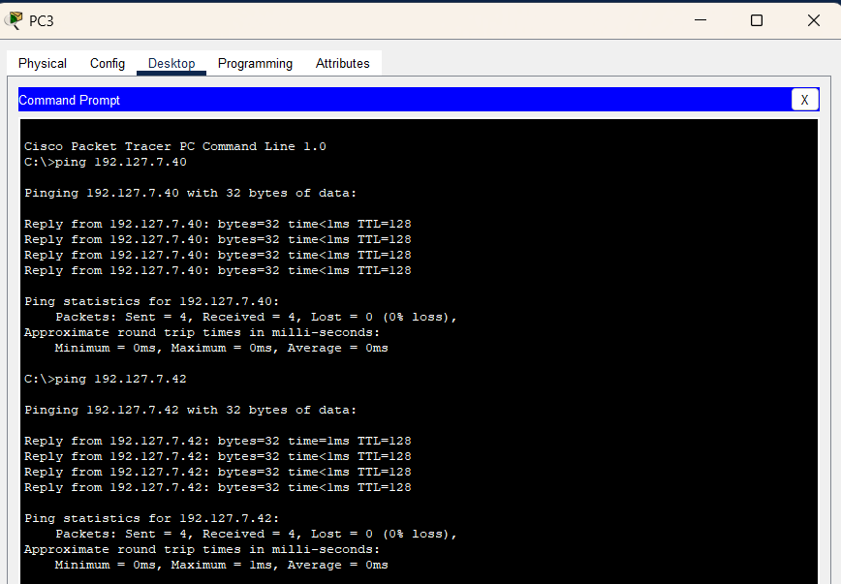

(e) Hybrid Topology
The bus section connects to the ring section, forming a Hybrid topology.
Devices Used
- Bus section: 5 Switches + 5 PCs
- Ring section: 4 Switches + 4 PCs
- Copper Straight-Through cables (PC → Switch)
- Copper Cross-Over cables (Switch → Switch)
Network Topology Diagram
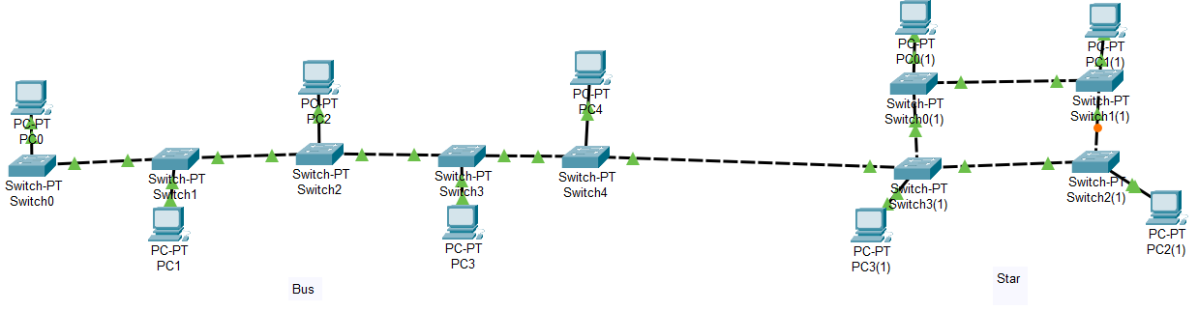
Fig: Hybrid Topology

IP Addressing Scheme
Device | Connected Switch | IP Address | Subnet Mask | Default Gateway
Bus PCs | Switch0–4 | 192.127.7.30–34 | 255.255.255.0 | 192.127.7.1
Ring PCs | Switch5–8 | 192.127.7.20–23 | 255.255.255.0 | 192.127.7.1

Procedure
Step 1:
Build the bus in line, the ring in a closed loop, and connect one switch from each section with a cross-over cable.
Step 2: Assign IP addresses as per the table.
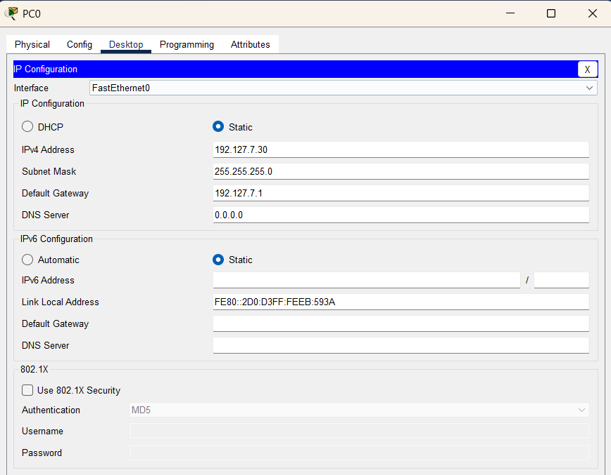
Step 3: Test connectivity:
  - Ping from Bus PCs → Ring PCs
  - Ping within Bus and Ring sections
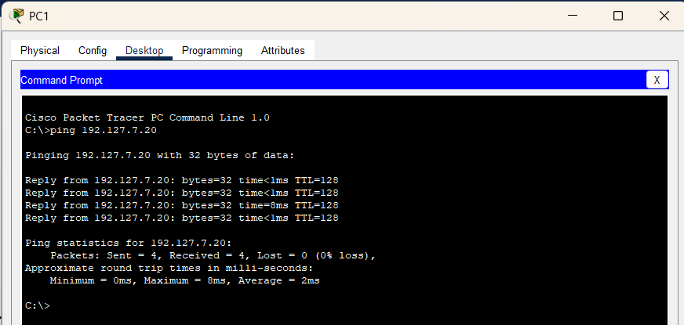
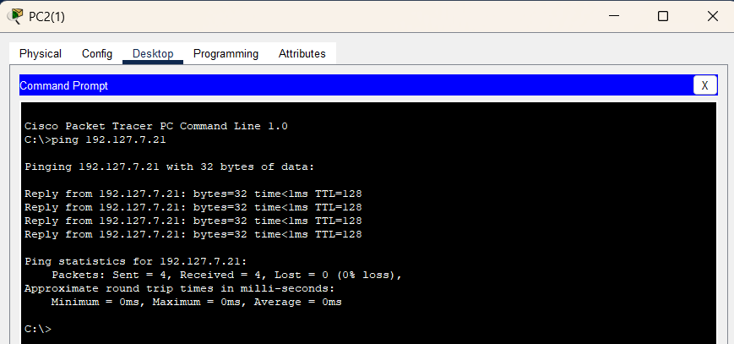
Observations:
- Star: PCs communicate via a central switch.
- Ring: Packets travel through each PC in sequence.
- Bus: PCs share a common hub.
- Mesh: PCs have direct links with all others.
- Hybrid: Combines star and bus sections.
Result:
Various network topologies were successfully simulated and tested in Packet Tracer.
Conclusion:
This lab highlighted the differences between topologies, their configurations, and connectivity methods, providing insight for designing efficient, scalable networks

