Lab Title: Bus and Star Topology Connection
Objective
To design and configure a network in Cisco Packet Tracer that connects a Bus topology and a Star topology using a router. IP addresses are manually assigned using CLI mode, and connectivity is verified between the two networks using ping.

Apparatus/Software Required
- Cisco Packet Tracer
- 5 PCs (2 in Bus, 3 in Star)
- 3 Switches (2 for Bus, 1 for Star)
- 1 Router
- Copper Straight-Through Cables

Network Topology Diagram
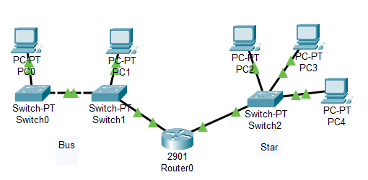
Fig: Bus and Star Topology Connection

IP Addressing Scheme
Device | Interface/PC | IP Address | Subnet Mask | Default Gateway
PC0 (Bus) | FastEthernet 0 | 192.127.7.2 | 255.255.255.0 | 192.127.7.1
PC1 (Bus) | FastEthernet 0 | 192.127.7.3 | 255.255.255.0 | 192.127.7.1
PC2 (Star) | FastEthernet 0 | 192.127.8.2 | 255.255.255.0 | 192.127.8.1
PC3 (Star) | FastEthernet 0 | 192.127.8.3 | 255.255.255.0 | 192.127.8.1
PC4 (Star) | FastEthernet 0 | 192.127.8.4 | 255.255.255.0 | 192.127.8.1
Router Fa0/0 | Bus side | 192.127.7.1 | 255.255.255.0 | —
Router Fa1/0 | Star side | 192.127.8.1 | 255.255.255.0 | —

Procedure
Step 1: Device Placement & Cabling
Connect PCs to switches, link switches to the router (Fa0/0 for Bus side, Fa0/1 for Star side).
Step 2: Assign IP Addresses to PCs
PC0> ipconfig 192.127.7.2 255.255.255.0 192.127.7.1
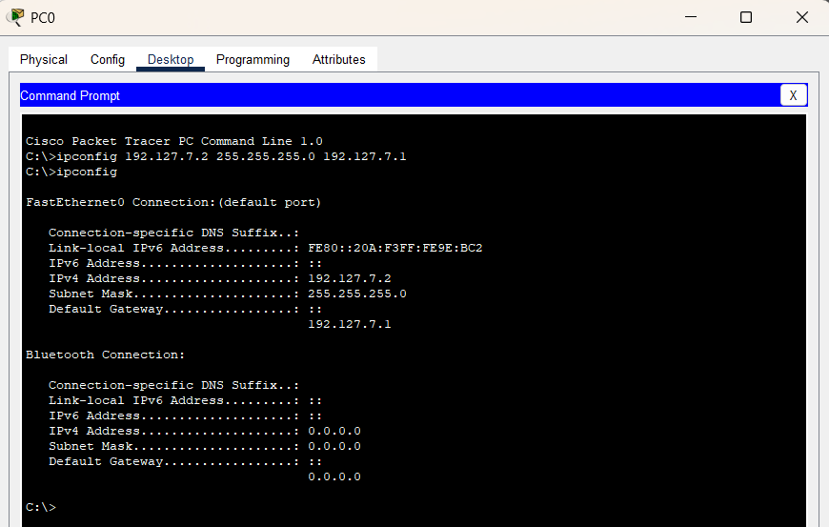
Similarly, For other PC’s with the help of above table.
- PC0 (Bus)
PC0> ipconfig 192.127.7.2 255.255.255.0 192.127.7.1
- PC1 (Bus)
PC1> ipconfig 192.127.7.3 255.255.255.0 192.127.7.1
- PC2 (Star)
PC2> ipconfig 192.127.8.2 255.255.255.0 192.127.8.1
- PC3 (Star)
PC3> ipconfig 192.127.8.3 255.255.255.0 192.127.8.1
- PC4 (Star)
PC4> ipconfig 192.127.8.4 255.255.255.0 192.127.8.1

Step 3: Configure Router Interfaces
Router> enable
Router# configure terminal
Router(config)# interface gigabitEthernet 0/0
Router(config-if)# ip address 192.127.7.1 255.255.255.0
Router(config-if)# no shutdown
Router(config-if)# exit
Router(config)# interface gigabitEthernet 0/1
Router(config-if)# ip address 192.127.8.1 255.255.255.0
Router(config-if)# no shutdown
Router(config-if)# exit
Router(config)# end
Router# write memory

Step 4: Test Connectivity
- From PC1 (Bus) → PC3 (Star):
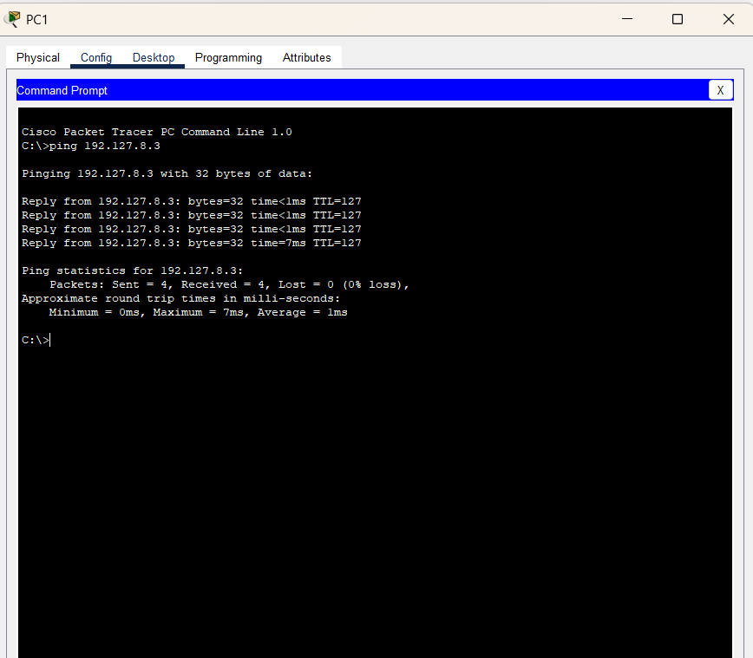
- From PC4 (Star) → PC0 (Bus):
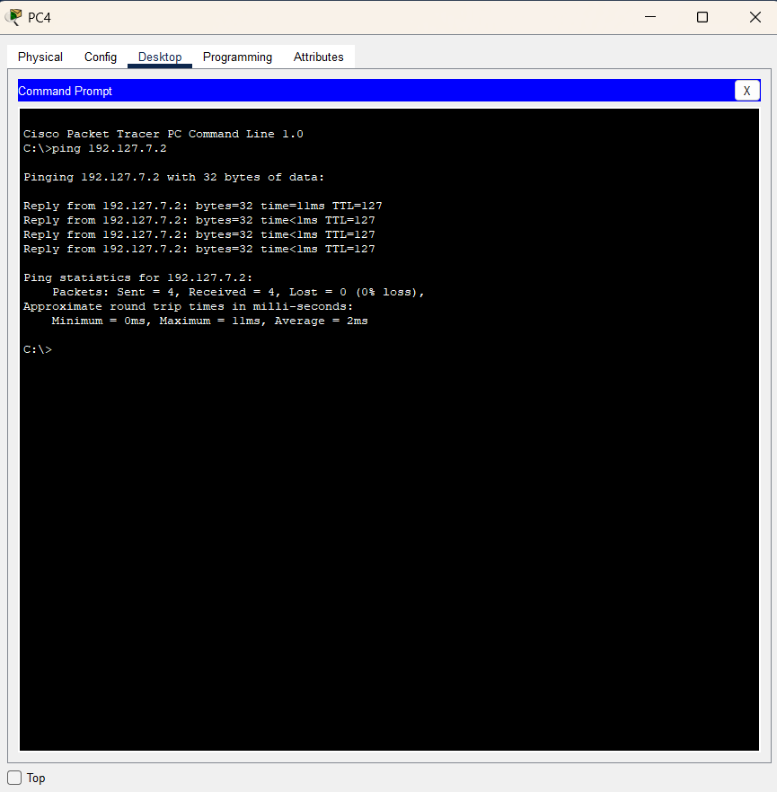
Observations
- Each topology communicated properly within its subnet.
- The router enabled communication between bus and star networks.
Result
The Bus and Star topologies were successfully interconnected, and cross-network pings verified communication.
Conclusion
This lab confirmed that different topologies can be interconnected using a router with separate subnets. Proper IP assignment and router configuration ensured seamless connectivity.

