Lab Title: Star and Tree Topology Connection
Objective
To design and configure a network in Cisco Packet Tracer that interconnects a Star topology and a Tree topology using a router. Each topology is assigned a distinct subnet. IP addresses are configured manually in CLI mode, and connectivity is verified across both networks using the ping command.

Apparatus/Software Required
- Cisco Packet Tracer
- 6 PCs (3 in Star, 3 in Tree)
- 4 Switches (1 for Star, 3 for Tree)
- 1 Router
- Copper Straight-Through Cables

Network Topology Diagram
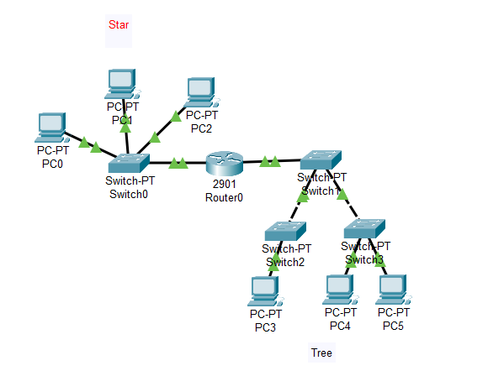
Fig: Star and Tree Topology Connection

IP Addressing Scheme
Device Interface/PC IP Address Subnet Mask Default Gateway
PC0 (Star) Fa0 192.127.10.2 255.255.255.0 192.127.10.1
PC1 (Star) Fa0 192.127.10.3 255.255.255.0 192.127.10.1
PC2 (Star) Fa0 192.127.10.4 255.255.255.0 192.127.10.1
PC3 (Tree) Fa0 192.127.20.2 255.255.255.0 192.127.20.1
PC4 (Tree) Fa0 192.127.20.3 255.255.255.0 192.127.20.1
PC5 (Tree) Fa0 192.127.20.4 255.255.255.0 192.127.20.1
Router Fa0/0 Star side 192.127.10.1 255.255.255.0 —
Router Fa1/0 Tree side 192.127.20.1 255.255.255.0 —
Procedure
Step 1: Device Placement & Cabling
Connect 6 PCs to 4 switches, link Star (PC0–PC2 → Switch0 → Router Fa0/0) and Tree (PC3–PC5 via Switch2 & Switch3, linked through Switch1 → Router Fa0/1) using straight-through cables.
Step 2: Assign IP Addresses to PCs (CLI Mode)
PC2> ipconfig 192.127.10.4 255.255.255.0 192.127.10.1
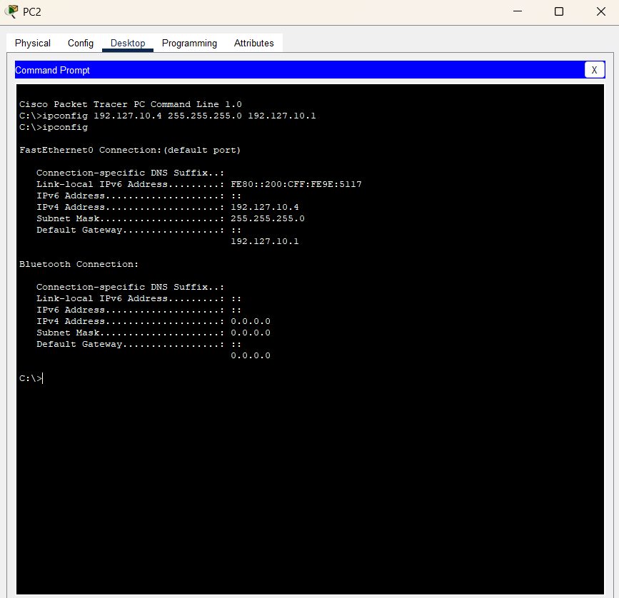
Similarly, For other PC’s using above table.

PC0
PC0> ipconfig 192.127.10.2 255.255.255.0 192.127.10.1
- PC1
PC1> ipconfig 192.127.10.3 255.255.255.0 192.127.10.1
- PC2
PC2> ipconfig 192.127.10.4 255.255.255.0 192.127.10.1
(b) Tree Topology PCs
- PC3
PC3> ipconfig 192.127.20.2 255.255.255.0 192.127.20.1
- PC4
PC4> ipconfig 192.127.20.3 255.255.255.0 192.127.20.1
- PC5
PC5> ipconfig 192.127.20.4 255.255.255.0 192.127.20.1
Step 3: Configure Router Interfaces
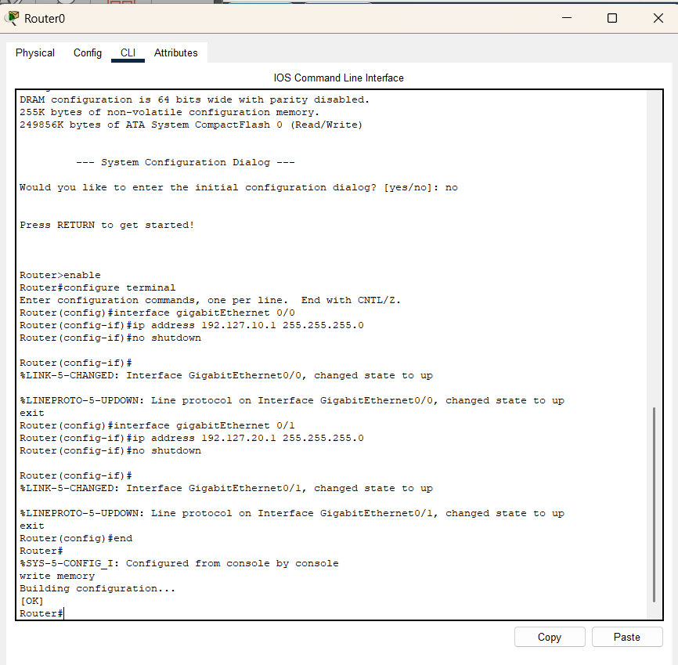
Step 4: Test Connectivity
- From PC2 (Star) → PC3 (Tree) using ping 192.127.20.2
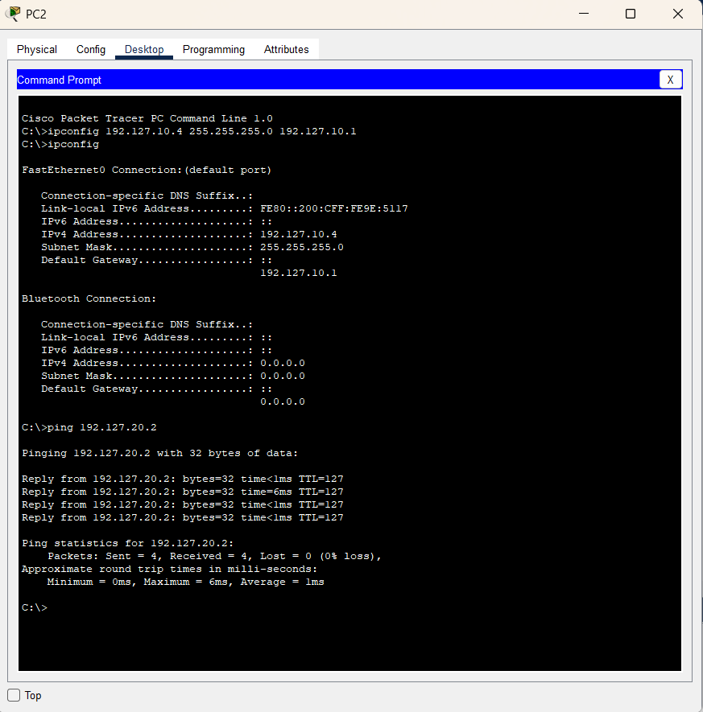
- From PC5 (Tree) → PC1 (Star) using ping 192.127.10.3.
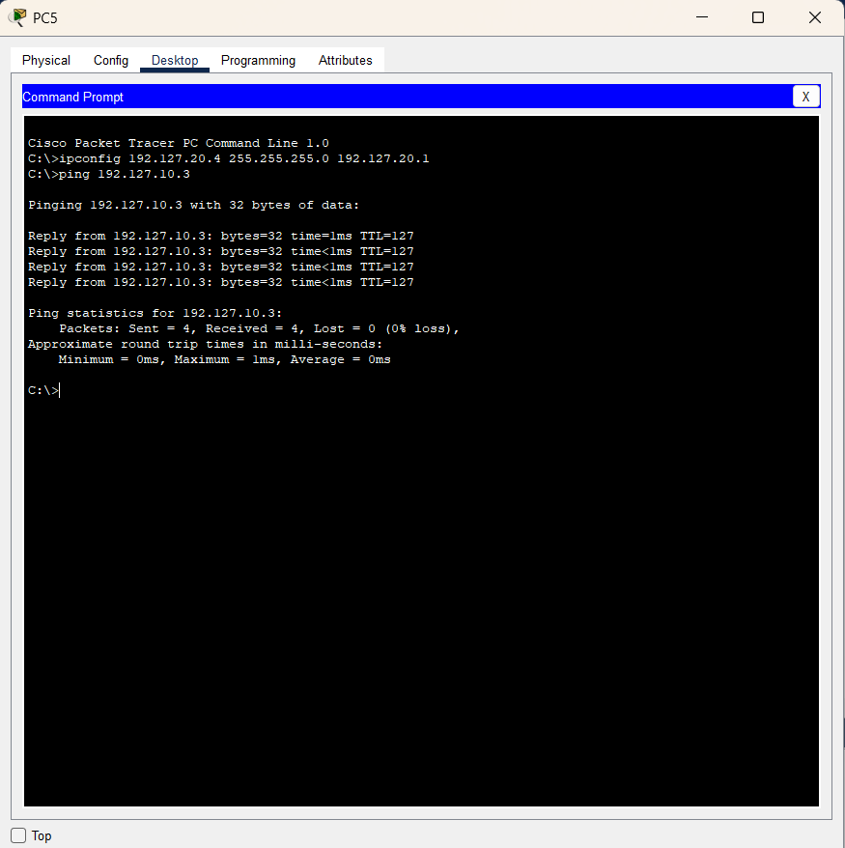

Observations
- Subnets communicate internally.
- Router links Star and Tree.
- Pings succeed with proper configs.
Result
Devices in both topologies communicated via router after IP setup.
Conclusion
This lab shows how routers connect different topologies. Correct IP addressing, subnetting, and gateway setup are essential for inter-network communication. It highlights the router’s role as a bridge between networks.

