Lab Title: Star, Ring, and Bus Topology Connection
Objective
To simulate a Cisco Packet Tracer network linking Star, Ring, and Bus topologies via a router with subnetting, manual IP configuration, and ping verification.
Apparatus/Software Required
- Cisco Packet Tracer
- 9 PCs (3 in Star, 3 in Ring, 3 in Bus)
- 7 Switches (1 for Star, 3 for Ring, 3 for Bus)
- 1 Router (with 3 FastEthernet/GigabitEthernet interfaces)
- Copper Straight-Through Cables

Network Topology Diagram
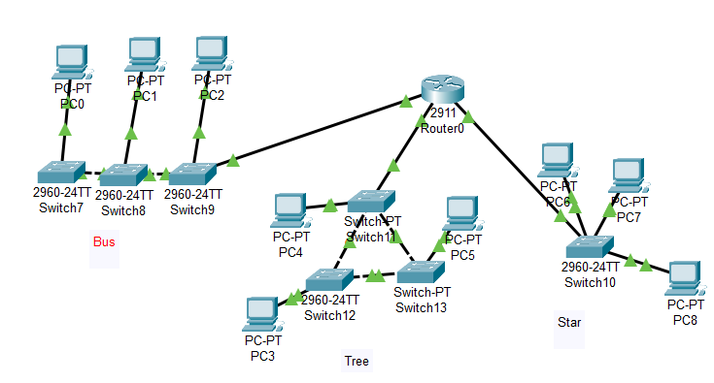
Fig: Interconnection of Star, Ring, and Bus Topologies

IP Addressing Scheme
Device | Interface/PC | IP Address | Subnet Mask | Default Gateway
PC0 (Bus) | Fa0 | 192.127.10.2 | 255.255.255.0 | 192.127.10.1
PC1 (Bus) | Fa0 | 192.127.10.3 | 255.255.255.0 | 192.127.10.1
PC2 (Bus) | Fa0 | 192.127.10.4 | 255.255.255.0 | 192.127.10.1
PC3 (Ring) | Fa0 | 192.127.20.2 | 255.255.255.0 | 192.127.20.1
PC4 (Ring) | Fa0 | 192.127.20.3 | 255.255.255.0 | 192.127.20.1
PC5 (Ring) | Fa0 | 192.127.20.4 | 255.255.255.0 | 192.127.20.1
PC6 (Star) | Fa0 | 192.127.30.2 | 255.255.255.0 | 192.127.30.1
PC7 (Star) | Fa0 | 192.127.30.3 | 255.255.255.0 | 192.127.30.1
PC8 (Star) | Fa0 | 192.127.30.4 | 255.255.255.0 | 192.127.30.1
Router Fa0/0 | Bus side | 192.127.10.1 | 255.255.255.0 | —
Router Fa1/0 | Ring side | 192.127.20.1 | 255.255.255.0 | —
Router Fa2/0 | Star side | 192.127.30.1 | 255.255.255.0 | —

Procedure
Step 1: Device Placement & Cabling
- Place 9 PCs, 7 switches, and 1 router.
- Bus Side: Connect PC0–PC2 via Switch0 → Switch1 → Switch2 → Router Fa0/0.
- Ring Side: Connect PC3, PC4, PC5 each to Switch3, Switch4, Switch5, then interconnect the switches in a closed loop → Router Fa0/1.
- Star Side: Connect PC6, PC7, PC8 to Switch6 → Router Fa0/2.
- Use straight-through cables for all connections.

Step 2: Assign IP Addresses to PCs (CLI Mode)
With the help of above table assign IP’s for each PC as follow:
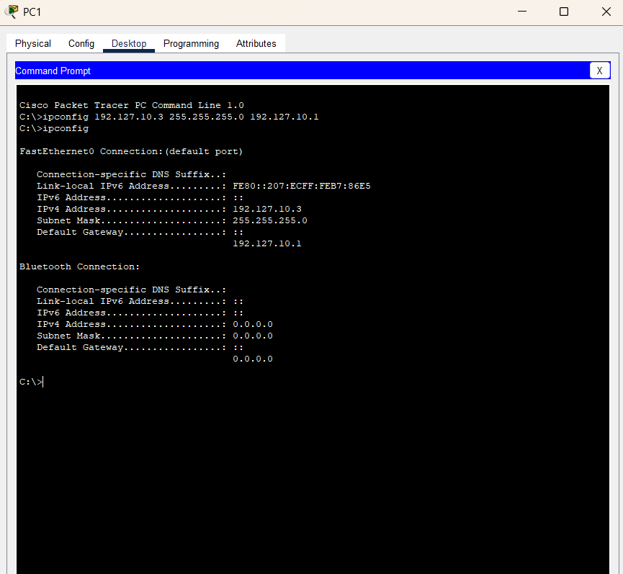

Step 3: Configure Router Interfaces
Configure the router with the help of above table:
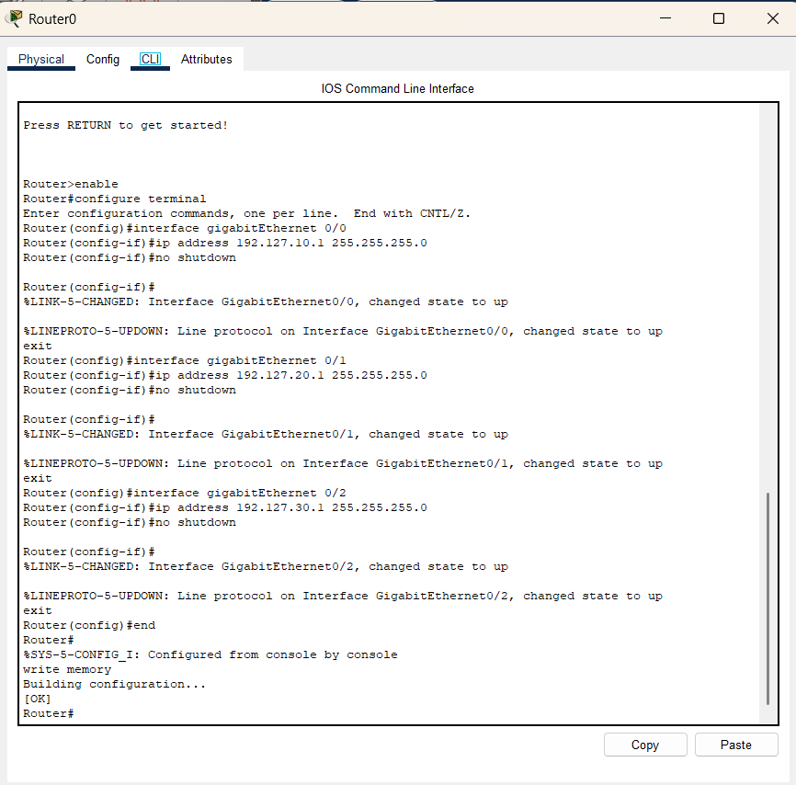

Step 4: Test Connectivity
- From PC1 (Bus) → PC4 (Ring):
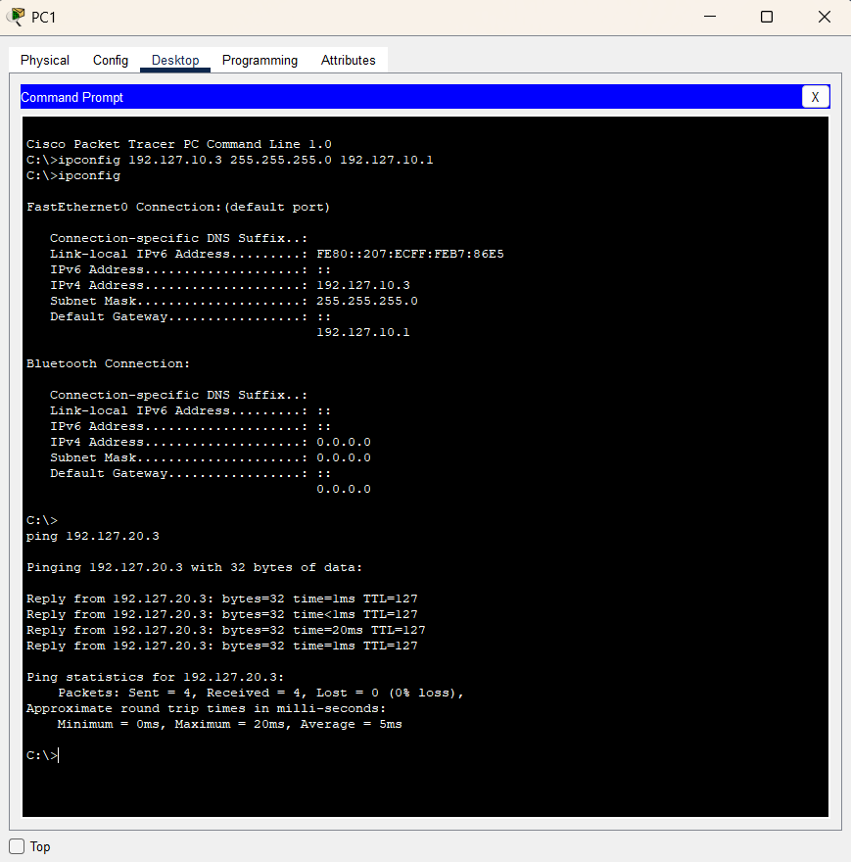
- From PC5 (Ring) → PC7 (Star):
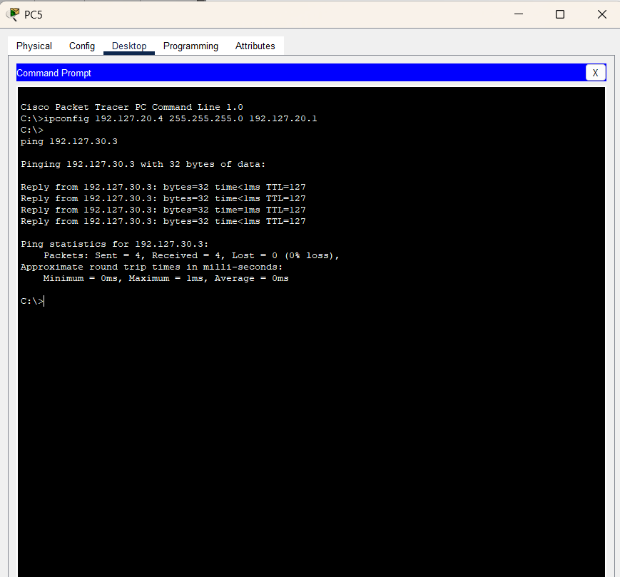
- From PC8 (Star) → PC1 (Bus):
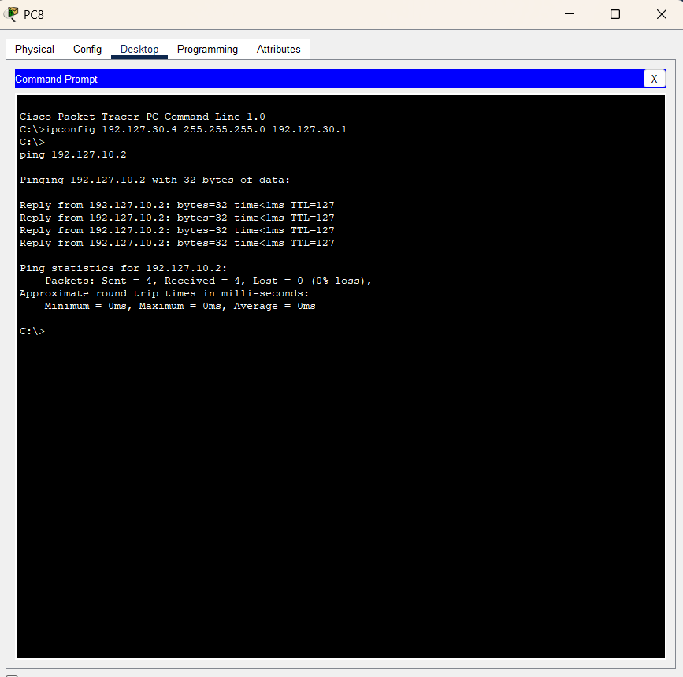
- Successful replies confirm proper interconnection.
Observations
- Each topology communicated within its own subnet.
- Router provided inter-network communication between Bus, Ring, and Star networks.
- Cross-topology pings succeeded after correct configuration.
Result
The Star, Ring, and Bus topologies were successfully interconnected through a router. Devices from different subnets communicated using ping.
Conclusion
This lab demonstrated how multiple topologies (Bus, Ring, and Star) can be integrated into a single network using a router. Proper subnetting and gateway configuration ensured seamless cross-network connectivity.

