Lab Title: Design and implement a network in Cisco Packet Tracer using at least 1 Router, 1 Switch, 1 Server, and 4 PCs. Configure DHCP server to automatically assign IP addresses to all PCs.

Objective
The main objective of this experiment is to design a simple LAN network in Cisco Packet Tracer consisting of a router, switch, server, and four PCs. The DHCP server is configured to automatically assign IP addresses to PCs, thereby reducing the need for manual configuration. The setup also ensures that all devices in the network can communicate effectively.

Apparatus/Software Required
- Cisco Packet Tracer
- 1 Router
- 1 Switch
- 1 Server (for DHCP configuration)
- 4 PCs
- Copper Straight-Through Cables
Network Topology Diagram
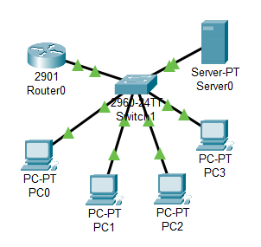
Fig: Network topology with DHCP-enabled server

IP Addressing Scheme
Device | IP Address | Subnet Mask | Default Gateway | Remarks
Router (Fa0/0) | 192.127.1.1 | 255.255.255.0 | — | Manually configured
Server (DHCP) | 192.127.1.2 | 255.255.255.0 | 192.127.1.1 | Manually configured
PC1 | 192.127.1.3 | 255.255.255.0 | 192.127.1.1 | Assigned by DHCP
PC2 | 192.127.1.4 | 255.255.255.0 | 192.127.1.1 | Assigned by DHCP
PC3 | 192.127.1.5 | 255.255.255.0 | 192.127.1.1 | Assigned by DHCP
PC4 | 192.127.1.6 | 255.255.255.0 | 192.127.1.1 | Assigned by DHCP

Procedure
Step 1: Network Topology
Devices required:
- 1 Router
- 1 Switch
- 1 Server (for DHCP)
- 4 PCs
Connections:
- Router ↔ Switch ↔ PCs + Server (use Copper Straight-Through cables).

Step 2: Configure Router Interface (GUI)
- Click Router → Config tab.
- Select the interface connected to the switch
- Assign the following:
  - IP Address: 192.127.1.1
  - Subnet Mask: 255.255.255.0
- Set Port Status = ON.
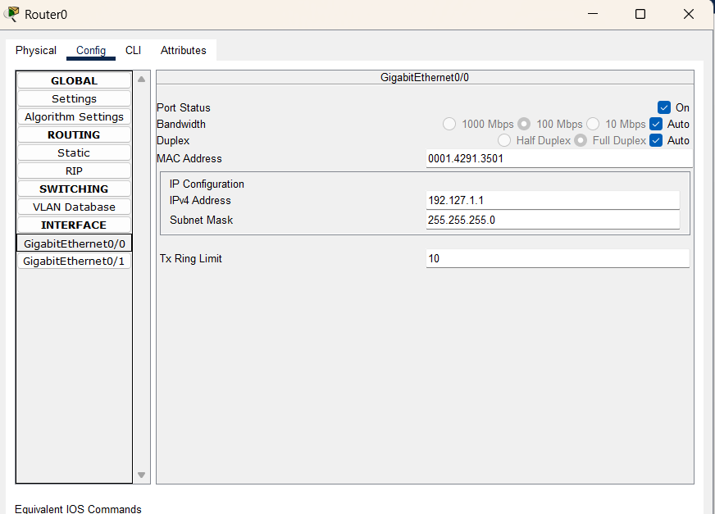

Step 3: Configure the Server as DHCP (GUI)
- Click the Server → Desktop tab → IP Configuration.
  - Assign a static IP (outside DHCP range):
    - IP Address: 192.127.1.2
    - Subnet Mask: 255.255.255.0
    - Default Gateway: 192.127.1.1
- Go to Server → Services tab → DHCP.
  - Turn DHCP = ON.
  - Fill in details:
    - Pool Name: LAN-POOL
    - Default Gateway: 192.127.1.1
    - DNS Server: 8.8.8.8 (Google’s Public DNS)
    - Start IP Address: 192.127.1.3
    - Subnet Mask: 255.255.255.0
    - Maximum Users: 50
  - Click Save/Add.
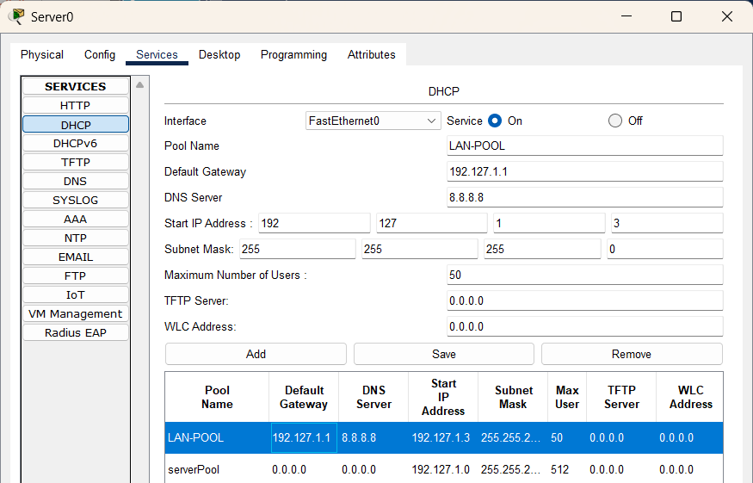
Step 4: Configure PCs to Use DHCP (GUI)
- Click each PC → Desktop → IP Configuration.
- Select DHCP.
- Each PC will automatically receive an IP address, for example:
  - PC1 → 192.127.1.3
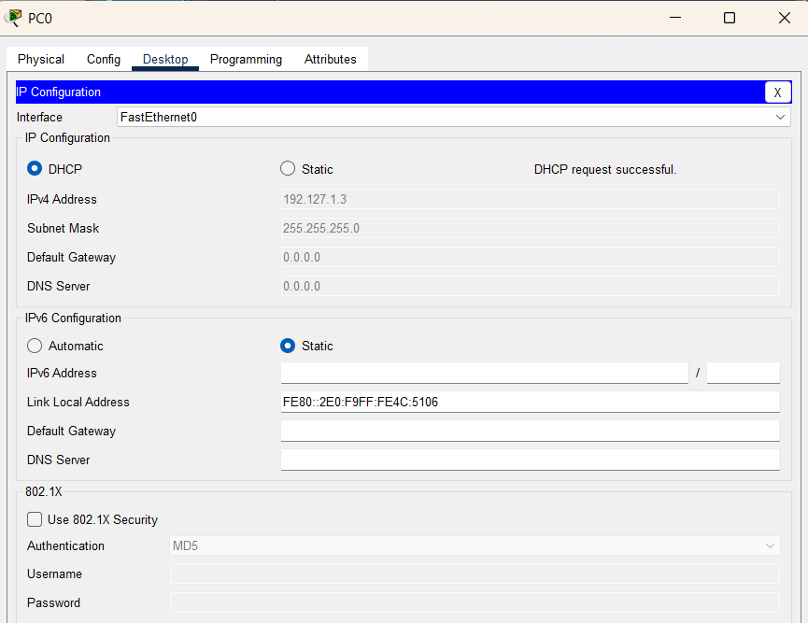
Step 5: Verification
- On each PC, open Command Prompt and type:
  - ipconfig → to verify automatically assigned IPs.
  - ping 192.127.1.1 → test connectivity with the router.
  - ping 192.127.1.2 → test connectivity with the server.
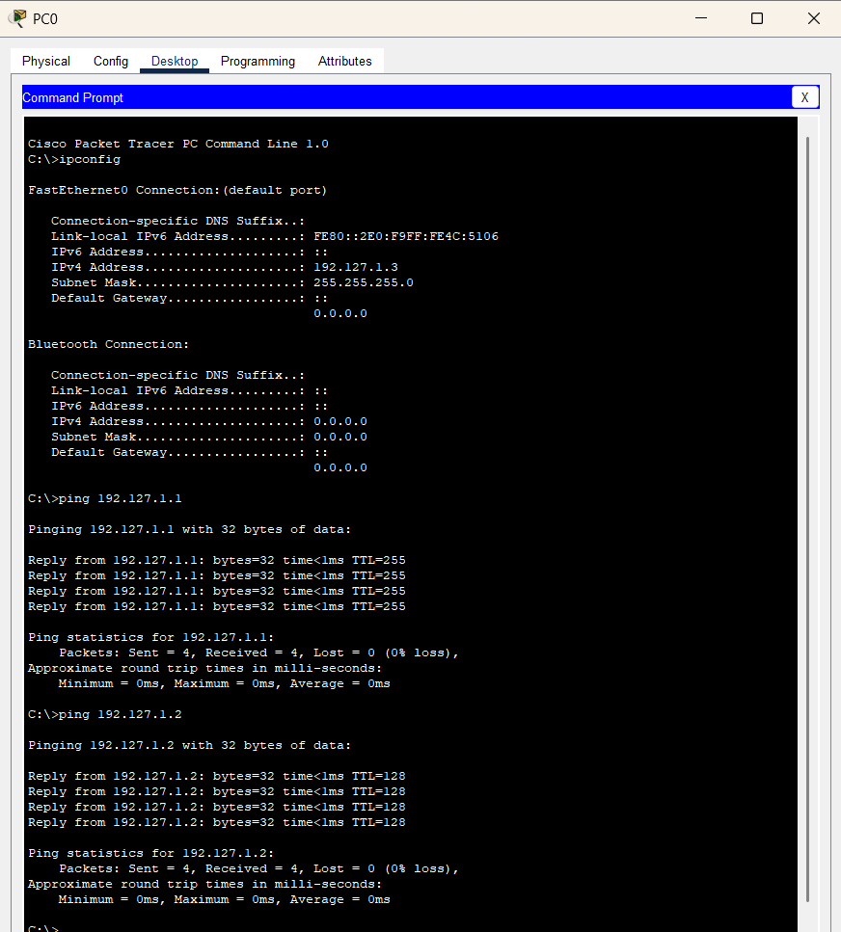
Replies are received means DHCP server setup is successful.

Observations
- PCs got no IP until DHCP was enabled.
- After enabling DHCP, all PCs received IPs automatically.
- Ping tests between router, server, and PCs were successful.
Result
The network worked as expected. The DHCP server automatically assigned IPs, and all devices communicated smoothly.

Conclusion
The lab showed how DHCP makes IP assignment simple and automatic. It saves time, avoids manual errors, and keeps the network connected reliably.

