Create database
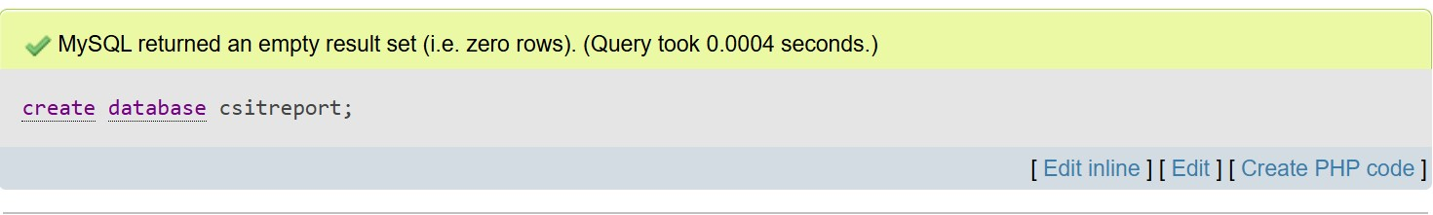
Consider the following relation
- Employee (eid, ename, post, department, salary, address)
- Project(pid, pname, type, ptime, pdate, budget)
- Works(ename, pname)
Create table employee
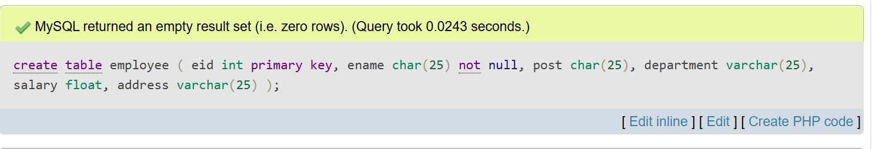
Create table project
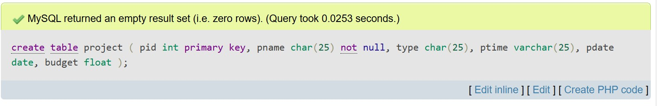
Create table works
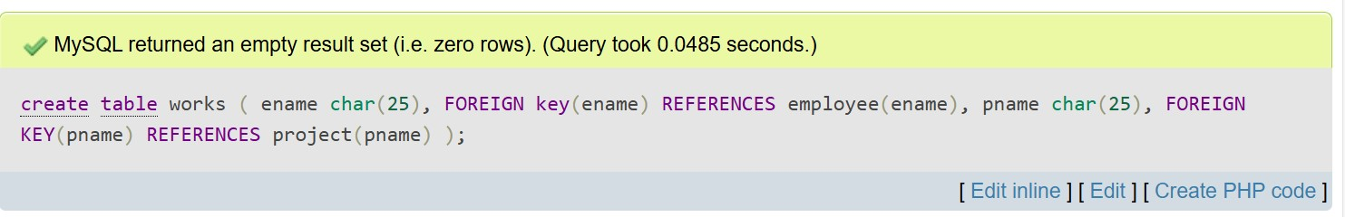
Describe employee
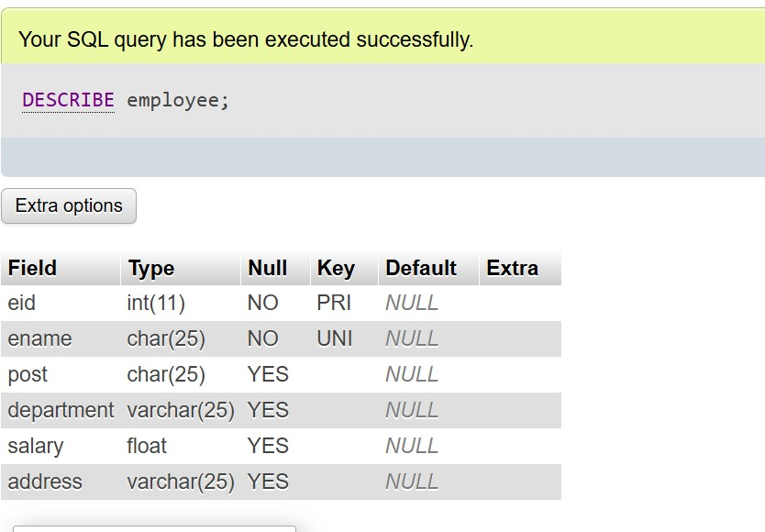
Insert employee
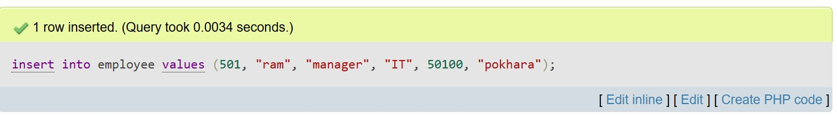
Describe project
Insert project
Describe works
Insert works
Display employee
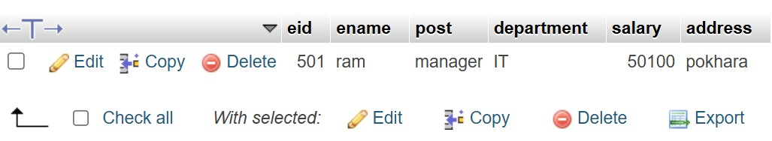
Display project
Display works
- Display employee name and total salary.
- 
 

