Title: Divide and conquer technique

Objective:
- To implement Quick sort with partition and analyze it’s complexity
- To implement Head sort and analyze it’s complexity
- To implement Merge sort and analyze it’s complexity
- To implement Randomized Quick sort and analyze it’s complexity

Theory
1. Merge Sort Algorithm
❖ Algorithm
- Start
- Read the array A, lower index low, and higher index high
- If low < high, then
- Compute
mid = (low + high) / 2
- Call MergeSort(A, low, mid) to sort the left subarray
- Call MergeSort(A, mid + 1, high) to sort the right subarray
- Merge the two sorted subarrays using Merge(A, low, mid, high)
- End
❖ Merge Procedure
- Initialize i = low, j = mid + 1, and k = low
- Create a temporary array temp[]
- While i ≤ mid and j ≤ high, do
a. If A[i] ≤ A[j], then
set temp[k] = A[i] and increment i
b. Else
set temp[k] = A[j] and increment j
c. Increment k
- Copy remaining elements of left subarray, if any
- Copy remaining elements of right subarray, if any
- Copy all elements from temp[] back to array A
❖ Time Complexity
- Best Case: O(n log n)
- Average Case: O(n log n)
- Worst Case: O(n log n)
❖ Space Complexity
- O(n) (temporary array + recursion stack)
❖ Trace:
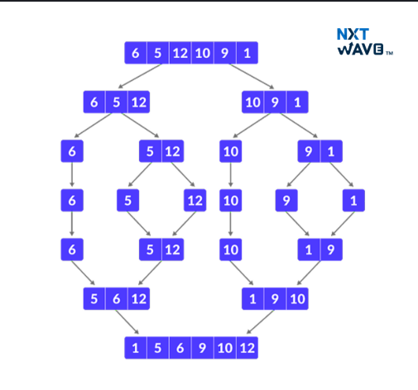

2. Heap Sort Algorithm
❖ Algorithm
- Start
- Read the array A and number of elements n
- Build a max heap from the given array
- For i = n down to 2, do
- Swap A[1] and A[i]
- Reduce heap size by one
- Apply Heapify(A, 1) to maintain heap property
- Repeat until the heap size becomes 1
- End
❖ Heapify Procedure
- Set largest = i
- Compute left = 2*i and right = 2*i + 1
- If left ≤ n and A[left] > A[largest], then
set largest = left
- If right ≤ n and A[right] > A[largest], then
set largest = right
- If largest ≠ i, then
swap A[i] and A[largest]
- Call Heapify(A, largest)
❖ Time Complexity
- Best Case: O(n log n)
- Average Case: O(n log n)
- Worst Case: O(n log n)
❖ Space Complexity
- O(1) (in-place)
- O(log n) (recursion stack)
❖ Trace:
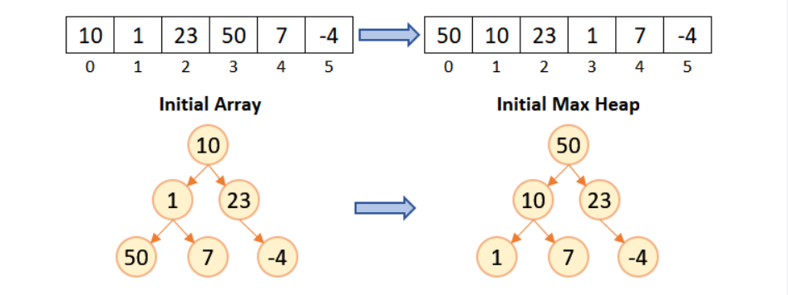
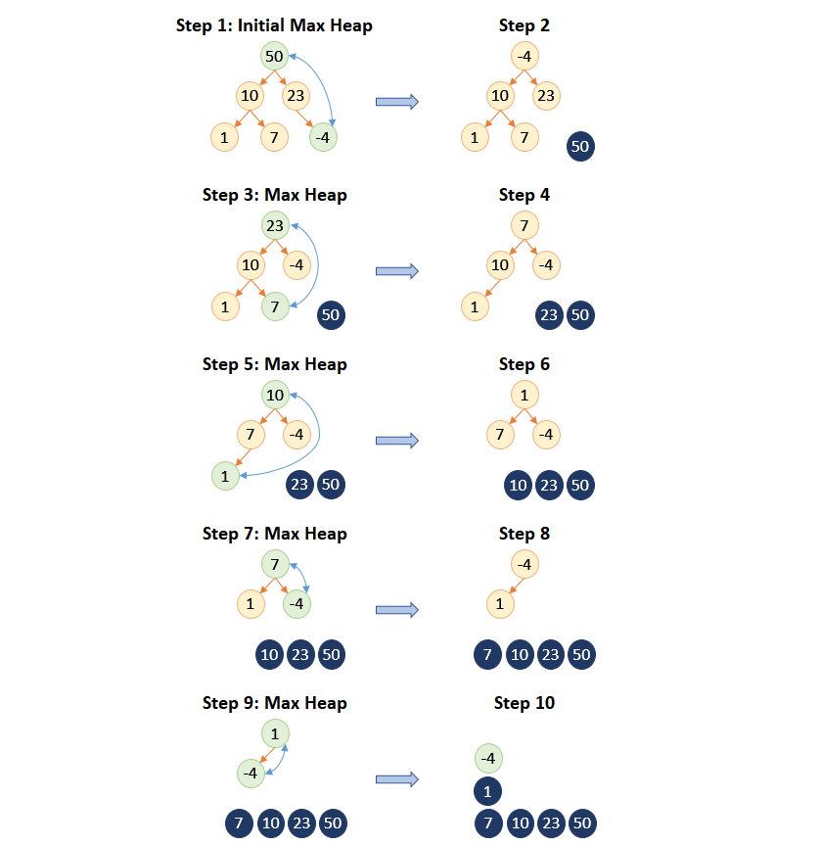

3. Quick Sort Algorithm
❖ Algorithm
- Start
- Read the array A, lower index low, and higher index high
- If low < high, then
- Partition the array and find pivot position p
- Call QuickSort(A, low, p − 1)
- Call QuickSort(A, p + 1, high)
- End
❖ Partition Procedure
- Select the last element A[high] as pivot
- Set i = low − 1
- For j = low to high − 1, do
a. If A[j] ≤ pivot, then
increment i and swap A[i] and A[j]
- Swap A[i + 1] and A[high]
- Return i + 1 as pivot position
❖ Time Complexity
- Best Case: O(n log n)
- Average Case: O(n log n)
- Worst Case: O(n²)
❖ Space Complexity
- Best/Average Case: O(log n)
- Worst Case: O(n)
❖ Trace:
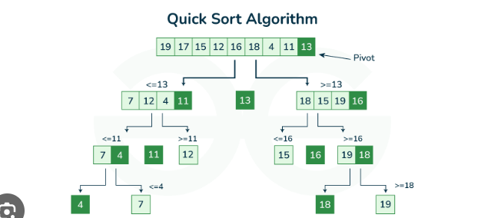

4. Randomized Quick Sort Algorithm
❖ Algorithm
- Start
- Read the array A, lower index low, and higher index high
- If low < high, then
- Choose a random pivot element
- Partition the array using the random pivot
- Call RandomizedQuickSort(A, low, p − 1)
- Call RandomizedQuickSort(A, p + 1, high)
- End
❖ Randomized Partition Procedure
- Generate a random index r such that low ≤ r ≤ high
- Swap A[r] and A[high]
- Apply the normal partition procedure
- Return the pivot position
❖ Time Complexity
- Best Case: O(n log n)
- Average Case: O(n log n)
- Worst Case: O(n²) (rare)
❖ Space Complexity
- Expected: O(log n)
- Worst Case: O(n)
❖ Trace:
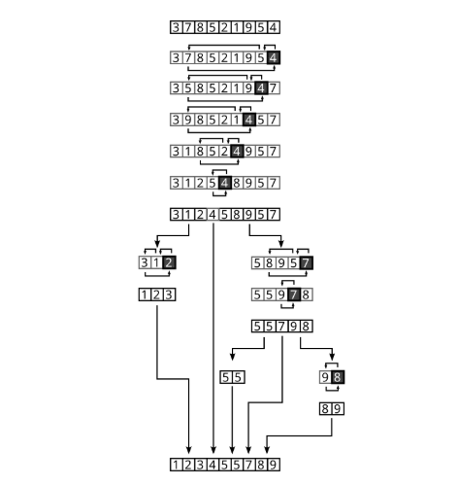

Code
#include <stdio.h>
#include <stdlib.h>
#include <time.h>

/* ---------- Utility Functions ---------- */
void printArray(int arr[], int n) {
int i;
for (i = 0; i < n; i++)
printf("%d ", arr[i]);
printf("\n");
}

void copyArray(int src[], int dest[], int n) {
int i;
for (i = 0; i < n; i++)
dest[i] = src[i];
}

/* ---------- MERGE SORT ---------- */
void merge(int arr[], int l, int m, int r) {
int i, j, k;
int n1 = m - l + 1;
int n2 = r - m;

int L[n1], R[n2];

for (i = 0; i < n1; i++)
L[i] = arr[l + i];
for (j = 0; j < n2; j++)
R[j] = arr[m + 1 + j];

i = 0;
j = 0;
k = l;

while (i < n1 && j < n2) {
if (L[i] <= R[j])
arr[k++] = L[i++];
else
arr[k++] = R[j++];
}

while (i < n1)
arr[k++] = L[i++];

while (j < n2)
arr[k++] = R[j++];
}

void mergeSort(int arr[], int l, int r) {
if (l < r) {
int m = (l + r) / 2;
mergeSort(arr, l, m);
mergeSort(arr, m + 1, r);
merge(arr, l, m, r);
}
}

/* ---------- HEAP SORT ---------- */
void heapify(int arr[], int n, int i) {
int largest = i;
int left = 2 * i + 1;
int right = 2 * i + 2;
int temp;

if (left < n && arr[left] > arr[largest])
largest = left;

if (right < n && arr[right] > arr[largest])
largest = right;

if (largest != i) {
temp = arr[i];
arr[i] = arr[largest];
arr[largest] = temp;
heapify(arr, n, largest);
}
}

void heapSort(int arr[], int n) {
int i, temp;

for (i = n / 2 - 1; i >= 0; i--)
heapify(arr, n, i);

for (i = n - 1; i > 0; i--) {
temp = arr[0];
arr[0] = arr[i];
arr[i] = temp;
heapify(arr, i, 0);
}
}

/* ---------- QUICK SORT ---------- */
int partition(int arr[], int low, int high) {
int pivot = arr[high];
int i = low - 1, j, temp;

for (j = low; j < high; j++) {
if (arr[j] < pivot) {
i++;
temp = arr[i];
arr[i] = arr[j];
arr[j] = temp;
}
}

temp = arr[i + 1];
arr[i + 1] = arr[high];
arr[high] = temp;

return i + 1;
}

void quickSort(int arr[], int low, int high) {
if (low < high) {
int pi = partition(arr, low, high);
quickSort(arr, low, pi - 1);
quickSort(arr, pi + 1, high);
}
}

/* ---------- RANDOMIZED QUICK SORT ---------- */
int randomPartition(int arr[], int low, int high) {
int random = low + rand() % (high - low + 1);
int temp = arr[random];
arr[random] = arr[high];
arr[high] = temp;

return partition(arr, low, high);
}

void randomizedQuickSort(int arr[], int low, int high) {
if (low < high) {
int pi = randomPartition(arr, low, high);
randomizedQuickSort(arr, low, pi - 1);
randomizedQuickSort(arr, pi + 1, high);
}
}

/* ---------- MAIN FUNCTION ---------- */
int main() {
int original[] = {64, 25, 12, 22, 11};
int n = sizeof(original) / sizeof(original[0]);
int arr[n];
int choice = 1;

srand(time(NULL));

while (choice != 0) {
printf("\n------ SORTING MENU ------\n");
printf("1. Merge Sort\n");
printf("2. Heap Sort\n");
printf("3. Quick Sort\n");
printf("4. Randomized Quick Sort\n");
printf("0. Exit\n");
printf("Enter your choice: ");
scanf("%d", &choice);

if (choice == 0)
break;

copyArray(original, arr, n);

printf("Original Array: ");
printArray(arr, n);

switch (choice) {
case 1:
mergeSort(arr, 0, n - 1);
printf("After Merge Sort: ");
break;
case 2:
heapSort(arr, n);
printf("After Heap Sort: ");
break;
case 3:
quickSort(arr, 0, n - 1);
printf("After Quick Sort: ");
break;
case 4:
randomizedQuickSort(arr, 0, n - 1);
printf("After Randomized Quick Sort: ");
break;
default:
printf("Invalid Choice!\n");
continue;
}
printArray(arr, n);
}
printf("\nProgram Terminated.\n");
return 0;
}

Output:
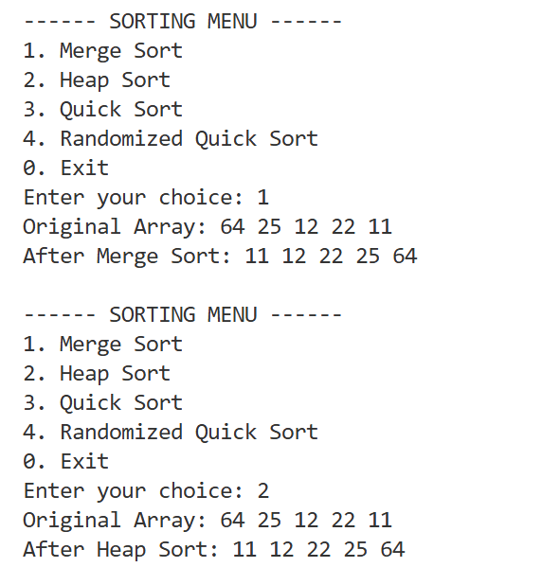
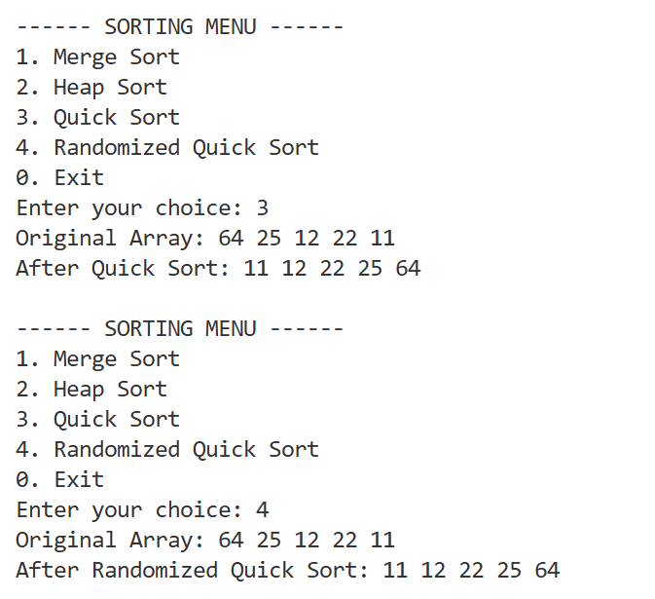
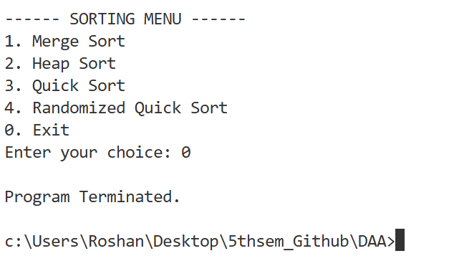

Conclusion
In this lab, Merge Sort, Heap Sort, Quick Sort, and Randomized Quick Sort were implemented successfully. All algorithms correctly sorted the given data and helped in understanding different sorting techniques and their efficiency.

