

Lab No: 1 Date: 2082/
Title: Write a Program to simulate Birthday Paradox in excel
The Birthday Paradox is a probability concept which states that in a group of just 23 people, there is more than a 50% chance that at least two people share the same birthday, assuming there are 365 possible birthdays and that each birthday is equally likely (uniform distribution). Although this seems counter-intuitive, the probability of a shared birthday increases rapidly as the number of people increases. This is because the comparison is made among pairs of people, not individual birthdays. With each additional person, the number of possible pairs increases, raising the likelihood of a match. The probability that no two people share the same birthday in a group of n people is given by:
$$P(\text{no match})=\frac{365}{365}×\frac{364}{365}×\frac{363}{365}×⋯×\frac{365-n+1}{365}$$
The probability that at least one pair shares a birthday is:
$$P(\text{at least one match})=1-P(\text{no match})$$Calculating this probability manually becomes increasingly complex for larger groups, so simulation using Excel is an effective method to estimate the probability. By generating random birthdays for multiple trials and counting occurrences of shared birthdays, we can observe and verify the Birthday Paradox practically.

Output:
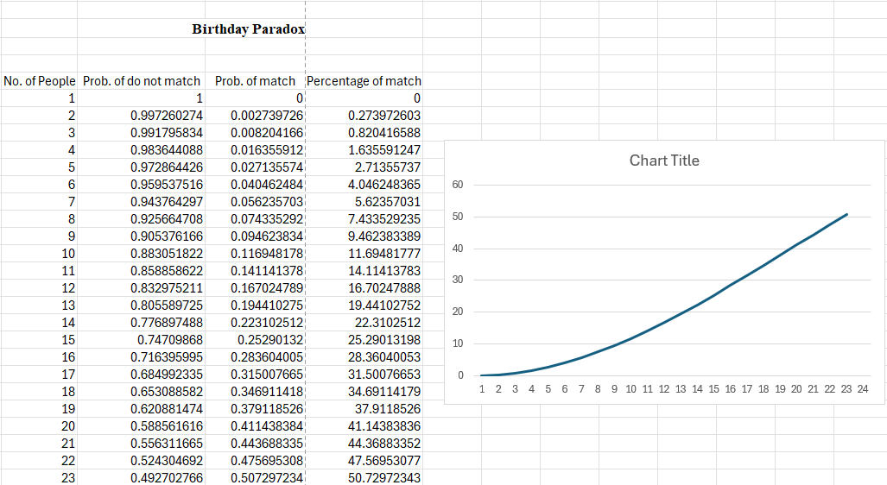

Conclusion:–
The Birthday Paradox was simulated successfully in Excel. The experiment shows that the probability of at least two people sharing the same birthday increases rapidly with group size. Even just with 23 people, the chance of a shared birthday is around 50%, confirming the paradox. Simulation provides an easy way to verify probability concepts practically.

