

Lab No. 11 Date: 2082/
Title: Write a program to find the multiplicative inverse using Extended Euclidean Algorithm

The multiplicative inverse of an integer a modulo m is an integer x such that: $(a⋅x) mod m=1$. In other words, when a is multiplied by x and divided by m, the remainder is 1. A multiplicative inverse exists only when a and m are coprime, that is, when $gcd⁡(a,m)=1$. To find this inverse efficiently, we use the Extended Euclidean algorithm. This algorithm not only computes the greatest common divisor (gcd) of two integers but also finds integers x and y that satisfy the equation:
$a⋅x+m⋅y=gcd⁡(a,m)$.
If the gcd is equal to 1, then the value of x obtained from this equation is the multiplicative inverse of a modulo m. If the gcd is not equal to 1, then the multiplicative inverse does not exist.

Algorithm:
- Use the Extended Euclidean Algorithm to compute $gcd⁡(a,m)$and find integers $x$and $y$such that:
$$a⋅x+m⋅y=gcd⁡(a,m)$$
- If $gcd⁡(a,m)≠1$, then the multiplicative inverse does not exist.
- If $gcd⁡(a,m)=1$, then $x$is the multiplicative inverse of $a$modulo $m$.
- If $x$is negative, make it positive using:
$$\text{inverse}=(x mod m+m) mod m$$
- Return inverse.

Language: C
IDE: VS Code
Source Code:
#include <stdio.h>

// Function to implement Extended Euclidean Algorithm
int extendedEuclid(int a, int b, int *x, int *y) {
if (b == 0) {
*x = 1;
*y = 0;
return a;
}
int x1, y1;
int gcd = extendedEuclid(b, a % b, &x1, &y1);
*x = y1;
*y = x1 - (a / b) * y1;
return gcd;
}
int main() {
int a, m;
int x, y;
printf("Enter number (a): ");
scanf("%d", &a);
printf("Enter modulus (m): ");
scanf("%d", &m);
int gcd = extendedEuclid(a, m, &x, &y);
if (gcd != 1) {
printf("Multiplicative inverse does not exist.\n");
} else {
int inverse = (x % m + m) % m; // Make positive
printf("Multiplicative inverse of %d mod %d is %d\n", a, m, inverse);
}
return 0;
}

Output:
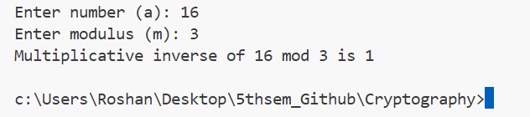

Conclusion:
In this lab, we implemented the Extended Euclidean algorithm to find the multiplicative inverse of a number under modulo arithmetic. We observed that the inverse exists only when the given number and modulus are coprime (gcd = 1). Thus, the experiment successfully demonstrated an efficient method to compute the multiplicative inverse.

