Title: Iterative Algorithms Implementation

Objective:
- To implement GCD using Iteration
- To implement Fibonacci series using Iteration
- To implement Factorial using Iteration
- To implement Linear Search using Iteration

Theory
1. GCD (Greatest Common Divisor)
- Algorithm (Euclidean Algorithm)
The Euclidean algorithm is used to find the greatest common divisor of two positive integers.
Steps:
- Start.
- Read two integers a and b.
- While b is not equal to 0, repeat:
  - Set r = a mod b.
  - Set a = b.
  - Set b = r.
- When b becomes 0, the value of a is the GCD.
- Stop.
- Time Complexity
- Best Case: O(1)
- Average Case: O(log n)
- Worst Case: O(log n)
where n is the smaller of the two numbers.
- Space Complexity
- O(1) (Constant space), as only a few variables are used.

2. Fibonacci Series
- Algorithm
The Fibonacci series is a sequence in which each number is the sum of the two preceding numbers.
Steps:
- Start.
- Read the number of terms n.
- Initialize a = 0, c=0 and b = 1.
- Print a and b.
- For i = 1 to n, repeat:
  - Print c.
  - Set a = b and b = c.
  - Set c= a + b

- Stop.
- Time Complexity
- O(n), where n is the number of terms.
- Space Complexity
- O(1) (Constant space), as only a fixed number of variables are used.

3. Factorial
- Algorithm
Factorial of a number n is the product of all positive integers less than or equal to n.
Steps:
- Start.
- Read a number n.
- Initialize fact = 1.
- For i = 1 to n, repeat:
  - Set fact = fact × i.
- Print fact.
- Stop.
- Time Complexity
- O(n), where n is the given number.
- Space Complexity
- O(1) (Constant space), as only one variable is used to store the result.

4. Linear Search
- Algorithm
Linear search is used to find an element in a list by checking each element one by one.
Steps:
- Start.
- Read the number of elements n.
- Read the array elements.
- Read the element to be searched key.
- For i = 0 to n − 1, repeat:
  - If array[i] == key, then:
    - Print "Element found".
    - Stop.
- If the element is not found after the loop, print "Element not found".
- Stop.
- Time Complexity
- Best Case: O(1) (element found at first position)
- Average Case: O(n)
- Worst Case: O(n) (element found at last position or not found)
- Space Complexity
- O(1) (Constant space), as no extra memory is required.

Code:
#include <stdio.h>
#include <stdlib.h>
#define size 5

int arr[size], i, j, opr, result, a, b, n, c;

/* Function to find GCD using iteration */
int GCD(int a, int b)
{
int r;
while (1)
{
if (a == 0)
return b;
else if (b == 0)
return a;

r = a % b;
a = b;
b = r;
}
}

/* Function to calculate factorial using iteration */
int fact(int n)
{
int ft = 1;

if (n == 0 || n == 1)
return 1;

for (i = 1; i <= n; i++)
{
ft = ft * i;
}
return ft;
}

/* Function for linear search */
int linearSearch(int arr[size], int searchVal)
{
for (i = 0; i < size; i++)
{
if (arr[i] == searchVal)
return i;
}
return -1;
}

/* Function to print Fibonacci series */
void fibonacci(int n)
{
a = 0;
b = 1;
c = 0;

for (i = 0; i < n; i++)
{
printf("%d ", c);
a = b;
b = c;
c = a + b;
}
}

/* Main Function */
int main()
{
do
{
printf("\n\nEnter 1 for GCD\n");
printf("Enter 2 for Factorial\n");
printf("Enter 3 for Linear Search\n");
printf("Enter 4 for Fibonacci Series\n");
printf("Enter 5 for Exit\n");
printf("Enter a number (1-5): ");
scanf("%d", &opr);
switch (opr)
{

case 1:
printf("Enter value of a and b:\n");
scanf("%d %d", &a, &b);
printf("The value of GCD(%d, %d) is: %d", a, b, GCD(a, b));
break;

case 2:
printf("Enter a number for factorial: ");
scanf("%d", &n);
printf("The factorial value of %d! is %d", n, fact(n));
break;

case 3:
printf("Enter an array of size 5:\n");
for (i = 0; i < size; i++)
{
scanf("%d", &arr[i]);
}

printf("Enter a number to search: ");
scanf("%d", &a);

int pos = linearSearch(arr, a);
if (pos == -1)
printf("Element not found\n");
else
printf("Element found at index: %d\n", pos);

break;

case 4:
printf("Enter the number of terms to print: ");
scanf("%d", &a);
fibonacci(a);
break;

case 5:
printf("Exit successfully\n");
break;

default:
printf("Enter a valid choice.\n");
break;
}
} while (opr != 5);

return 0;
}

Output:
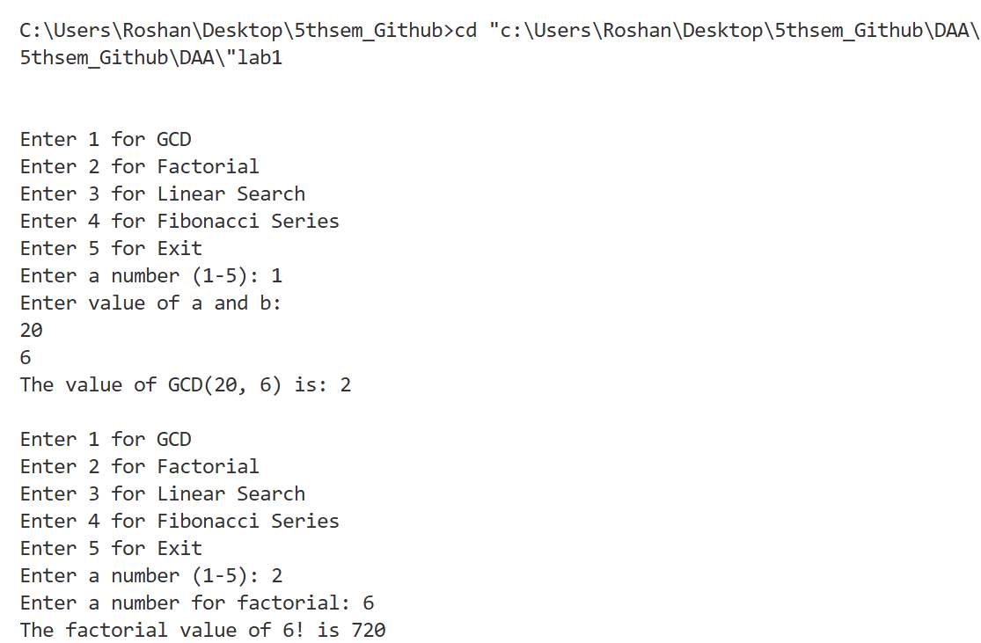
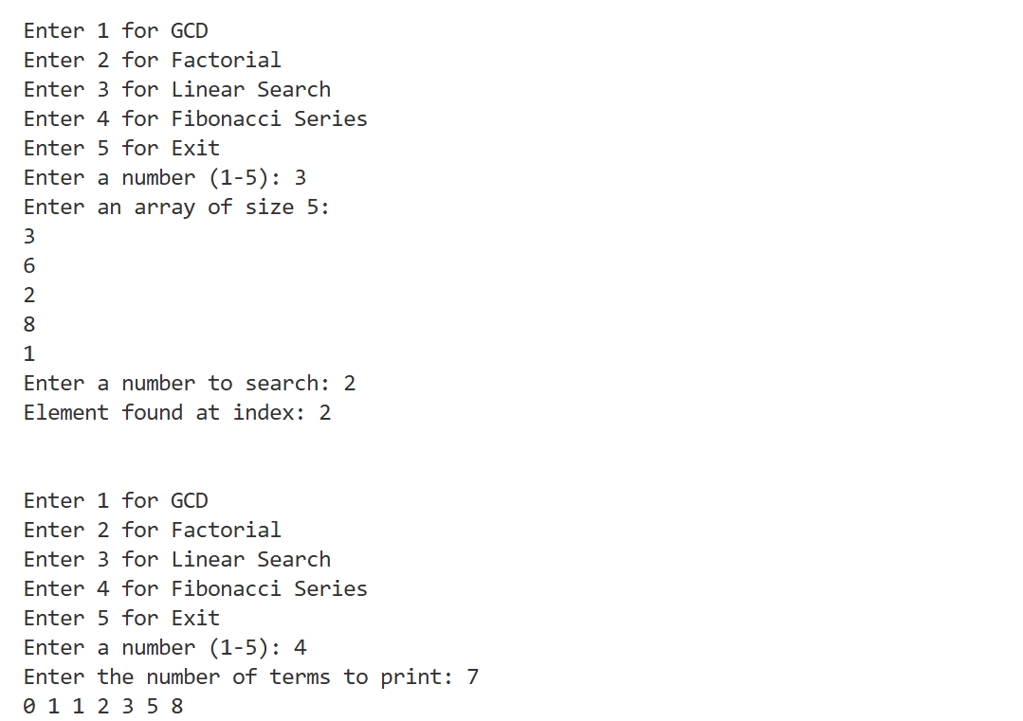
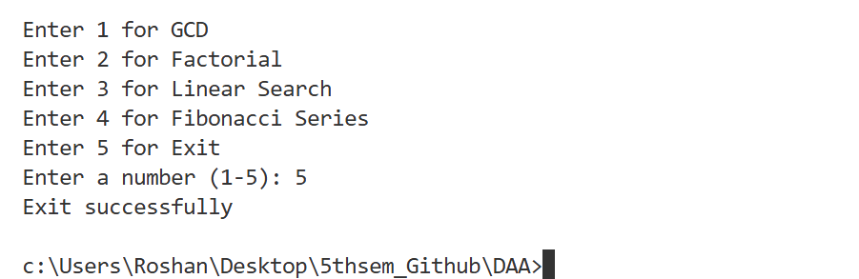

Conclusion:
In this lab, iterative algorithms for GCD, Fibonacci series, Factorial, and Linear Search were successfully implemented using the C programming language. This lab helped in understanding the use of iteration, control structures, and algorithm efficiency. The correct execution of the program confirms the effectiveness of the implemented algorithms.

