Title: Binary search and Min-Max Finding Algorithm using Recursion

Objective:
- To implement the Binary Search algorithm using recursion
- To find the minimum and maximum elements using a recursion approach

Theory
1. Recursive Binary Search Algorithm
- Algorithm
- Start
- Read the sorted array A, search element x, lower index low, and higher index high
- If low > high, then
return -1 and go to Step 8
- Compute
mid = (low + high) / 2
- If A[mid] = x, then
return mid and go to Step 8
- Else if A[mid] > x, then
call BinarySearch(A, low, mid − 1, x)
- Else
call BinarySearch(A, mid + 1, high, x)
- End
- Time Complexity
- Best Case: O(1)
- Average Case: O(log n)
- Worst Case: O(log n)
- Space Complexity
- O(log n) (recursion stack)
- Trace:
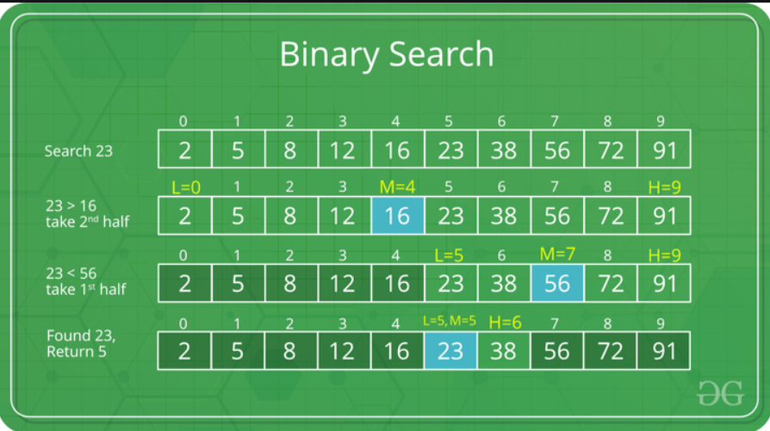
2. Minimum and Maximum Algorithm Using Recursion
- Algorithm
- Start
- Read the array A, lower index low, and higher index high
- If low = high, then
set min = A[low], max = A[low]
return (min, max) and go to Step 9
- If high = low + 1, then
a. If A[low] < A[high], then
set min = A[low], max = A[high]
b. Else
set min = A[high], max = A[low]
return (min, max) and go to Step 9
- Compute
mid = (low + high) / 2
- Recursively find (min1, max1) in subarray (low, mid)
- Recursively find (min2, max2) in subarray (mid + 1, high)
- Set
min = minimum(min1, min2)
max = maximum(max1, max2)
return (min, max)
- End

- Time Complexity
- Best Case: O(n)
- Average Case: O(n)
- Worst Case: O(n)
- Space Complexity
- O(log n) (recursion stack)
- Trace:
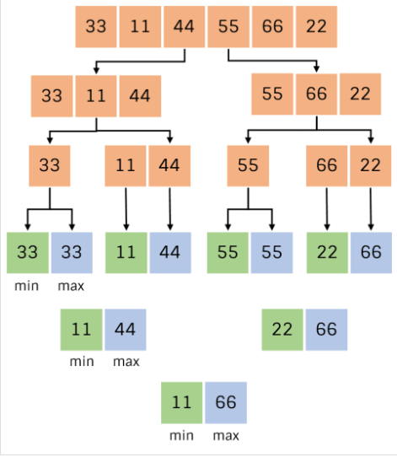

Code
#include <stdio.h>
int n, arr[100], min, max, mid, max1, min1;

void MinMax(int arr[], int l, int r)
{
int min1, max1, min2, max2, mid;

/* Case 1: Only one element */
if (l == r)
{
min = max = arr[l];
return;
}

/* Case 2: Two elements */
if (l == r - 1)
{
if (arr[l] < arr[r])
{
min = arr[l];
max = arr[r];
}
else
{
min = arr[r];
max = arr[l];
}
return;
}

/* Case 3: More than two elements */
mid = (l + r) / 2;

/* Left half */
MinMax(arr, l, mid);
min1 = min;
max1 = max;

/* Right half */
MinMax(arr, mid + 1, r);
min2 = min;
max2 = max;

/* Combine results */
min = (min1 < min2) ? min1 : min2;
max = (max1 > max2) ? max1 : max2;
}
void insertElement()
{
printf("Enter the size of array: ");
scanf("%d", &n);
printf("Enter %d elements: ", n);
for (int i = 0; i < n; i++)
{
scanf("%d", &arr[i]);
}
}

int BinarySearch(int arr[], int l, int r, int key)
{
if (l <= r)
{
int m = (l + r) / 2;
if (arr[m] == key)
{
return m;
}
else if (arr[m] > key)
{
return BinarySearch(arr, l, m - 1, key);
}
else if (arr[m] < key)
{
return BinarySearch(arr, m + 1, r, key);
}
}
return -1;
}

int main()
{
int opr, key;
do
{
printf("\nEnter 1 for Minimax finding algorithm");
printf("\nEnter 2 for Binary search");
printf("\nEnter 3 for exit");
printf("\nEnter the operation(1-3): ");
scanf("%d", &opr);
switch (opr)
{
case 1:
insertElement();
MinMax(arr, 0, n - 1);
printf("Minimum element = %d\n", min);
printf("Maximum element = %d\n", max);
break;
case 2:
printf("\nEnter Elements in ascending order\n");
insertElement();
printf("Enter key to search: ");
scanf("%d", &key);
printf("Key is found at index: %d\n", BinarySearch(arr, 0, n - 1, key));
break;
case 3:
printf("Exit successfully");
break;
default:
printf("Please Enter a valid operation\n");
break;
}
} while (opr != 3);
return 0;
}

Output:
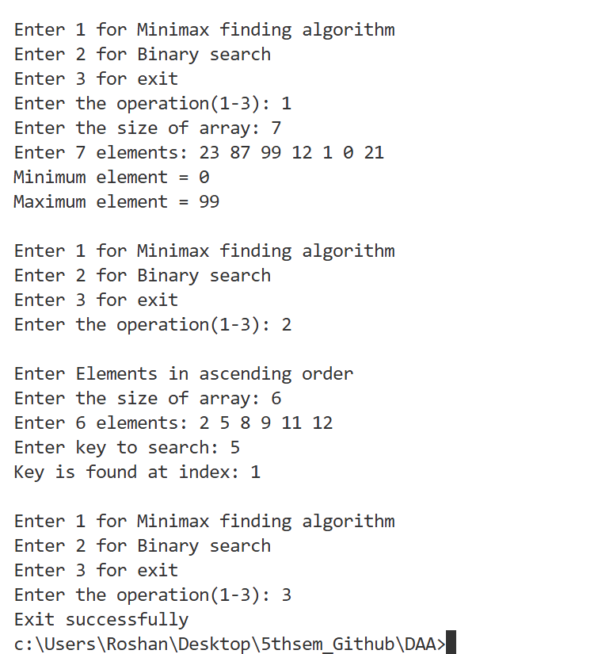

Conclusion
In this laboratory experiment, the Binary Search algorithm and the Minimum–Maximum finding algorithm were successfully implemented using recursion. The experiment helped in understanding the divide-and-conquer technique and the efficiency of recursive algorithms.

