return 0;
}

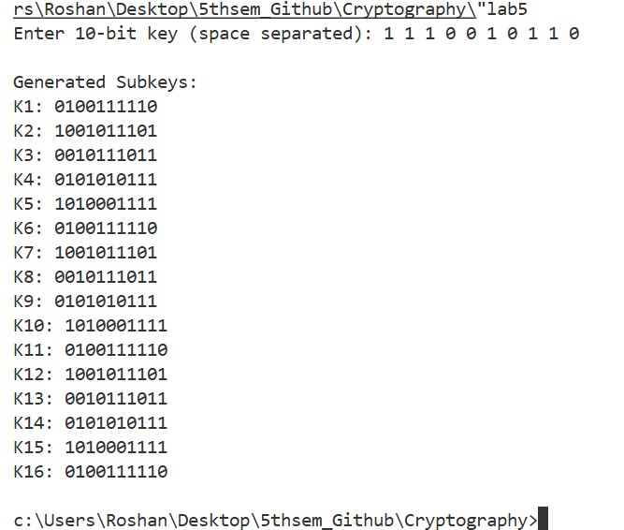
Output:

Conclusion:
Thus, the program successfully generates the two subkeys K1 and K2 from a given 10-bit key using the DES key scheduling algorithm. This experiment helps in understanding how permutations and shifts contribute to the security of symmetric encryption algorithms.

Source code:
#include <stdio.h>
#include <string.h>

int main() {
char msg[100];
char hex[200];
char state[4][4][3];
int i, j, k = 0;
printf("Enter message: ");
scanf("%s", msg);
int len = strlen(msg);
/* Convert message characters to hexadecimal */
for (i = 0; i < len; i++) {
sprintf(hex + (i * 2), "%02x", msg[i]);
}
printf("\nHex representation: %s\n", hex);
int hexLen = strlen(hex);
for (j = 0; j < 4; j++) {
for (i = 0; i < 4; i++) {
if (k + 1 < hexLen) {
state[i][j][0] = hex[k++];
state[i][j][1] = hex[k++];
} else {
state[i][j][0] = '0';
state[i][j][1] = '0';
}
state[i][j][2] = '\0';
}
}
/* Display state matrix */
printf("\nState Matrix:\n");
for (i = 0; i < 4; i++) {
printf("| ");
for (j = 0; j < 4; j++) {
printf("%s | ", state[i][j]);
}
printf("\n");
}

return 0;
}

Output:
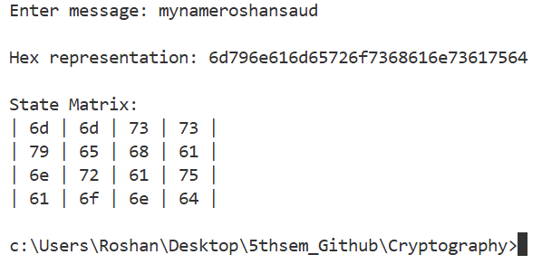
Conclusion:
Thus, the program successfully converts the input plaintext message into a 4 × 4 AES state array following the standard column-wise mapping. This experiment provides a clear understanding of the internal data representation used in AES and highlights the importance of standard-defined structures in cryptographic algorithms.

Source code:
#include <stdio.h>
/* Function to compute (base^exp) mod mod */
long long modPower(long long base, long long exp, long long mod)
{
long long result = 1;
base = base % mod;
printf("\nComputing %lld^%lld mod %lld\n", base, exp, mod);
while (exp > 0)
{
if (exp % 2 == 1)
{
result = (result * base) % mod;
printf("result = (result * base) mod n = %lld\n", result);
}
base = (base * base) % mod;
printf("base = (base * base) mod n = %lld\n", base);
exp = exp / 2;
}
return result;
}
/* Miller Rabin Test */
int millerRabin(long long n, long long b)
{
if (n <= 1 || n == 4)
return 0;
if (n <= 3)
return 1;
long long m = n - 1;
int k = 0;
printf("\nStep 1: Express n-1 as m * 2^k\n");
while (m % 2 == 0)
{
m = m / 2;
k++;
}
printf("n - 1 = %lld\n", n - 1);
printf("m = %lld, k = %d\n", m, k);
printf("So, %lld = %lld * 2^%d\n", n - 1, m, k);
printf("\nStep 2: Compute T = b^m mod n\n");
long long T = modPower(b, m, n);
printf("T = %lld\n", T);
printf("\nStep 3: Check conditions\n");
if (T == 1 || T == n - 1)
{
printf("T = 1 or n-1 -> Probably Prime\n");
return 1;
}
printf("\nStep 4: Repeated squaring\n");
for (int i = 1; i < k; i++)
{
T = (T * T) % n;
printf("Iteration %d -> T = (T^2 mod n) = %lld\n", i, T);
if (T == n - 1)
{
printf("T = n-1 -> Probably Prime\n");
return 1;
}
}
printf("No condition satisfied -> Composite\n");
return 0;
}
int main()
{
long long n, b;
printf("Enter the integer (n): ");
scanf("%lld", &n);
printf("Enter the base value (b): ");
scanf("%lld", &b);
if (b <= 1 || b >= n)
{
printf("Invalid base value!\n");
return 0;
}

if (millerRabin(n, b))
printf("\nResult: %lld is Probably Prime.\n", n);
else
printf("\nResult: %lld is Composite.\n", n);
return 0;
}

Output:
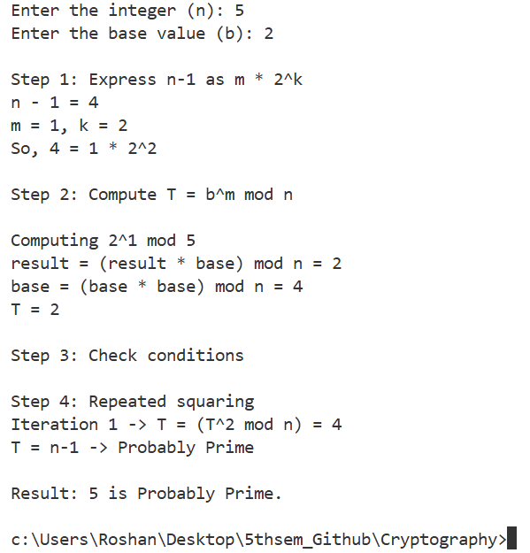
Conclusion:
Thus, the program was successfully implemented to test the primality of a number using the Miller–Rabin algorithm. The method provides an efficient and reliable way to determine whether a number is prime, particularly for large values, demonstrating its importance in computational and cryptographic applications.

