

Lab No: 10 Date: 2082/
Title: Write a program to test if user input two integer is primitive root or not
A Primitive Root Modulo n is a number g such that its powers generate all the numbers from 1 to n−1 under modulo n. In other words, if g is a primitive root of a prime number n, then the values of $g^{1},g^{2},g^{3},...,g^{n-1}$modulo n produce all integers from 1 to n−1 without repetition.
For a number to be a primitive root, it must first be coprime with n, meaning their Greatest Common Divisor must be 1. Primitive roots are important concepts in Number Theory and are widely used in cryptographic systems such as the Diffie–Hellman Key Exchange.
Algorithm
- Start the program.
- Input two integers g (possible primitive root) and n (prime number).
- Compute gcd(g, n).
- If gcd(g, n) ≠ 1, then g is not a primitive root.
- Otherwise, compute $g^{i}mod n$for i = 1 to n−1.
- If the value 1 appears before i = n−1, then g is not a primitive root.
- If 1 appears only when i = n−1, then g is a primitive root of n.
- Display the result.
- End the program.

Language: C
IDE: VS Code
Source code:
#include <stdio.h>
// -------------------- GCD FUNCTION --------------------
int gcd(int a, int b) {
// Repeat until b becomes 0
while (b != 0) {
int temp = b;
b = a % b;
a = temp;
}
return a;
}
// -------------------- POWER FUNCTION --------------------
// This function calculates (base^exp) % mod
int power(int base, int exp, int m) {
int result = 1; // Initialize result as 1
// Multiply base 'exp' times
for(int i = 0; i < exp; i++) {
result = (result * base) % m;
// Take mod each time to keep number small
}
return result; // Return final result
}
// -------------------- MAIN FUNCTION --------------------
int main() {
int g, n; // g = possible primitive root
// n = prime number
int flag = 1; // assume primitive root initially
printf("Enter value of g (possible primitive root): ");
scanf("%d", &g);
printf("Enter value of n (prime number): ");
scanf("%d", &n);
// ---------- STEP 1: CHECK GCD CONDITION ----------
// A primitive root must be coprime with n
// So gcd(g, n) must be 1
if(gcd(g, n) != 1) {
printf("%d is NOT a primitive root of %d\n", g, n);
return 0; // Stop program if condition fails
}
// ---------- STEP 2: CHECK POWERS ----------
// We check g^i mod n, for i=1 to n-1
for(int i = 1; i < n; i++) {
int val = power(g, i, n); // calculate g^i mod n
printf(" %d^%d mod %d = %d\n",g, i,n, val); // print trace table
if(val == 1 && i < n - 1) {
flag = 0;
break;
}
}
// ---------- FINAL RESULT ----------
if(flag)
printf("%d is a primitive root of %d\n", g, n);
else
printf("%d is NOT a primitive root of %d\n", g, n);

return 0;
}

Output:
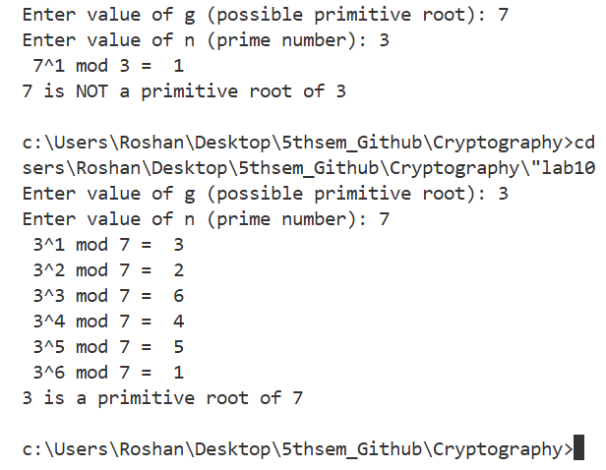
Conclusion:
In this experiment, a program was developed to test whether a given number is a Primitive Root Modulo n of another number. The program checks the coprime condition using the Greatest Common Divisor and verifies the modular powers of the number. This experiment helped in understanding primitive roots and their significance in Number Theory and cryptographic applications.

