

Lab No: 12 Date: 2082/
Title: Write a program to simulate Diffie-Hellman key exchange algorithm.
The Diffie–Hellman method is an important mathematical concept used in modern cryptography. It plays a significant role in many security protocols used on the internet today. This technique was introduced in 1976 by Whitfield Diffie and Martin Hellman. The main purpose of this algorithm is to allow two users to establish a common secret key over a public network without previously sharing any secret information. One of the major advantages of the Diffie–Hellman technique is that even if a third party intercepts the communication, it becomes extremely difficult for them to determine the shared key. Because of this property, the algorithm is widely used for secure key exchange and helps maintain the privacy and security of transmitted data.
Algorithm:
Step 1: Choose two public values: a large prime number p and a generator g.
Step 2: Alice selects a private key a, while Bob selects a private key b.
Step 3: Alice calculates A = gᵃ mod p, and Bob calculates B = gᵇ mod p. They then exchange these values A and B with each other.
Step 4: Alice computes the shared key K = Bᵃ mod p, while Bob computes K = Aᵇ mod p.
Step 5: Both Alice and Bob obtain the same secret key K = gᵃᵇ mod p, which can be used for secure communication.

Language: C
IDE: VS Code
Source code:
#include <stdio.h>
// Function to calculate gcd
int gcd(int a, int b)
{
while (b != 0)
{
int temp = b;
b = a % b;
a = temp;
}
return a;
}
// Function to check primitive root modulo p
int isPrimitiveRoot(int g, int p)
{
if (gcd(g, p) != 1)
{
printf("\nSince gcd(%d, %d) != 1, g cannot be a primitive root.\n", g, p);
return 0;
}
int value = 1;

for (int i = 1; i < p; i++)
{
value = (value * g) % p;
if (value == 1 && i != p - 1)
{
printf("\n%d^%d mod %d = 1 (appeared too early)\n", g, i, p);
return 0;
}
}
return 1;
}
// Function to compute (base^exp) % mod
long long powerMod(long long base, long long exp, long long mod)
{
long long result = 1;
for (long long i = 0; i < exp; i++)
{
result = (result * base) % mod;
}
return result;
}
int main()
{
long long p, g;
long long a, b;
long long A, B;
long long keyA, keyB;
// Input prime and primitive root
printf("Enter prime number (p): ");
scanf("%lld", &p);
printf("Enter primitive root candidate (g): ");
scanf("%lld", &g);
// Check if g is primitive root
if (!isPrimitiveRoot(g, p))
{
printf("\n%lld is NOT a primitive root modulo %lld. Choose another g.\n", g, p);
return 0;
}
else
{
printf("\n%lld is a valid primitive root modulo %lld.\n", g, p);
}
printf("\nEnter Alice's private key (a): ");
scanf("%lld", &a);
printf("Enter Bob's private key (b): ");
scanf("%lld", &b);
A = powerMod(g, a, p);
B = powerMod(g, b, p);
printf("\nAlice's Public Key (A): %lld\n", A);
printf("Bob's Public Key (B): %lld\n", B);
keyA = powerMod(B, a, p);
keyB = powerMod(A, b, p);
printf("\nShared Key computed by Alice: %lld\n", keyA);
printf("Shared Key computed by Bob: %lld\n", keyB);
if (keyA == keyB)
printf("\nKey Exchange Successful! Both keys match.\n");
else
printf("\nKey Exchange Failed!\n");
return 0;
}

Output:
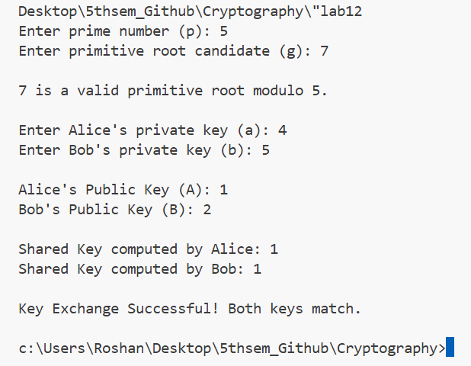
Conclusion:
In this lab, we implemented the Diffie–Hellman Key Exchange algorithm and understood how two parties can create a shared secret key over an insecure communication channel without sending the key directly. The experiment helped us learn about modular arithmetic and the role of public and private keys in cryptography. Thus, Diffie–Hellman is an important method used in modern secure communication systems.

