

Lab No: 13 Date: 2082/
Title: Write a program to simulate RSA cryptosystem
RSA is a widely used public-key cryptographic system for secure communication. The security of RSA is based on the difficulty of factoring large numbers into their prime factors. In RSA, each user has two keys: a public key used for encryption and a private key used for decryption. The algorithm uses modular exponentiation to convert a plaintext message into ciphertext and then recover the original message.
Encryption and decryption are represented as:
- Encryption: $C=M^{e} mod n$
- Decryption: $M=C^{d} mod n$
Algorithm
Step 1: Start
Step 2: Input two prime numbers p and q
Step 3: Compute n = p × q
Step 4: Compute φ(n) = (p − 1)(q − 1)
Step 5: Choose e such that 1 < e < φ(n) and gcd(e, φ(n)) = 1
Step 6: Compute d such that (d × e) ≡ 1 (mod φ(n))
Step 7: Input message M (0 < M < n)
Step 8: Encrypt message: C = M^e mod n
Step 9: Decrypt ciphertext: M = C^d mod n
Step 10: Display encrypted and decrypted message
Step 11: Stop

Language: C
IDE: VS Code
Source code:
#include <stdio.h>
// Function to find GCD
int gcd(int a, int b) {
if (b == 0)
return a;
return gcd(b, a % b);
}
// Function to compute (base^exp) % mod
long long power(long long base, long long exp, long long mod) {
long long result = 1;
while (exp > 0) {
result = (result * base) % mod;
exp--;
}
return result;
}
int main() {
int p, q, n, phi, e, d = 0;
long long msg, cipher, decrypted;
// Input primes
printf("Enter prime number p: ");
scanf("%d", &p);
printf("Enter prime number q: ");
scanf("%d", &q);
// Show calculation of n
n = p * q;
printf("\nCalculation of n:\n");
printf("n = p * q\n");
printf("n = %d * %d = %d\n\n", p, q, n);
// Show calculation of phi
phi = (p - 1) * (q - 1);
printf("Calculation of phi:\n");
printf("phi = (p - 1) * (q - 1)\n");
printf("phi = (%d - 1) * (%d - 1)\n", p, q);
printf("phi = %d\n\n", phi);
// Input e
printf("Enter value of e (1 < e < %d and gcd(e, %d) = 1): ", phi,phi);
scanf("%d", &e);
// Validate e
if (e <= 1 || e >= phi || gcd(e, phi) != 1) {
printf("Invalid value of e! It must be co-prime with %d.\n",phi);
return 0;
}
// Calculate d
for (int i = 1; i < phi; i++) {
if ((e * i) % phi == 1) {
d = i;
break;
}
}
printf("\nPublic Key (e, n): (%d, %d)\n", e, n);
printf("Private Key (d, n): (%d, %d)\n", d, n);
// Input message
printf("\nEnter message (integer < %d): ", n);
scanf("%lld", &msg);
// Encryption
printf("\nEncryption Process:\n");
printf("Cipher = (Message^e) mod n\n");
printf("Cipher = (%lld^%d) mod %d\n", msg, e, n);
cipher = power(msg, e, n);
printf("Cipher = %lld\n", cipher);
// Decryption
printf("\nDecryption Process:\n");
printf("Message = (Cipher^d) mod n\n");
printf("Message = (%lld^%d) mod %d\n", cipher, d, n);
decrypted = power(cipher, d, n);
printf("Decrypted Message = %lld\n", decrypted);
return 0;
}

Output:
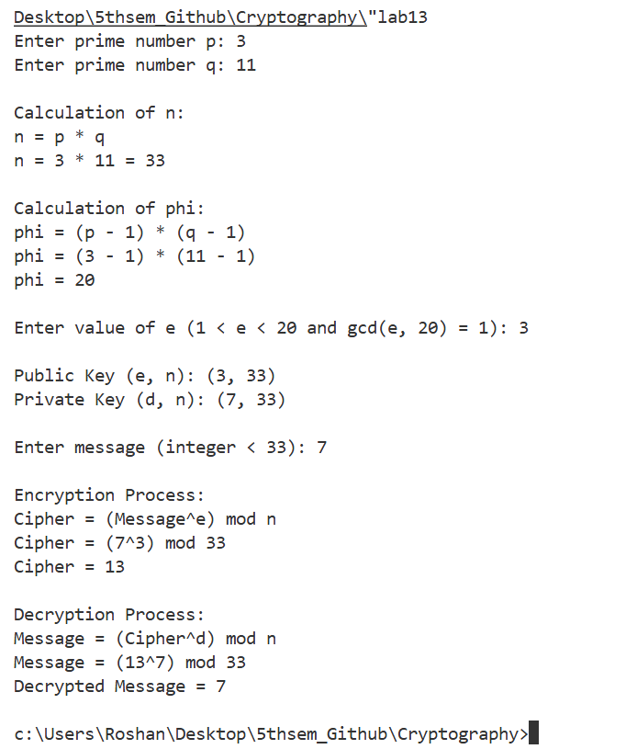
Conclusion:
In this lab, we implemented the RSA cryptographic algorithm and understood how public-key encryption works. We learned how two prime numbers are used to generate public and private keys and how messages are encrypted and decrypted using modular exponentiation. This experiment helped us understand the importance of prime numbers and key generation in cryptography. Therefore, RSA is an important algorithm used to ensure secure communication in modern digital systems.

