

Lab No: 14 Date: 2082/
Title: Write a program to simulate the Elgamal cryptosystem
The ElGamal Cryptosystem is a public-key encryption method that is based on the discrete logarithm problem, which makes it difficult for attackers to determine the private key. It is used to provide secure communication by allowing encryption with a public key and decryption with a private key. In this system, two public parameters are selected: a large prime number p and a primitive root g modulo p. The user then selects a private key x, and the corresponding public key is computed using modular exponentiation. During encryption, a random number k is chosen for each message to increase security.
Algorithm
Step 1: Start and choose a large prime number p and primitive root g modulo p
Step 2: Choose private key x such that $1≤x≤p-2$
Step 3: Compute public key: $y=g^{x} mod p$
Step 4: Input message M and choose random integer k such that $1≤k≤p-2$
Step 5: Encrypt the message
$$C1=g^{k} mod p \\ C2=M×(y^{k} mod p) mod p$$
Step 6: Send the ciphertext pair (C1, C2)
Step 7: Decrypt the message
$$M=C2×(C1^{x})^{-1} mod p$$
Step 8: Display the decrypted message and stop.

Language: C
IDE: VS Code
Source code:
#include <stdio.h>
// Function to compute (base^exp) % mod
long long power(long long base, long long exp, long long mod)
{
long long result = 1;
base = base % mod;
while (exp > 0)
{
if (exp % 2 == 1)
result = (result * base) % mod;
base = (base * base) % mod;
exp = exp / 2;
}
return result;
}
// Function to find modular inverse using Fermat's theorem
long long modInverse(long long a, long long p)
{
return power(a, p - 2, p);
}
int main()
{
long long p, g, x, y;
long long m, k;
long long c1, c2, s, decrypted;
printf("Enter prime number p: ");
scanf("%lld", &p);
printf("Enter primitive root g: ");
scanf("%lld", &g);
printf("Enter private key x: ");
scanf("%lld", &x);
// Public key calculation
y = power(g, x, p);
printf("\nPublic Key Calculation:\n");
printf("y = g^x mod p\n");
printf("y = %lld^%lld mod %lld = %lld\n", g, x, p, y);
printf("\nPublic Key (p, g, y) = (%lld, %lld, %lld)\n", p, g, y);
printf("Private Key x = %lld\n", x);
// Encryption
printf("\nEnter message m: ");
scanf("%lld", &m);
printf("Enter random integer k: ");
scanf("%lld", &k);
c1 = power(g, k, p);
c2 = (m * power(y, k, p)) % p;
printf("\nEncryption Formulas:\n");
printf("C1 = g^k mod p = %lld\n", c1);
printf("C2 = m * y^k mod p = %lld\n", c2);
// Decryption
s = power(c1, x, p);
decrypted = (c2 * modInverse(s, p)) % p;
printf("\nDecryption Formulas:\n");
printf("Shared Secret s = C1^x mod p = %lld\n", s);
printf("m = C2 * s^-1 mod p = %lld\n", decrypted);
return 0;
}
Output:
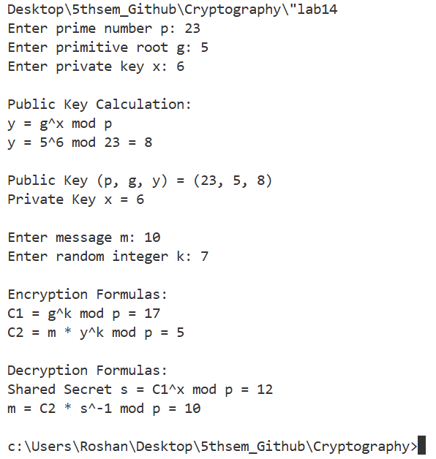
Conclusion:
In this lab, we implemented the RSA cryptographic algorithm and understood how public-key encryption works. We learned how two prime numbers are used to generate public and private keys and how messages are encrypted and decrypted using modular exponentiation. This experiment helped us understand the importance of prime numbers and key generation in cryptography.

