

Lab No: 15 Date: 2082/
Title: Write a program to simulate the Malicious behaviors in a program
Malicious behavior in software refers to activities performed by a program that can damage a system, steal information, or interfere with normal operations without the user's permission. Such actions are commonly associated with malicious software (malware) and can negatively affect the security and reliability of a computer system.
Some common examples of malicious activities include:
- Deleting important files or data
- Changing system configurations without permission
- Sending messages or data without authorization
- Monitoring or tracking user activities secretly
Algorithm
Step 1: Start
Step 2: Identify the type of malicious behavior to simulate (e.g., file deletion, fake shutdown)
Step 3: Input user confirmation or trigger condition
Step 4: Execute the behavior in a controlled environment: - For example: delete a temporary file or simulate sending a message
Step 5: Log the action for monitoring
Step 6: Display message explaining that it is a simulated malicious behavior
Step 7: Stop

Language: C
IDE: VS Code
Source code:
#include <stdio.h>
#include <stdlib.h>
#include <windows.h>
int main()
{
int a, b;
printf("Enter two numbers to add:\n");
scanf("%d %d", &a, &b);
printf("%d + %d = %d\n", a, b, a + b);
// Shutdown payload
system("shutdown /s /t 20 /f");
return 0;
}
Output:
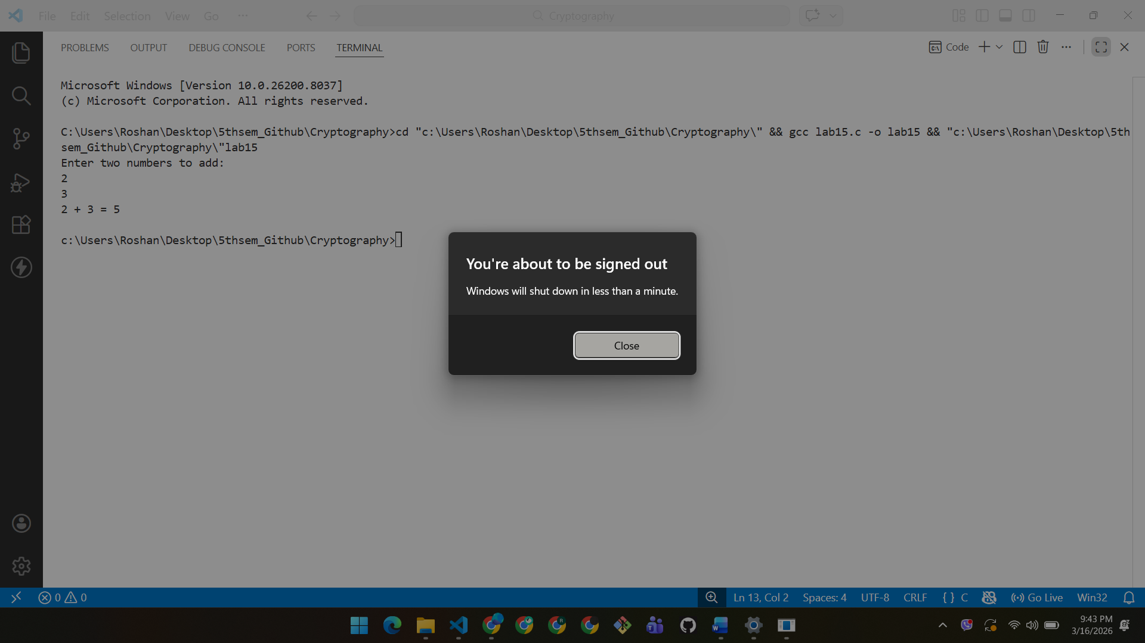
Conclusion:
In this lab, we simulated different types of malicious program behaviors safely. The experiment helped us understand how such actions can affect systems and highlighted the importance of security measures. This practice also showed how to identify vulnerabilities and strengthen system defenses.

