Title: Iterative sorting Algorithm

Objective:
- To implement Bubble sort and analyze it's complexity
- To implement Selection sort and analyze it's complexity
- To implement Insertion sort and analyze it's complexity

Theory:
- Bubble sort
- Algorithm
- Start.
- Read the number of elements n and the array A.
- For i = 0 to n − 2:
- For j = 0 to n − i − 2:
  - If A[j] > A[j + 1], swap A[j] and A[j + 1].
- Repeat until the array is sorted.
- Stop.

- Trace
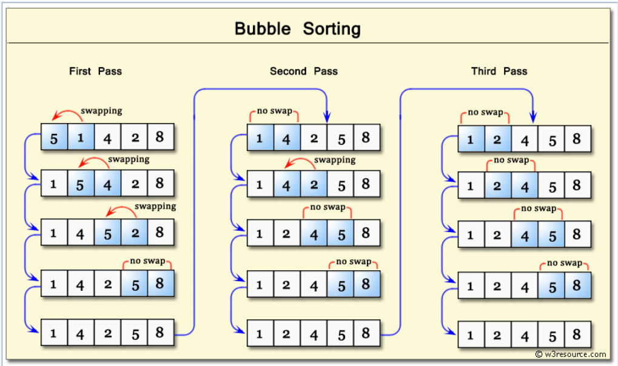
- time complexity
Best Case | Average Case | Worst Case
O(n) | O(n²) | O(n²)

- Selection sort
- Algorithm
- Start.
- Read the number of elements n and the array A.
- For i = 0 to n − 2:
- Assume the minimum element is at index i.
- For j = i + 1 to n − 1:
  - If A[j] < A[min], update min.
- Swap A[i] with A[min].
- Repeat until the array is sorted.
- Stop.

- Trace
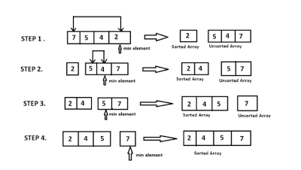
https://www.geeksforgeeks.org/dsa/selection-sort-algorithm-2/
- time complexity
Best Case | Average Case | Worst Case
O(n²) | O(n²) | O(n²)

- Insertion sort
- Algorithm
- Start.
- Read the number of elements n and the array A.
- For i = 1 to n − 1:
- Store A[i] as key.
- Compare key with elements before it.
- Shift elements greater than key one position ahead.
- Insert key at its correct position.
- Repeat until the array is sorted.
- Stop.

- Trace
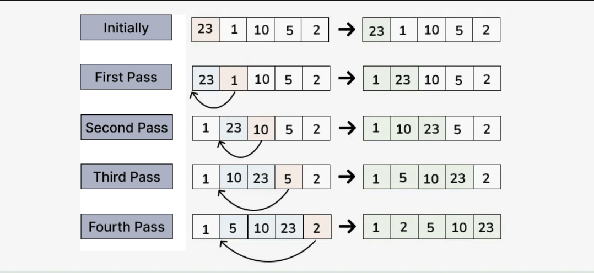

- time complexity
Best Case | Average Case | Worst Case
O(n) | O(n²) | O(n²)

Code:
#include <stdio.h>
int n, arr[100], opr, i, j, temp;

void insertElement()
{
printf("Enter the size of array: ");
scanf("%d", &n);
printf("Enter %d elements: \n", n);
for (i = 0; i < n; i++)
{
scanf("%d", &arr[i]);
}
}
void displayElement()
{
printf("array: ");
printf("[ ");
for (i = 0; i < n; i++)
{
printf("%d ", arr[i]);
}
printf("]");
printf("\n");
}

void bubbleSort()
{
for (i = 0; i < n-1 ; i++)
{
for (j = 0; j < n - i - 1; j++)
{
if(arr[j]>arr[j+1]){
temp = arr[j];
arr[j] = arr[j + 1];
arr[j + 1] = temp;
}
}
}
printf("Sorted successfully \n");
}
void insertionSort()
{
for(i=1; i<n; i++){
int key = arr[i];
j = i-1;
while(j>=0 && arr[j]>key){
arr[j+1]= arr[j];
j = j-1;
}
arr[j+1]= key;
}
printf("Sorted successfully \n");
}
void selectionSort()
{
for(i=0; i<n-1; i++){
int min = i;
for(j=i+1; j<n; j++){
if(arr[j]<arr[min])
min = j;
}
temp = arr[i];
arr[i] = arr[min];
arr[min] = temp;
}
printf("Sorted successfully \n");
}

int main()
{
int opr;
do{
printf("\nEnter 1 to insert element\n");
printf("Enter 2 for display\n");
printf("Enter 3 for Bubble Sort\n");
printf("Enter 4 for insertion Sort\n");
printf("Enter 5 for Selection sort\n");
printf("Enter 6 for exit\n");
printf("Enter the operation(1-6): ");
scanf("%d", &opr);
switch (opr)
{
case 1:
insertElement();
break;
case 2:
displayElement();
break;
case 3:
bubbleSort();
break;
case 4:
insertionSort();
break;
case 5:
selectionSort();
break;
case 6:
printf("Exit successfully\n");
break;
default:
printf("Please Enter a valid operation\n");
break;
}
}while(opr!=6);
}

Output:
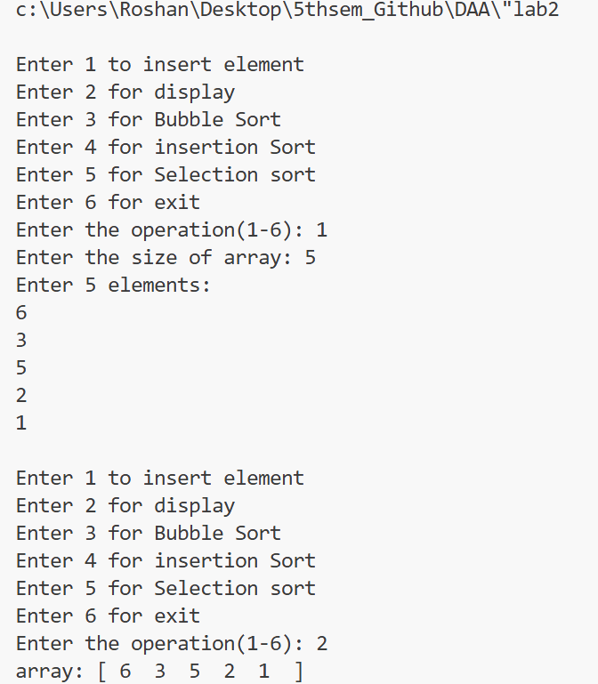
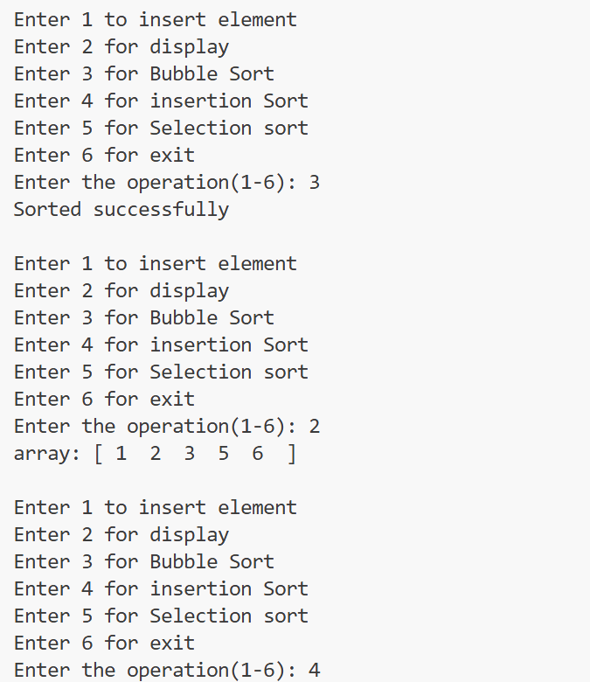
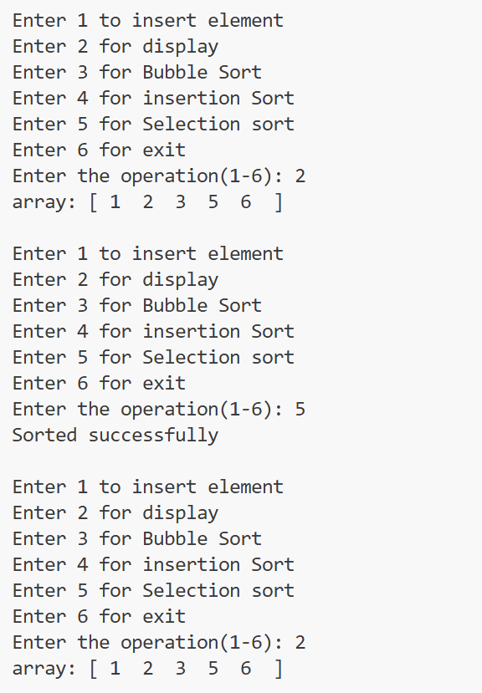
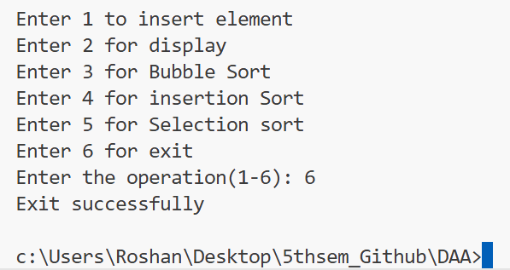

Conclusion
In this lab, Bubble Sort, Selection Sort, and Insertion Sort were implemented successfully. The analysis shows that, in the worst case, all three sorting algorithms have a time complexity of O(n²) and require O(1) auxiliary space. Hence, these algorithms are suitable for learning purposes but are not efficient for large datasets.

