Title: Greedy strategy

Objective:
1. To implement Fractional knapsack problem and analyze it's complexity
2. To implement Job sequencing problem and analyze it's complexity
3. To implement Kruskal’s and Prims algorithm for MST
4. To implement Dijkstra’s algorithm for finding shortest path

Theory
1. Fractional Knapsack Problem
The Fractional Knapsack problem is an optimization problem that uses the greedy approach to maximize profit. Items can be taken either fully or partially based on their profit-to-weight ratio, making it more flexible than the 0/1 Knapsack problem.
Problem Statement
Given n items, each with a profit and weight, and a knapsack of fixed capacity W, determine the maximum profit that can be obtained by selecting whole or fractional parts of items such that the total weight does not exceed W.
Algorithm
- Calculate the profit-to-weight ratio for each item.
- Sort the items in descending order of their ratios.
- Initialize total profit as zero.
- Select items one by one:
  - If the full item can be added, include it entirely.
  - Otherwise, include the fractional part of the item that fits.
- Stop when the knapsack capacity becomes zero.

Time and Space Complexity
- Time Complexity:
$O(nlog⁡n)$due to sorting of items.
- Space Complexity:
$O(n)$for storing profits, weights, and ratios.

2. Job Sequencing with Deadline
Job Sequencing with Deadline is a scheduling problem that applies the greedy technique to select jobs in such a way that total profit is maximized while meeting given deadlines.
Problem Statement
Given a set of n jobs, each with a deadline and associated profit, determine the sequence of jobs that maximizes total profit such that no job misses its deadline.
Algorithm
- Sort all jobs in descending order of profit.
- Find the maximum deadline among all jobs.
- Create a slot array to store scheduled jobs.
- For each job (in sorted order), schedule it in the latest available slot before its deadline.
- Calculate total profit from scheduled jobs.
Time and Space Complexity
- Time Complexity:
$O(n^{2})$due to nested loops for scheduling.
- Space Complexity:
$O(n)$for job and slot arrays.

3. Kruskal’s Algorithm
Kruskal’s Algorithm is a greedy algorithm used to find the Minimum Spanning Tree of a weighted undirected graph by selecting edges with the smallest weights while avoiding cycles.
Problem Statement
Given a connected weighted undirected graph, find a Minimum Spanning Tree such that the total weight of all edges in the tree is minimized.
Algorithm
- Sort all edges in ascending order of their weights.
- Initialize each vertex as a separate set.
- Select the smallest edge and check whether it forms a cycle.
- If no cycle is formed, include the edge in the MST.
- Repeat until the MST contains n−1 edges.
Time and Space Complexity
- Time Complexity:
$O(Elog⁡E)$due to edge sorting.
- Space Complexity:
$O(V)$for parent array.
4. Prim’s Algorithm
Prim’s Algorithm is a greedy method for constructing a Minimum Spanning Tree by starting from a single vertex and repeatedly adding the minimum weight edge that connects the tree to a new vertex.
Problem Statement
Given a connected weighted undirected graph, find a Minimum Spanning Tree that connects all vertices with the minimum total edge weight.
Algorithm
- Start from an arbitrary vertex.
- Mark the starting vertex as selected.
- Find the minimum weight edge connecting a selected vertex to an unselected vertex.
- Add the edge to the MST and mark the vertex as selected.
- Repeat until all vertices are included.
Time and Space Complexity
- Time Complexity:
$O(V^{2})$when using adjacency matrix.
- Space Complexity:
$O(V^{2})$for adjacency matrix storage.
5. Dijkstra’s Algorithm
Dijkstra’s Algorithm is a greedy algorithm used to find the shortest path from a source vertex to all other vertices in a graph with non-negative edge weights.
Problem Statement
Given a weighted graph and a source vertex, determine the shortest distance from the source to every other vertex in the graph.
Algorithm
- Initialize distance of source vertex as 0 and others as infinity.
- Mark all vertices as unvisited.
- Select the unvisited vertex with the minimum distance.
- Update distances of adjacent vertices.
- Mark the selected vertex as visited.
- Repeat until all vertices are visited.
Time and Space Complexity
- Time Complexity:
$O(V^{2})$using adjacency matrix.
- Space Complexity:
$O(V)$for distance and visited arrays.

Source code:
#include <stdio.h>
#include <stdlib.h>
#include <limits.h>

#define MAX 100

/* ---------------- FRACTIONAL KNAPSACK ---------------- */
void fractionalKnapsack() {
int n;
printf("Enter number of items: ");
scanf("%d", &n);

float weight[n], profit[n], ratio[n];
for (int i = 0; i < n; i++) {
printf("Enter profit and weight for item %d: ", i + 1);
scanf("%f %f", &profit[i], &weight[i]);
ratio[i] = profit[i] / weight[i];
}

float capacity;
printf("Enter capacity of knapsack: ");
scanf("%f", &capacity);

// Sort items by profit/weight ratio (descending)
for (int i = 0; i < n - 1; i++) {
for (int j = i + 1; j < n; j++) {
if (ratio[i] < ratio[j]) {
float temp = ratio[i];
ratio[i] = ratio[j];
ratio[j] = temp;

temp = profit[i];
profit[i] = profit[j];
profit[j] = temp;

temp = weight[i];
weight[i] = weight[j];
weight[j] = temp;
}
}
}

float totalProfit = 0;
for (int i = 0; i < n; i++) {
if (weight[i] <= capacity) {
capacity -= weight[i];
totalProfit += profit[i];
} else {
totalProfit += profit[i] * (capacity / weight[i]);
break;
}
}

printf("Maximum profit = %.2f\n", totalProfit);
}

/* ---------------- JOB SEQUENCING WITH DEADLINE ---------------- */
typedef struct {
int id;
int deadline;
int profit;
} Job;

void jobSequencing() {
int n;
printf("Enter number of jobs: ");
scanf("%d", &n);

Job jobs[n];
for (int i = 0; i < n; i++) {
jobs[i].id = i + 1;
printf("Enter deadline and profit for job %d: ", i + 1);
scanf("%d %d", &jobs[i].deadline, &jobs[i].profit);
}

// Sort jobs by profit (descending)
for (int i = 0; i < n - 1; i++) {
for (int j = i + 1; j < n; j++) {
if (jobs[i].profit < jobs[j].profit) {
Job temp = jobs[i];
jobs[i] = jobs[j];
jobs[j] = temp;
}
}
}

int maxDeadline = 0;
for (int i = 0; i < n; i++)
if (jobs[i].deadline > maxDeadline)
maxDeadline = jobs[i].deadline;

int slot[maxDeadline];
for (int i = 0; i < maxDeadline; i++)
slot[i] = -1;

int totalProfit = 0;
for (int i = 0; i < n; i++) {
for (int j = jobs[i].deadline - 1; j >= 0; j--) {
if (slot[j] == -1) {
slot[j] = jobs[i].id;
totalProfit += jobs[i].profit;
break;
}
}
}

printf("Job sequence: ");
for (int i = 0; i < maxDeadline; i++)
if (slot[i] != -1)
printf("J%d ", slot[i]);

printf("\nTotal profit: %d\n", totalProfit);
}

/* ---------------- KRUSKAL'S ALGORITHM ---------------- */
typedef struct {
int u, v, weight;
} Edge;

int findParent(int parent[], int i) {
while (parent[i] != i)
i = parent[i];
return i;
}

void kruskal() {
int n, e;
printf("Enter number of vertices and edges: ");
scanf("%d %d", &n, &e);

Edge edges[e];
for (int i = 0; i < e; i++) {
printf("Enter u v weight for edge %d: ", i + 1);
scanf("%d %d %d", &edges[i].u, &edges[i].v, &edges[i].weight);
}

// Sort edges by weight
for (int i = 0; i < e - 1; i++) {
for (int j = i + 1; j < e; j++) {
if (edges[i].weight > edges[j].weight) {
Edge temp = edges[i];
edges[i] = edges[j];
edges[j] = temp;
}
}
}

int parent[n + 1];
for (int i = 1; i <= n; i++)
parent[i] = i;

int count = 0, totalWeight = 0;
printf("Edges in MST:\n");

for (int i = 0; i < e && count < n - 1; i++) {
int setU = findParent(parent, edges[i].u);
int setV = findParent(parent, edges[i].v);

if (setU != setV) {
printf("%d - %d = %d\n", edges[i].u, edges[i].v, edges[i].weight);
totalWeight += edges[i].weight;
parent[setU] = setV;
count++;
}
}

printf("Total weight of MST: %d\n", totalWeight);
}

/* ---------------- PRIM'S ALGORITHM ---------------- */
void prim() {
int n;
printf("Enter number of vertices: ");
scanf("%d", &n);

int graph[n][n];
printf("Enter adjacency matrix (0 if no edge):\n");
for (int i = 0; i < n; i++)
for (int j = 0; j < n; j++)
scanf("%d", &graph[i][j]);

int selected[n];
for (int i = 0; i < n; i++)
selected[i] = 0;

selected[0] = 1;
int totalWeight = 0;

printf("Edges in MST:\n");
for (int edges = 0; edges < n - 1; edges++) {
int min = INT_MAX, x = -1, y = -1;

for (int i = 0; i < n; i++) {
if (selected[i]) {
for (int j = 0; j < n; j++) {
if (!selected[j] && graph[i][j] && graph[i][j] < min) {
min = graph[i][j];
x = i;
y = j;
}
}
}
}

printf("%d - %d = %d\n", x, y, min);
totalWeight += min;
selected[y] = 1;
}

printf("Total weight of MST: %d\n", totalWeight);
}

/* ---------------- DIJKSTRA'S ALGORITHM ---------------- */
void dijkstra() {
int n;
printf("Enter number of vertices: ");
scanf("%d", &n);

int graph[n][n];
printf("Enter adjacency matrix (0 if no edge):\n");
for (int i = 0; i < n; i++)
for (int j = 0; j < n; j++)
scanf("%d", &graph[i][j]);

int src;
printf("Enter source vertex (0 to %d): ", n - 1);
scanf("%d", &src);

int dist[n], visited[n];
for (int i = 0; i < n; i++) {
dist[i] = INT_MAX;
visited[i] = 0;
}

dist[src] = 0;

for (int count = 0; count < n - 1; count++) {
int min = INT_MAX, u = -1;

for (int i = 0; i < n; i++)
if (!visited[i] && dist[i] < min) {
min = dist[i];
u = i;
}

visited[u] = 1;

for (int v = 0; v < n; v++) {
if (!visited[v] && graph[u][v] &&
dist[u] != INT_MAX &&
dist[u] + graph[u][v] < dist[v]) {
dist[v] = dist[u] + graph[u][v];
}
}
}

printf("Vertex\tDistance from Source\n");
for (int i = 0; i < n; i++)
printf("%d\t%d\n", i, dist[i]);
}

/* ---------------- MAIN MENU ---------------- */
int main() {
int choice;
do {
printf("\n--- Algorithm Menu ---\n");
printf("1. Fractional Knapsack\n");
printf("2. Job Sequencing with Deadline\n");
printf("3. Kruskal's Algorithm\n");
printf("4. Prim's Algorithm\n");
printf("5. Dijkstra's Algorithm\n");
printf("0. Exit\n");
printf("Enter your choice: ");
scanf("%d", &choice);

switch (choice) {
case 1: fractionalKnapsack(); break;
case 2: jobSequencing(); break;
case 3: kruskal(); break;
case 4: prim(); break;
case 5: dijkstra(); break;
case 0: printf("Exiting...\n"); break;
default: printf("Invalid choice! Try again.\n");
}
} while (choice != 0);

return 0;
}

Output:
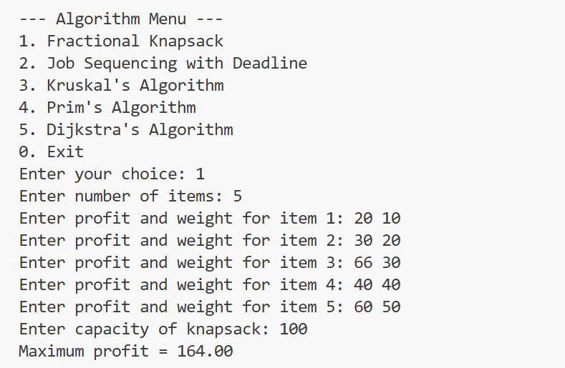
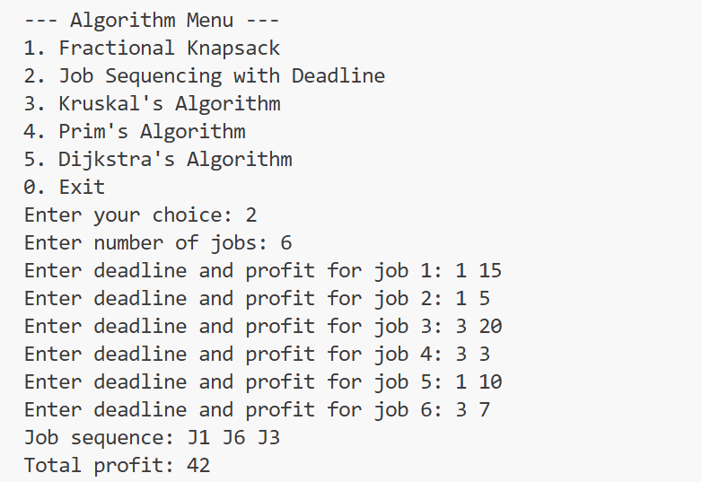
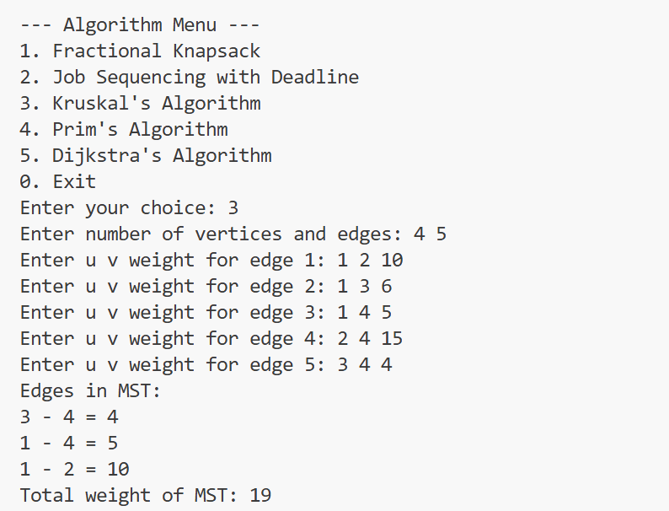
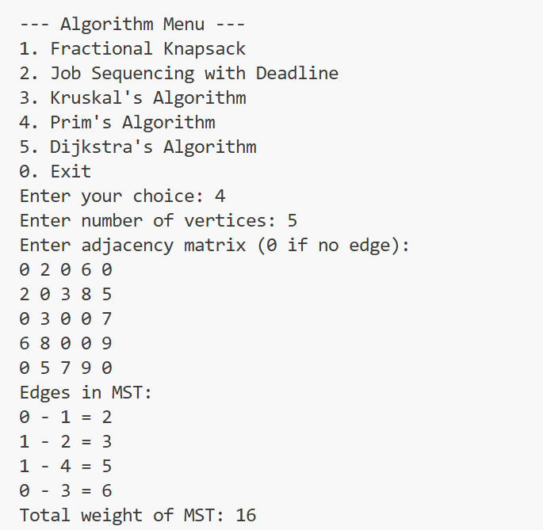
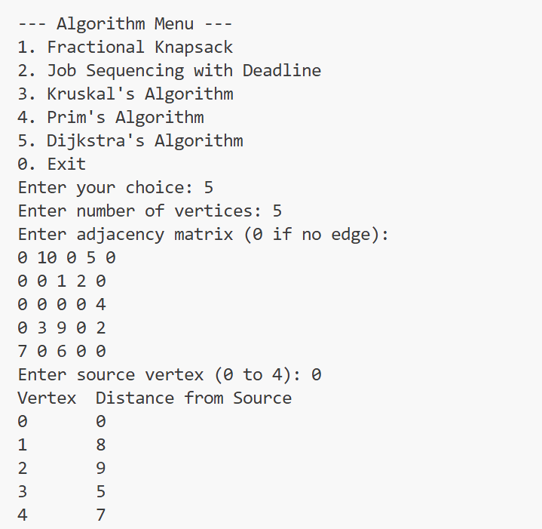
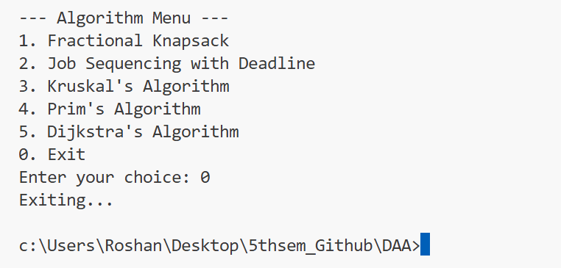

Conclusion
In this laboratory experiment, various greedy and graph algorithms such as Fractional Knapsack, Job Sequencing, Kruskal’s, Prim’s, and Dijkstra’s algorithms were studied and implemented. These algorithms efficiently solve optimization, scheduling, and shortest path problems by making optimal choices at each step. The experiment helped in understanding their working principles and applications in real-world problems. Thus, greedy and graph algorithms play a vital role in designing efficient computational solutions.

