
Lab no: 01 Date:2082/
Title: Explain the concepts of UI and UX in detail. Discuss their importance in modern web and mobile application design. Illustrate your answer with suitable real-world examples of popular applications or websites.
Objective:
To learn the basic ideas of User Interface (UI) and User Experience (UX) and understand why they are important in modern web and mobile applications.
Theory:
User Interface (UI):
User Interface (UI) design focuses on the visual and interactive parts of a digital product that users directly interact with. It includes elements like buttons, icons, text styles, colors, spacing, images, input boxes, and navigation menus. UI design decides how these elements are arranged, styled, and presented on the screen. The main aim of UI design is to make the interface visually appealing and easy to understand so users can quickly know how to use the product.
User Experience (UX):
User Experience (UX) design deals with the complete experience a user has while interacting with a product. This starts from discovering the product, learning how to use it, completing tasks, and even coming back to use it again. UX is not limited to just the interface; it also includes other aspects like onboarding, error handling, customer support, and the overall feeling a user gets during interaction.
Importance of UI and UX:
From a Business Perspective:
• Customer Retention: Simple and user-friendly design helps reduce frustration and encourages users to return.
• Higher Conversion Rates: Clear navigation and effective call-to-action buttons increase sign-ups and sales.
• Lower Support Costs: Easy-to-use products reduce the need for customer support.
• Brand Value: Good UX helps a product stand out in a competitive market.
• Accessibility & Compliance: Many regions require accessible design, making UX important legally as well.
From a User Perspective:
• Efficiency: Users can complete tasks more quickly and easily.
• Trust & Reliability: A well-designed interface builds confidence, especially in apps like banking or shopping.
• Emotional Satisfaction: Smooth interactions and attractive design create a positive user experience.

Real-World Examples:
Example A — Airbnb (Web & Mobile):
Airbnb is a great example of strong UI and UX integration. The booking process is simple: users select a location, dates, and number of guests, then browse available options. Information is shown step by step, which prevents users from feeling overwhelmed. The design uses clean layouts, good spacing, and high-quality images to create a comfortable and trustworthy experience. Both guest and host interfaces maintain consistency while serving different purposes.
Example B — Spotify (Mobile Application):
Spotify effectively handles a large collection of music while keeping the app easy to use. It recommends personalized playlists like Discover Weekly and Daily Mix, helping users find songs they like quickly. The dark theme makes it comfortable for long use, and album covers are clearly highlighted. A small music player stays visible at the bottom, allowing users to browse without stopping their music.
Example C — Duolingo (Mobile Application):
Duolingo combines education with engaging design. It uses features like streaks, rewards, and leaderboards to motivate users. New users can start learning immediately without signing up first, which makes the experience less stressful. Bright colors and fun graphics make the app more enjoyable compared to traditional learning methods.
Conclusion:
UI and UX are essential parts of any successful digital product and work closely together. UI deals with the visual design, such as layout, colors, and typography, while UX focuses on the overall usability and satisfaction of the user. In today’s fast-paced digital world, good UI/UX design is very important. It is not only about making a product look good but also about making it easy, useful, and enjoyable for users.


Lab no: 02 Date:2082
Title: Logo Design – E-Commerce Platform
Objective:
Design a creative and professional logo for an online shopping (e-commerce) platform. The logo should reflect trust, simplicity, and digital commerce. Briefly explain the design concept, color choice, and typography used.
Logo Design:

Design Concept:
The logo represents a modern e-commerce platform using a shopping bag as the main symbol of online purchasing. The circular orbit around the bag reflects global connectivity and digital commerce. The overall design is simple, modern, and visually balanced to create a professional look.

Color Palette:
The logo uses a vibrant gradient for a modern feel:
- Purple → trust and reliability
- Orange–Yellow gradient → energy and shopping activity
- Golden ring → global reach and movement
- Light background → clarity and focus

Typography:
- “E-COMMERCE” is bold and uppercase for strong visibility
- “ONLINE SHOPPING” is simple and spaced for clarity. This creates a clear and professional hierarchy.

Conclusion:
The logo effectively combines simplicity, modern design, and meaningful symbols to represent a trustworthy and dynamic online shopping platform.



Lab no: 03 Date:2082
Title: Logo Design – Travel and Tour Website
Objective:
Design a logo for a travel and tour website that represents adventure, exploration, or tourism services. Explain how the logo visually communicates the brand identity and target audience
Logo Design:


Design Concept
The Tour & Travel logo is designed to represent the idea of journey, exploration, and tourism services. The logo includes an airplane flying upward with luggage, symbolizing travel, movement, and adventure. The curved flight path of the airplane creates a sense of motion, showing the beginning of a new journey. The suitcase icons represent travel preparation and tourism services provided by the company.
Color Palette
- Dark Brown / Maroon: Used for the icons and text to represent reliability, professionalism, and stability.
- Light Beige Background: Creates a calm and simple look while making the travel symbols clearly visible.

Typography
Simple and clean typography is used to make the brand name “Tour & Travel” easy to read and memorable. The slightly stylish font gives a modern and professional appearance suitable for a travel service.
Target Audience
The logo is designed for travelers, tourists, and adventure seekers who are interested in exploring new places and planning trips. It appeals to people looking for travel services, tour packages, and tourism guidance.
Conclusion
The logo effectively communicates the idea of travel, adventure, and exploration through the use of airplane and luggage symbols. The simple design, balanced colors, and clear typography help create a recognizable and professional brand identity.


Lab no: 04 Date:2082
Title: User Interface Design – Authentication & Dashboard
Objective:
- Design a User Interface (UI) for the following pages using any suitable design tool (e.g., Figma, Adobe XD, Canva, Photoshop, etc.):
a. Login Page
b. Home Page
- Clearly label UI components such as buttons, input fields, navigation menus, and icons. Also explain how your design improves usability and user experience.
Logo Design:

- Login page
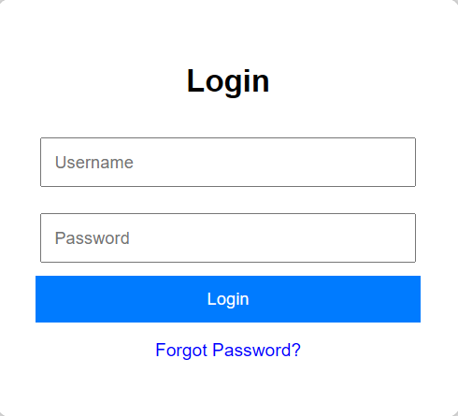

- Home page
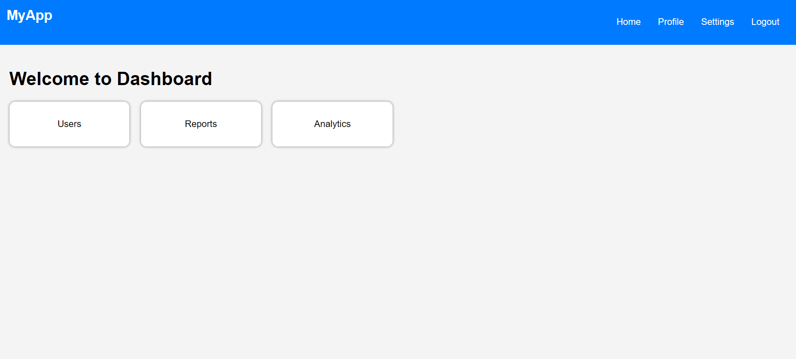
Design Concept:
The interface represents a simple and modern web application dashboard with a login system. The login page allows users to securely access the system by entering their username and password. After successful login, users are directed to the dashboard where different system features are organized in a clear and accessible layout. The dashboard includes functional sections such as Users, Reports, and Analytics, which allow users to manage information and view system data. A navigation menu at the top provides quick access to Home, Profile, Settings, and Logout, helping users easily move between different parts of the application. The overall layout is clean, structured, and designed to provide a user-friendly experience.
Color Palette:
The interface uses a clean and professional color scheme:
• Blue navigation bar → represents trust, stability, and professionalism
• Light gray background → creates a neutral workspace and improves readability
• White input fields and cards → highlight important interactive elements
• Blue action buttons → emphasize important actions such as login and navigation
Typography:
• The “Login” and “Welcome to Dashboard” headings are larger and bold to clearly indicate the main sections of the interface.
• Form labels such as Username and Password are simple and easy to read for better usability.
• Navigation menu text (Home, Profile, Settings, Logout) is clean and minimal to maintain a professional appearance.
Conclusion:
The interface design focuses on simplicity, usability, and clarity. The structured layout, clear navigation, and balanced color scheme create a professional web application environment that allows users to easily log in and access different dashboard features efficiently.


Lab no: 05 Date:2082
Title: Social media Graphic Design
Objective:
Create an attractive Facebook cover image for a college or educational institution using any design tool. The design should reflect the institution’s academic identity, professionalism, and branding. Mention the tools and design principles used.
Logo Design:


Design Concept:
The cover image uses a left-aligned layout where the college name and location are placed clearly for easy visibility, while the right side contains geometric shapes that add a modern and creative touch. The central message “Empowering Global Leaders” is highlighted to reflect the institution’s vision and academic excellence. The overall design is clean, balanced, and suitable for a professional educational institution.

Color Palette:
- Dark Teal Background → represents professionalism, trust, and academic strength
- Yellow/Golden Accent → highlights key message and adds energy
- Light Blue & White Shapes → create contrast and modern visual appeal

Typography:
- College Name (Bold Sans-Serif) → clear and strong for identity
- Tagline & Location (Simple Sans-Serif) → easy readability
- Main Highlight Text (Bold & Larger) → draws attention to the message

Technical Specifications:
- Size: 820 × 312px (Facebook cover standard)
- Color Mode: RGB
- Format: PNG
- Tool Used: Canva

Conclusion:
The design effectively combines modern layout, strong typography, and a clean color scheme to create a professional and attractive Facebook cover for an educational institution.



Lab no: 06 Date:2082/
Title: ID Card Design
Objective:
Design a student or staff ID card using any appropriate tool. The ID card should include essential elements such as photo placeholder, name, ID number, department, institution logo, and validity details.
Logo Design:
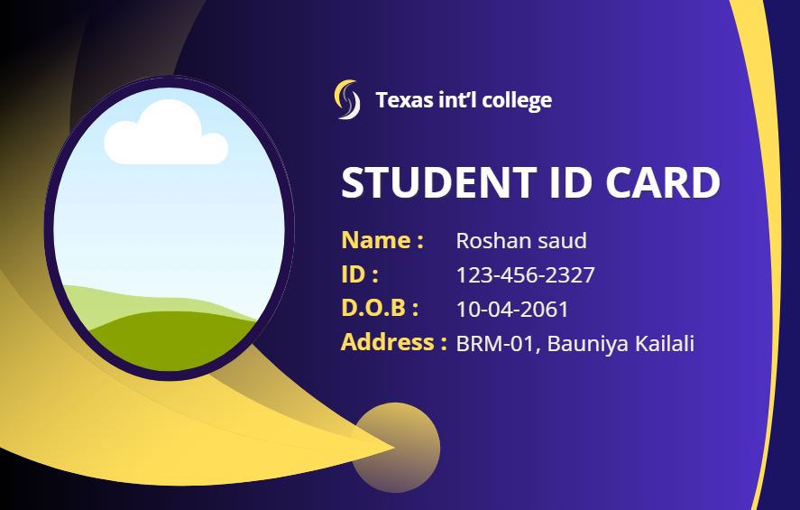
Design Concept
The Student ID Card is designed to clearly represent the identity of students at Texas International College. The design includes a photo section on the left inside an oval frame, which allows easy identification of the student. The right side of the card displays important information such as Name, ID number, Date of Birth, and Address in a structured format. The purple background with curved yellow shapes adds a modern and attractive appearance while maintaining a professional look suitable for an educational institution.
Color Palette
- Purple Background: Represents professionalism, creativity, and academic identity.
- Yellow Curved Shapes: Add visual contrast and make the card design more dynamic and appealing.
- White Text: Ensures clear readability of important information.
Typography
Simple and clear typography is used to display the college name, student ID title, and personal information. Bold text highlights important labels such as Name, ID, D.O.B, and Address, making the information easy to read and quickly identifiable.
Technical Specifications
- Card Size: Standard ID card size (CR80 – 85.60 mm × 53.98 mm)
- Resolution: High resolution suitable for printing
- Color Mode: RGB for digital design and can be converted to CMYK for printing
- Design Tool: Canva
Conclusion
The student ID card design effectively combines professional colors, clear typography, and organized information layout. The use of a photo section and structured text makes the card easy to read and suitable for identification within the college environment.

