

Lab No: 10 Date: 2082/
Title: AI-Based Text-to-Speech (TTS) System
Objective: To generate human-like speech using an AI-based text-to-speech (TTS) system and analyze its features and applications.
Theory:
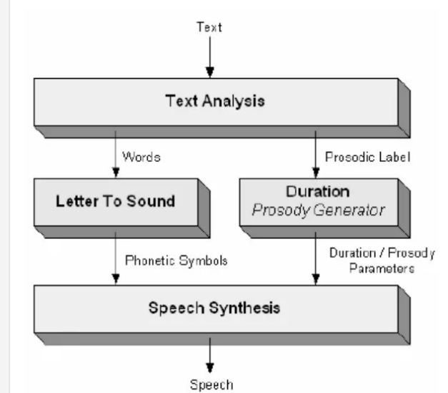
Text-to-Speech (TTS) is a technology that converts written text into spoken words using artificial intelligence and speech synthesis techniques. It allows computers and digital devices to produce natural-sounding speech automatically. TTS systems are widely used in applications such as virtual assistants, navigation systems, audiobooks, and accessibility tools.
Modern AI-based TTS systems use machine learning and deep learning algorithms to generate speech that closely resembles human voices. These systems analyze the input text and convert it into phonetic sounds, which are then combined to produce clear and understandable speech output. Fig: Text-To-Speech system architecture

Some popular AI-based TTS systems include Google Text-to-Speech, Amazon Polly, and Microsoft Azure Text to Speech. These tools provide multiple voice options, language support, and customizable speech parameters.
Key features of AI-based TTS systems include natural voice generation, support for multiple languages, adjustable speech speed and pitch, and integration with different applications. These features make TTS technology useful for improving accessibility, especially for visually impaired users who rely on audio output to access digital content.

Conclusion
AI-based text-to-speech systems enable computers to generate natural and clear spoken language from text. They improve accessibility and enhance user interaction with digital systems. With features like multiple voices and language support, TTS technology plays an important role in modern applications and user-friendly software systems.

