

Lab No: 13 Date: 2082/
Title: WAP to covert image into gray scale using any high-level programming (C#, C++, Python).
Objective:
To write a program that converts a colored image into a grayscale image using a high-level programming language.
Source code:
# WAP to convert image into grayscale using Python
from PIL import Image
# open image
img = Image.open("nature.jpg")
# convert to grayscale
gray_img = img.convert("L")
# save new image
gray_img.save("gray_image.jpg")
print("Image converted to grayscale successfully!")

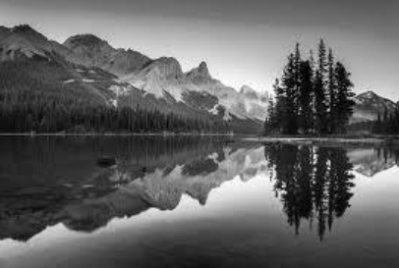
Output:
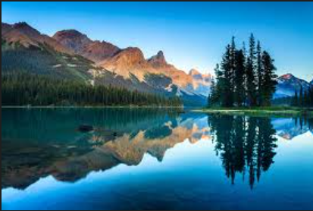
Conclusion:
The program successfully converts a colored image into grayscale by removing the color information and keeping only the intensity values. This experiment demonstrates the basic concept of image processing using a high-level programming language.

