

Lab No: 14 Date: 2082/
Title: WAP to covert image into black and white using any high-level programming (C#, C++, Python).
Objective:
To develop a program that converts a colored image into a black and white image using a high-level programming language.
Source code:
from PIL import Image
# Open the image
img = Image.open("nature.jpg")
# Convert to grayscale
gray = img.convert("L")
# Convert to Black & White using threshold
bw = gray.point(lambda x: 255 if x > 128 else 0, '1')
# Save output image
bw.save("black_white.jpg")
print("Image converted to Black & White successfully")

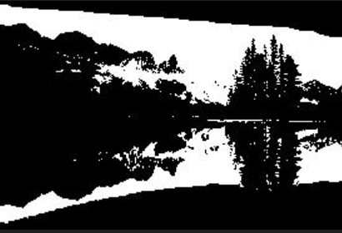
Output:
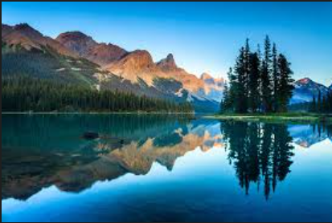

Conclusion:
The program successfully converts the given image into a black and white format using image processing techniques. This experiment helps in understanding basic image transformation using programming.

