

Lab No: 16 Date: 2082/
Title: WAP to generate a sound using any high-level programming (C#, C++, Python).
Objective:
To develop a program that generates sound using a high-level programming language.
Source code:
import winsound
# Generate sound
frequency = 1000 # Frequency in Hertz
duration = 1000 # Duration in milliseconds
winsound.Beep(frequency, duration)
print("Sound generated successfully")

Output:
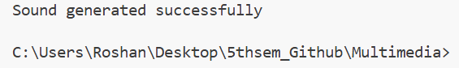
Conclusion:
The program successfully generates sound signals using programming techniques. This experiment helps in understanding the basic concept of digital sound generation in multimedia systems.

