

Lab No: 17 Date: 2082/
Title: Write a program to calculate the file size in bytes for a 30 sec recording at 44.1 kHz, 8 bits resolution stereo sound using any high-level programming (C#, C++, Python).
Objective:
To write a program that calculates the file size of a 30-second stereo audio recording based on sampling rate, bit resolution, and number of channels.
Source code:
sample_rate = 44100 # in Hz
bit_depth = 8 # bits per sample
channels = 2 # stereo
duration = 30 # seconds
# Calculate file size in bytes
file_size_bytes = sample_rate * bit_depth * channels * duration // 8
print("File size:", file_size_bytes, "bytes")

Output:
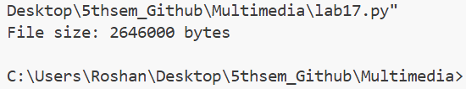

Output:
