

Lab No: 18 Date: 2082/
Title: Write a program to implement Huffman Coding for compression. Write a program to implement run length encoding using any high-level programming (C#, C++, Python).
Objective:
To implement Huffman Coding and Run Length Encoding techniques for data compression using a high-level programming language.
Source code:
import heapq
from collections import Counter
# ---------- Huffman Coding ----------
class Node:
def __init__(self, char, freq):
self.char = char
self.freq = freq
self.left = None
self.right = None
def __lt__(self, other):
return self.freq < other.freq
def build_tree(text):
frequency = Counter(text)
heap = []
for char, freq in frequency.items():
heapq.heappush(heap, Node(char, freq))
while len(heap) > 1:
left = heapq.heappop(heap)
right = heapq.heappop(heap)
merged = Node(None, left.freq + right.freq)
merged.left = left
merged.right = right
heapq.heappush(heap, merged)
return heap[0]
def generate_codes(node, code="", codes={}):
if node is None:
return
if node.char is not None:
codes[node.char] = code
generate_codes(node.left, code + "0", codes)
generate_codes(node.right, code + "1", codes)
return codes
def huffman_encoding(text):
tree = build_tree(text)
codes = generate_codes(tree)
print("\nHuffman Codes:")
for char, code in codes.items():
print(char, ":", code)
encoded = ''.join(codes[c] for c in text)
print("Encoded Text:", encoded)

# ---------- Run Length Encoding ----------
def run_length_encoding(data):
encoding = ""
i = 0
while i < len(data):
count = 1
while i + 1 < len(data) and data[i] == data[i + 1]:
i += 1
count += 1
encoding += data[i] + str(count)
i += 1
return encoding
# ---------- Main Menu ----------
print("Compression Techniques")
print("1. Huffman Coding")
print("2. Run Length Encoding")
choice = int(input("Enter your choice: "))
text = input("Enter the text: ")
if choice == 1:
huffman_encoding(text)
elif choice == 2:
compressed = run_length_encoding(text)
print("Compressed Text:", compressed)
else:
print("Invalid Choice")

Output:
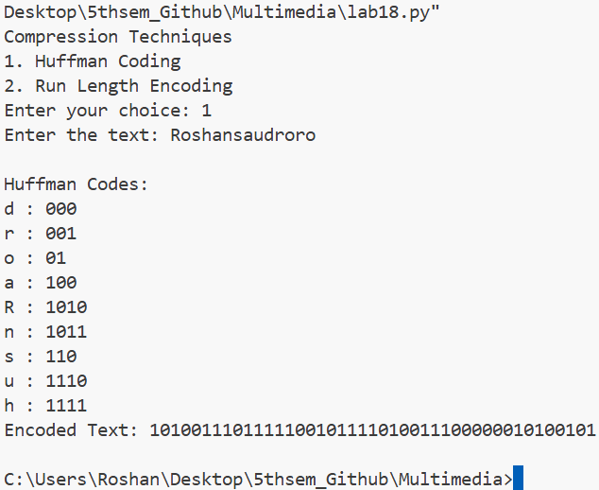
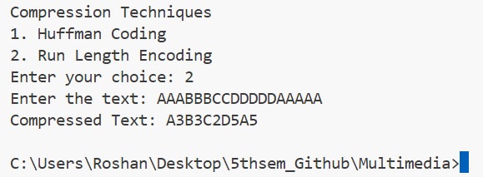
Conclusion:
The program successfully demonstrates Huffman Coding and Run Length Encoding techniques for compressing data. This experiment shows how compression algorithms help reduce storage space and improve data transmission efficiency.

