

Lab No: 19 Date: 2082/
Title: Bouncing Ball Animation
Objective:
- Create an animation to demonstrate a ball bouncing on steps.
- The animation should clearly show gravity, impact, and realistic motion
Procedure:
Step 1: Open Macromedia Flash and create a new document.
Step 2: Draw the steps on the stage using the Rectangle Tool.
Step 3: Draw a ball using the Oval Tool.
Step 4: Select the ball and press F8 to convert it into a Movie Clip symbol.
Step 5: Place the ball at the top of the steps in the first frame.
Step 6: Insert keyframes at different positions in the timeline.
Step 7: Move the ball downward to the next step in the new keyframe.
Step 8: Continue inserting keyframes and moving the ball so it appears to bounce on each step.
Step 9: Apply Motion Tween between the frames to create smooth motion.
Step 10: Press Ctrl + Enter to preview the animation.




Output:
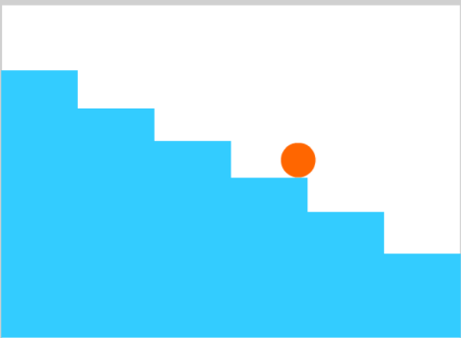



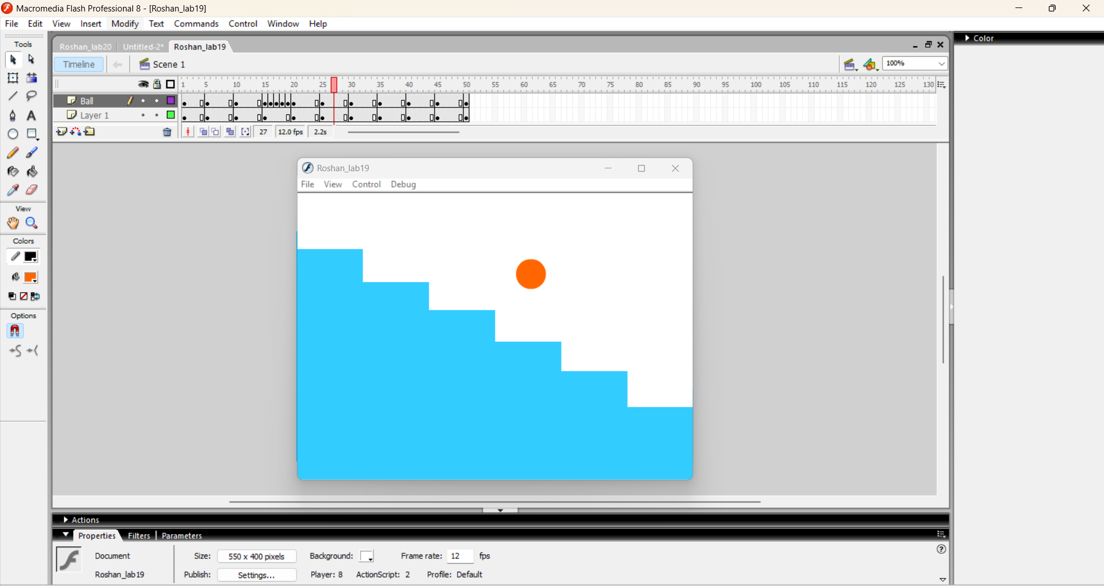

Conclusion:
Thus, the bouncing ball animation was successfully created. This experiment helped to understand motion tweening and how gravity and impact can be visually represented in animation.

