

Lab No: 20 Date: 2082/
Title: Cloud Movement Animation
Objective:
- Create an animation to simulate the movement of a cloud across the sky.
- Emphasize smooth transitions and natural motion.
Procedure:
Step 1: Open Macromedia Flash and create a new document.
Step 2: Draw the sky background using the Rectangle Tool and fill it with blue color.
Step 3: Draw a cloud using the Oval Tool or Pencil Tool.
Step 4: Select the cloud and press F8 to convert it into a Movie Clip symbol.
Step 5: Place the cloud on the left side of the stage in the first frame.
Step 6: Insert a keyframe at a later frame in the timeline.
Step 7: Move the cloud to the right side of the stage.
Step 8: Apply Motion Tween between the frames for smooth movement.
Step 9: Press Ctrl + Enter to preview the animation.



Output:




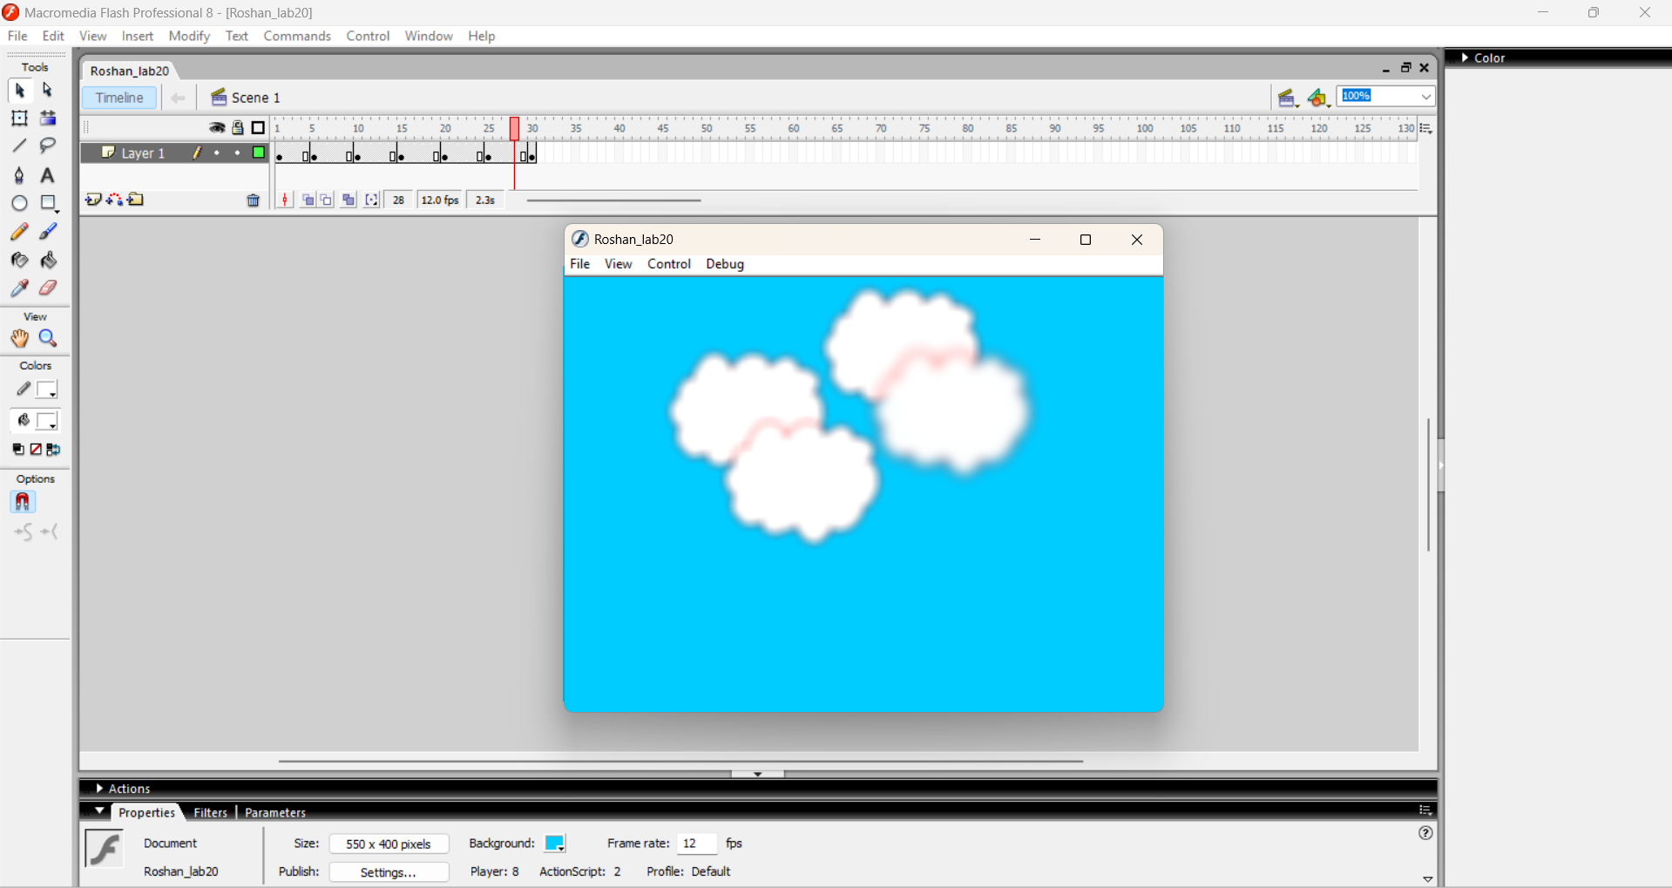

Conclusion:
Thus, the cloud movement animation was successfully created showing smooth and natural motion.

