

Lab No: 21 Date: 2082/
Title: Growing Moon Animation
Objective:
- Create an animation to represent the growth of the moon (e.g., from new moon to full moon).
- The animation should visually depict gradual size or phase changes.
Procedure:
Step 1: Open Macromedia Flash and create a new document.
Step 2: Draw a dark sky background on the stage.
Step 3: Draw the moon using the Oval Tool.
Step 4: Select the moon and press F8 to convert it into a Movie Clip symbol.
Step 5: Place a small moon in the first frame representing the new moon.
Step 6: Insert several keyframes in the timeline.
Step 7: Gradually increase the size or visible portion of the moon in each keyframe.
Step 8: Apply Motion Tween between frames for smooth transition.
Step 9: Press Ctrl + Enter to preview the animation.




Output:




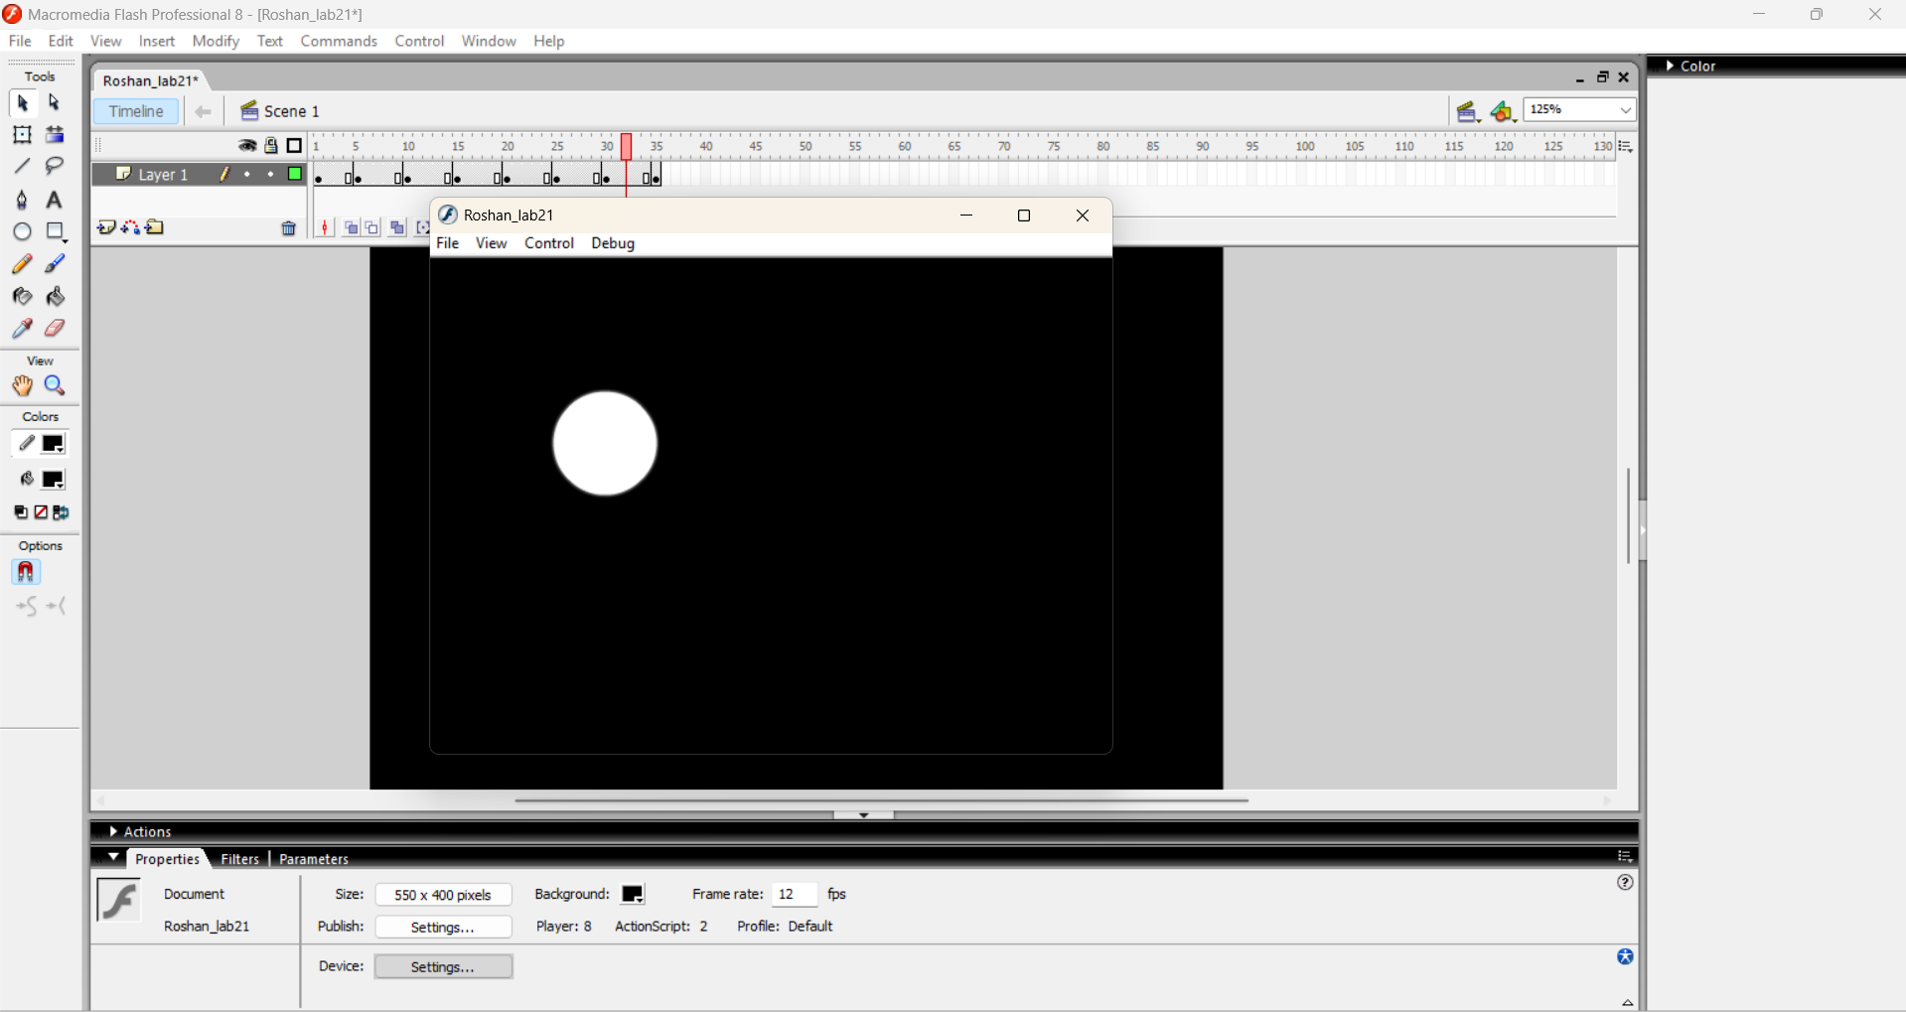

Conclusion:
Thus, the growing moon animation was successfully created, demonstrating gradual size and phase changes.

