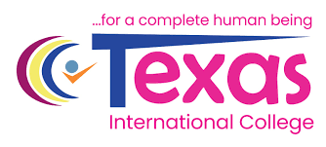

Lab No: 7 Date: 2082/
Title: Design Tools & Workflow
Objective: To Compare any two UI/UX or graphic design tools that I used in the above tasks. Discuss their features, advantages, and limitations.
Theory:
Two commonly used design tools are Figma and Adobe Photoshop.
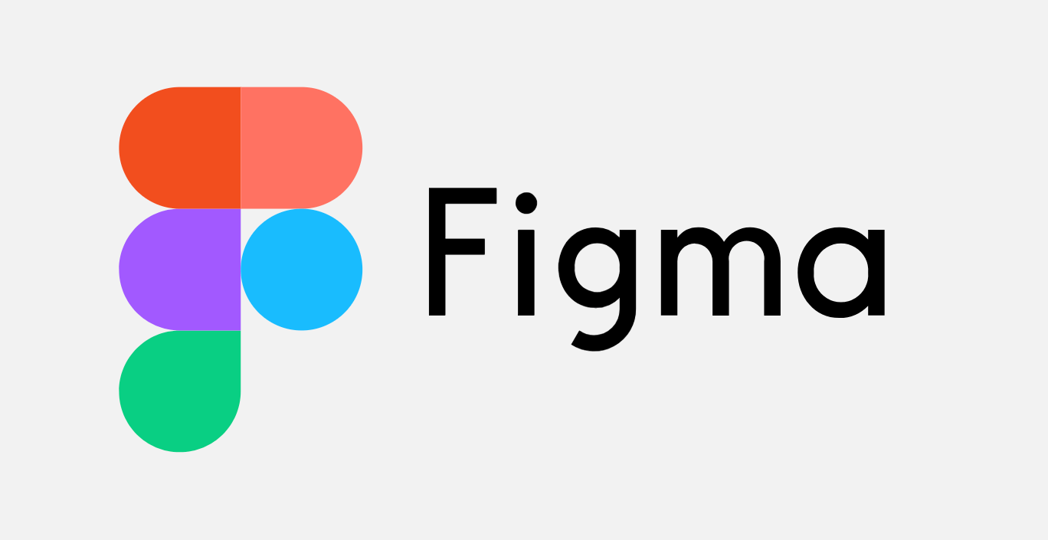
Figma is a cloud-based UI/UX design tool mainly used for interface design, wireframing, and prototyping. It allows multiple users to collaborate in real time on the same project. Designers can create components, reusable design elements, and interactive prototypes.
Features of Figma:
- Real-time collaboration
- Cloud-based access
- Prototyping and wireframing tools
- Reusable components and design systems
Advantages of Figma:
- Easy team collaboration
- Works directly in a web browser
- Simple interface and fast sharing
Limitations of Figma:
- Requires internet connection for full functionality
- Limited advanced photo editing features
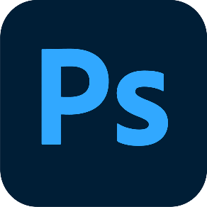
Adobe Photoshop is a powerful graphic design and image editing software widely used for creating and editing images, illustrations, and visual assets.
Features of Photoshop:
- Advanced image editing tools
- Layer-based editing system
- Wide range of filters and effects
- Support for high-quality graphics and images
Advantages of Photoshop:
- Very powerful editing capabilities
- Professional-quality graphic creation
- Supports many file formats
Limitations of Photoshop:
- Requires installation and higher system resources
- Not mainly designed for UI prototyping or collaboration
- Learning curve for beginners

Conclusion
In conclusion, Figma and Adobe Photoshop are useful design tools with different purposes. Figma is best for UI/UX design and team collaboration, while Photoshop is better for advanced graphic and image editing. The choice of tool depends on the type of design work required.

