

Lab No: 2 Date: 2082/
Title: Write a Program to encrypt and decrypt the user input message and key using Caesar cipher
The Caesar Cipher is a substitution cipher in which each letter of the plaintext is replaced by another letter that is a fixed number of positions ahead in the alphabet. This fixed number is called the key or shift value. For example, if the key is 3, then: A → D, W → Z
During encryption, the plaintext is shifted forward by the key value.
During decryption, the encrypted text (cipher text) is shifted backward by the same key value to obtain the original message.

Algorithm
Encryption
- Start
- Read the message and key
- Shift each alphabet character forward by the key
- Stop
Decryption
- Start
- Read the encrypted message and key
- Shift each alphabet character backward by the key
- Stop

Language: C
IDE: VS Code
Source code:
#include <stdio.h>
#include <ctype.h>

void encrypt(char text[], int key) {
int i;
for (i = 0; text[i] != '\0'; i++) {
char ch = text[i];
if (isupper(ch)) {
text[i] = (ch - 'A' + key) % 26 + 'A';
}
else if (islower(ch)) {
text[i] = (ch - 'a' + key) % 26 + 'a';
}
}
}

void decrypt(char text[], int key) {
int i;
for (i = 0; text[i] != '\0'; i++) {
char ch = text[i];

if (isupper(ch)) {
text[i] = (ch - 'A' - key + 26) % 26 + 'A';
}
else if (islower(ch)) {
text[i] = (ch - 'a' - key + 26) % 26 + 'a';
}
}
}

int main() {
char message[100];
int key1, key2;

printf("Enter the message: ");
fgets(message, sizeof(message), stdin);

printf("Enter the key to encrypt: ");
scanf("%d", &key1);
encrypt(message, key1);
printf("Encrypted Message: %s", message);

int i=0;
while(i!=3){
printf("\nEnter the key to decrypt: ");
scanf("%d", &key2);
if(key1==key2){
decrypt(message, key2);
printf("Decrypted Message: %s", message);
return 0;
}
else{
printf("Sorry, Key doesn't match");
i++;
}
}
return 0;
}

Output:
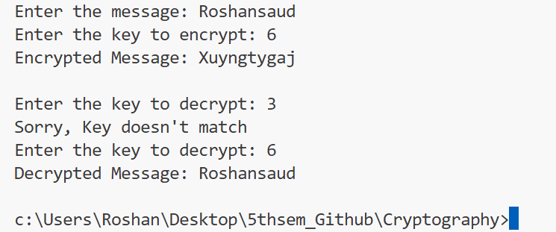

Conclusion:
The Caesar Cipher program performs both encryption and decryption using a single key. This experiment demonstrates a simple method of securing information and helps in understanding basic encryption techniques.

