

Lab No: 3 Date: 2082/
Title: Write a Program to encrypt and decrypt the user input message and key using Play fair cipher
One of the classical encryption techniques is the Playfair Cipher, which encrypts data using a 5×5 matrix of letters formed with the help of a keyword. The Playfair cipher works on pairs of letters (digraphs) instead of single letters, making it more secure than simple substitution ciphers.
Encryption Algorithm
- Read the plain text and key from the user.
- Remove duplicate letters from the key and create a 5×5 matrix (I and J combined).
- Fill remaining alphabet letters in the matrix.
- Split the plain text into letter pairs (add X if needed).
- Encrypt each pair using Playfair rules:
Same row → next letter, Same column → below letter, Rectangle → opposite corners
- Display the encrypted text and stop.
Decryption Algorithm
- Read the encrypted text and use the same key matrix.
- Divide the cipher text into letter pairs.
- Decrypt each pair using reverse Playfair rules: Same row → previous letter, Same column → above letter, Rectangle → opposite corners
- Display the decrypted message.

Language: C
IDE: VS Code
Source code:
#include <stdio.h>
#include <string.h>
#include <ctype.h>

char matrix[5][5];
void generateMatrix(char key[]) {
int used[26] = {0};
int i, j, k = 0;

for (i = 0; key[i]; i++) {
if (key[i] == 'J') key[i] = 'I';
if (!used[key[i] - 'A']) {
matrix[k / 5][k % 5] = key[i];
used[key[i] - 'A'] = 1;
k++;
}
}

for (i = 0; i < 26; i++) {
if (i + 'A' == 'J') continue;
if (!used[i]) {
matrix[k / 5][k % 5] = i + 'A';
k++;
}
}
}

void printMatrix() {
int i, j;
printf("\nPlayfair Matrix:\n");
for (i = 0; i < 5; i++) {
for (j = 0; j < 5; j++)
printf("%c ", matrix[i][j]);
printf("\n");
}
}

void findPosition(char ch, int *row, int *col) {
int i, j;
if (ch == 'J') ch = 'I';
for (i = 0; i < 5; i++)
for (j = 0; j < 5; j++)
if (matrix[i][j] == ch) {
*row = i;
*col = j;
}
}

void playfair(char text[], int mode) {
int i, r1, c1, r2, c2;
for (i = 0; i < strlen(text); i += 2) {
findPosition(text[i], &r1, &c1);
findPosition(text[i + 1], &r2, &c2);

if (r1 == r2) {
text[i] = matrix[r1][(c1 + mode + 5) % 5];
text[i + 1] = matrix[r2][(c2 + mode + 5) % 5];
} else if (c1 == c2) {
text[i] = matrix[(r1 + mode + 5) % 5][c1];
text[i + 1] = matrix[(r2 + mode + 5) % 5][c2];
} else {
text[i] = matrix[r1][c2];
text[i + 1] = matrix[r2][c1];
}
}
}

int main() {
char key1[100],key2[100], message[100];
int i,j, len;

printf("Enter key: ");
scanf("%s", key1);

printf("Enter message: ");
scanf("%s", message);

for (i = 0; key1[i]; i++) key1[i] = toupper(key1[i]);
for (i = 0; message[i]; i++) message[i] = toupper(message[i]);

len = strlen(message);
for (i = 0; i < len; i += 2) {
if (message[i] == message[i + 1]) {
for ( j = len; j > i + 1; j--)
message[j] = message[j - 1];
message[i + 1] = 'X';
len++;
}
}
if (len % 2 != 0) {
message[len++] = 'X';
message[len] = '\0';
}

generateMatrix(key1);
printMatrix();
playfair(message, 1);
printf("\nEncrypted Text: %s", message);
i=0;
while(i!=3){
printf("\nEnter key: ");
scanf("%s", key2);

for (j = 0; key2[j]; j++)
key2[j] = toupper(key2[j]);

if(strcmp(key1,key2)==0){
playfair(message, -1);
printf("Decrypted Text: %s\n", message);
return 0;
}
else{
printf("\nPlease, enter correct key.");
i++;
}
}

return 0;
}

Output:
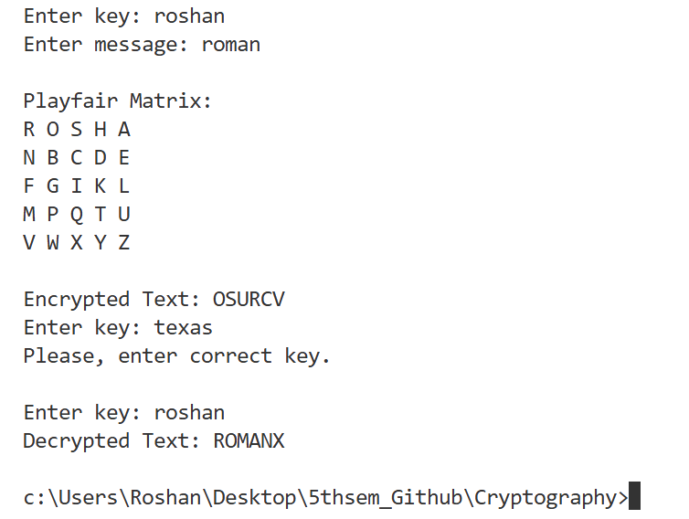

Conclusion:
Thus, the Playfair Cipher encryption and decryption program was successfully implemented. The program securely converts the plain text into cipher text using a key and retrieves the original message through decryption. This experiment helps in understanding the basics of classical cryptography and secure data communication.

