

Lab No: 4 Date: 2082/
Title: Write a Program to encrypt and decrypt the user input message and rails using Rail-fence cipher
The Rail Fence Cipher is a classical transposition cipher used in cryptography to encrypt messages by rearranging their letters. In this method, the plain text is written in a zig-zag pattern across multiple rows (called rails), like the rails of a fence. Once the text is arranged, the encrypted message is obtained by reading the letters row by row.
Algorithm
Encryption Algorithm
- Read the plain text message from the user.
- Read the number of rails.
- Arrange the characters in a zig-zag pattern across the given rails.
- Read the characters row-wise to generate the encrypted text.
- Display the encrypted message.
Decryption Algorithm
- Read the encrypted text and number of rails.
- Mark the zig-zag pattern based on the rails.
- Fill the encrypted text row-wise into the pattern.
- Read the characters in zig-zag order to obtain the original message.
- Display the decrypted message.

Language: C
IDE: VS Code
Source code:
#include <stdio.h>
#include <string.h>

void printMatrix(char mat[][100], int rail, int len) {
int i, j;

printf("\nRail Fence Matrix:\n");
for (j = 0; j < len; j++) printf("----");
printf("-\n");

for (i = 0; i < rail; i++) {
printf("|");
for (j = 0; j < len; j++) {
if (mat[i][j] == '\0')
printf(" |");
else
printf(" %c |", mat[i][j]);
}
printf("\n");
for (j = 0; j < len; j++) printf("----");
printf("-\n");
}
}

void encrypt(char text[], int rail, char cipher[]) {
char mat[rail][100];
int i, j, k = 0;
int row = 0, dir = 1;
int len = strlen(text);

for (i = 0; i < rail; i++)
for (j = 0; j < 100; j++)
mat[i][j] = '\0';

for (i = 0; i < len; i++) {
mat[row][i] = text[i];
row += dir;
if (row == rail - 1 || row == 0)
dir = -dir;
}

int col = len;
while (row != 0 && row != rail - 1) {
mat[row][col++] = 'X';
row += dir;
}

int totalCols = col;

printMatrix(mat, rail, totalCols);

for (i = 0; i < rail; i++)
for (j = 0; j < totalCols; j++)
if (mat[i][j] != '\0')
cipher[k++] = mat[i][j];

cipher[k] = '\0';
}

void decrypt(char cipher[], int rail, char plain[]) {
char mat[rail][100];
int i, j, k = 0;
int row = 0, dir = 1;
int len = strlen(cipher);

for (i = 0; i < rail; i++)
for (j = 0; j < len; j++)
mat[i][j] = '\0';

for (i = 0; i < len; i++) {
mat[row][i] = '*';
row += dir;
if (row == rail - 1 || row == 0)
dir = -dir;
}

for (i = 0; i < rail; i++)
for (j = 0; j < len; j++)
if (mat[i][j] == '*')
mat[i][j] = cipher[k++];

row = 0; dir = 1;
for (i = 0; i < len; i++) {
plain[i] = mat[row][i];
row += dir;
if (row == rail - 1 || row == 0)
dir = -dir;
}
plain[i] = '\0';
}

int main() {
char text[100], cipher[100], plain[100];
int rail;

printf("Enter message: ");
scanf("%s", text);

printf("Enter number of rails: ");
scanf("%d", &rail);

encrypt(text, rail, cipher);
printf("\nEncrypted Text: %s\n", cipher);

decrypt(cipher, rail, plain);
printf("Decrypted Text: %s\n", plain);

return 0;
}

Output:
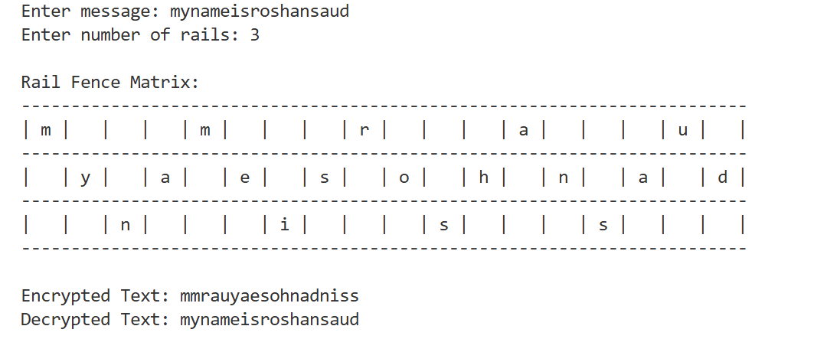
Conclusion:
Thus, the Rail Fence cipher encryption and decryption program was successfully implemented. The program correctly converts the plain text into cipher text and retrieves the original message using the specified number of rails. This experiment provides a clear understanding of classical transposition ciphers and secure message transmission.

