

Lab No: 6 Date: 2082/
Title: Write a program to convert the user input message into state array
The Advanced Encryption Standard (AES) is a symmetric block cipher that operates on a fixed block size of 128 bits (16 bytes). AES represents the plaintext internally as a 4 × 4 state array of bytes, known as the State matrix. The input message is mapped into the state array in a column-wise manner, as defined by the AES standard (FIPS-197). This structure is mandatory and is required for performing AES operations such as SubBytes, ShiftRows, MixColumns, and AddRoundKey.
Algorithm:
- Read a 16-character input message from the user.
- Initialize a 4 × 4 state array.
- Fill the state array column-wise using the input message.
- Display the contents of the state array in matrix form.

Language: C
IDE: VS Code
Source code:
#include <stdio.h>
#include <string.h>

int main() {
char msg[100];
char state[4][4][3]; // 2 chars + '\0'
int i, j, k = 0;
printf("Enter message: ");
scanf("%s", msg);
// Fill the state array column-wise
for (j = 0; j < 4; j++) {
for (i = 0; i < 4; i++) {
if (k + 1 < strlen(msg)) {
state[i][j][0] = msg[k++];
state[i][j][1] = msg[k++];
} else {
state[i][j][0] = 'X';
state[i][j][1] = 'X';
}
state[i][j][2] = '\0';
}
}

// Display the matrix using pipes
printf("\nState Matrix:\n");
for (i = 0; i < 4; i++) {
printf("| ");
for (j = 0; j < 4; j++) {
printf("%s | ", state[i][j]);
}
printf("\n");
}
return 0;
}

Output:
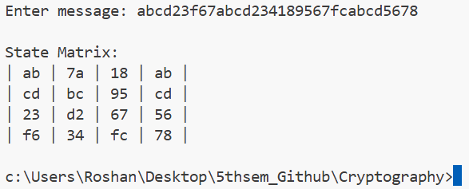
Conclusion:
Thus, the program successfully converts the input plaintext message into a 4 × 4 AES state array following the standard column-wise mapping. This experiment provides a clear understanding of the internal data representation used in AES and highlights the importance of standard-defined structures in cryptographic algorithms.

