

Lab No: 7 Date: 2082/
Title: Write a program to test the prime numbers using Fermat’s theorem.
A prime number is a number greater than 1 that is divisible only by 1 and itself. Fermat’s Little Theorem, proposed by Pierre de Fermat, states that if p is a prime number and a is any integer such that 1 < a < p, then: a^(p−1) ≡ 1 (mod p). This property can be used to test whether a number is prime. If the condition fails, the number is not prime. If it satisfies the condition, the number is probably prime.
Algorithm:
- Start.
- Read an integer n from the user.
- If n ≤ 1, print “Not Prime” and stop.
- Choose an integer a such that 1 < a < n.
- Compute result = a^(n−1) mod n using modular exponentiation.
- If result ≠ 1, print “n is Not Prime”.
- Else print “n is Probably Prime”.
- Stop.

Language: C
IDE: VS Code
Source code:
#include <stdio.h>
#include <stdlib.h>

// Simple function to calculate (a^(p-1)) % n
long long simple_power(long long base, long long power, long long n) {
long long result = 1;
long long i;
for (i = 0; i < power; i++) {
result = (result * base) % n;
}
return result;
}

// Fermat Test
int fermat_test(long long n, long long a) {
if (n <= 1)
return 0;
int i;
if (simple_power(a, n - 1, n) != 1)
return 0;
return 1; // Probably prime
}

int main() {
long long n,a;
printf("Enter a number: ");
scanf("%lld", &n);
printf("Enter a base: ");
scanf("%lld", &a);
if (fermat_test(n,a)){
printf("Since %lld^(%lld-1) = 1(mod %d) is true\n",a,n,n);
printf("Hence, %lld is probably prime.\n", n);
}
else{
printf("Since %lld^(%lld-1) = 1(mod %d) is not true\n",a,n,n);
printf("Hence, %lld is not prime.\n", n);
}
return 0;
}

Output:
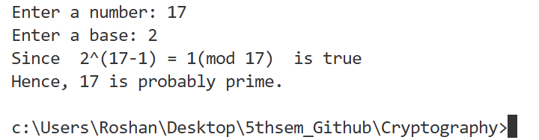
Conclusion:
Thus, the program tests whether a number is prime using Fermat’s Little Theorem. It provides a simple and fast method for primality testing, though it may not be fully accurate for some special composite numbers.

