KOUSTAV DAS | 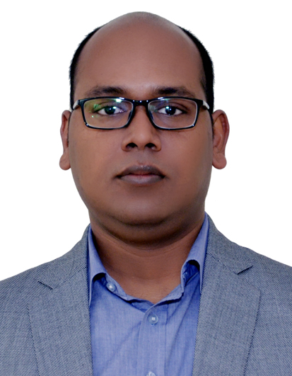
Koustav has over 10 years of experience in working with start-up ecosystem in India. He has mentored several entrepreneurs and helped them in building their business plans. He is passionate about working with entrepreneurs and shares their excitement for making a start-up successful.

He has been instrumental in designing the operating models for different business incubators and has rich experience in execution of the models as well.

Having worked with organizations like STEP & Venture Lab of Thapar Institute of Engineering & Technology, Indian Institute of Corporate Affairs (Under Ministry of Corporate affairs), Artificial Limbs Manufacturing Corporation of India (GOI Undertaking), IIM Lucknow & Confederation of Indian Industry Koustav understands linkages between all 7 key stakeholders (start-ups, incubators, corporate, investors, mentors, Government and research institutions) of startup ecosystem.

Currently Koustav is working as CEO of NITF Bhubaneswar.

