**Solutions**

***PART 1 [50 marks]***

*Translate the following statements into Python expressions in IDLE:*

***Note down the response to each. Do they differ from what you would expect?***

**[Each question carries 5 marks]**

1. The perimeter of a rectangle with length 9 & width 6

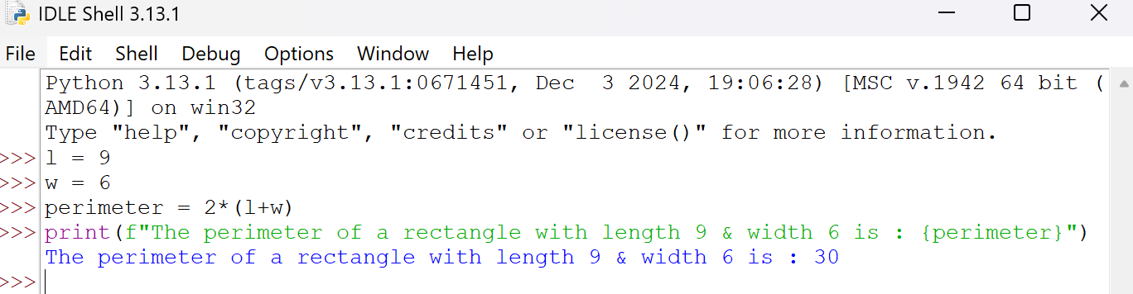

1. Python is great, it’s wild!

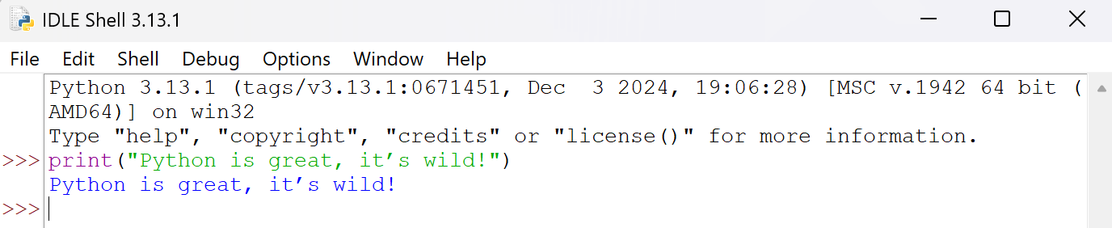

1. 2 to the 10thpower

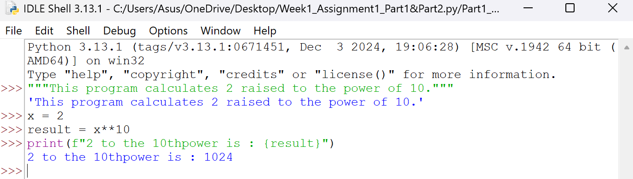

1. 7 factorial minus 5 factorial

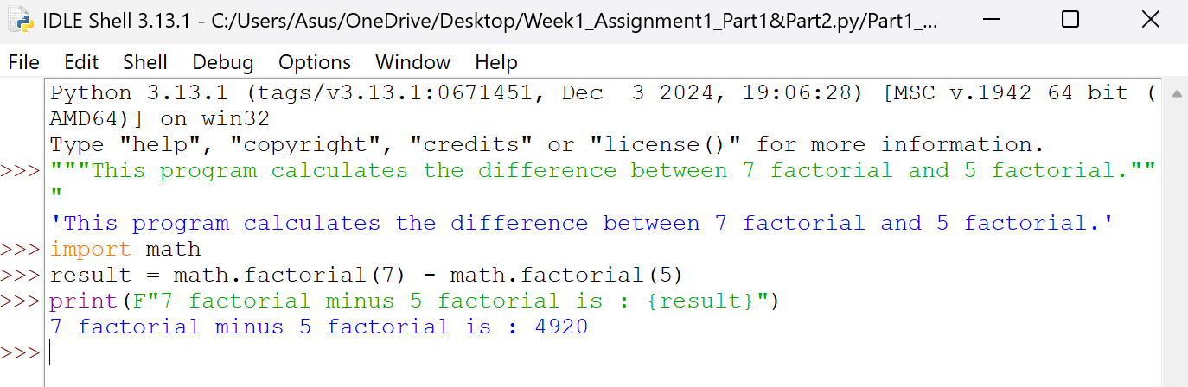

1. Your forename multiplied by 5

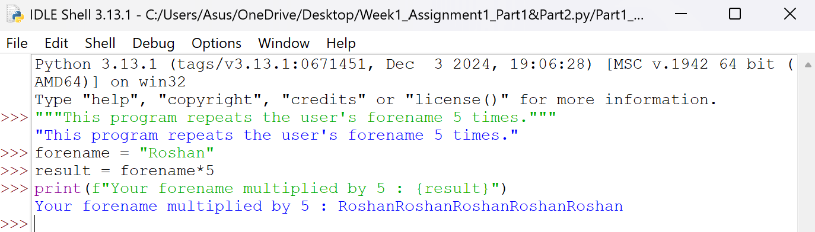

1. Your name left justified 15 spaces

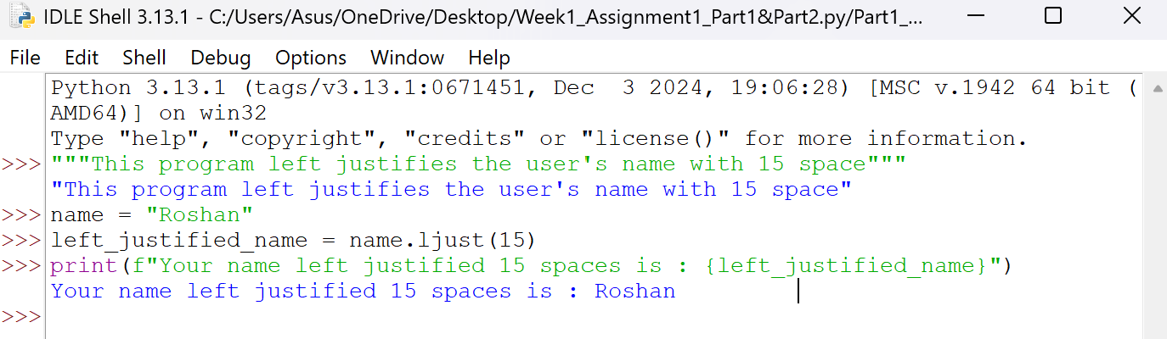

7. PI to 5 decimal places

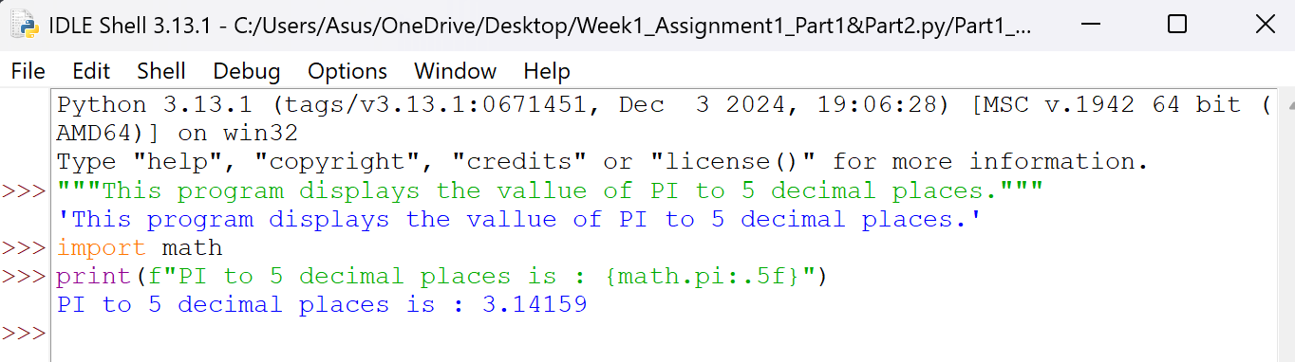

8. 200 modulus 12

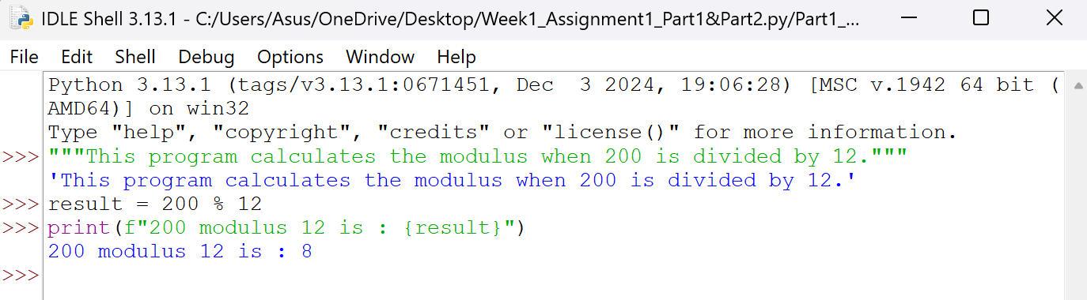

9. 7.2 as an integer value

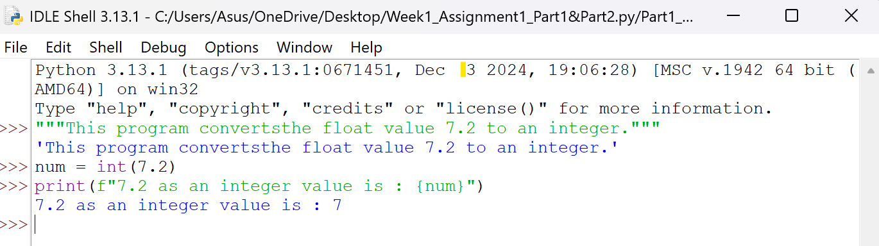

10. The Unicode encoding for your name

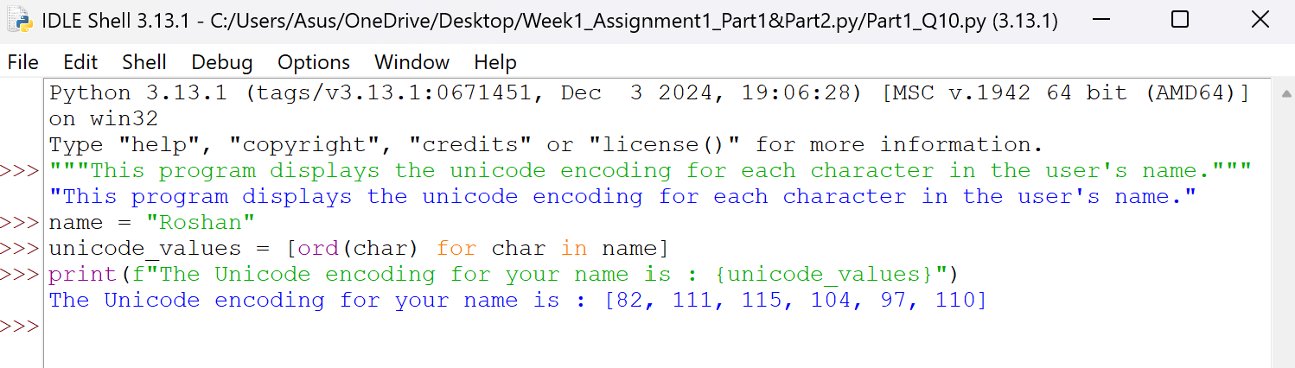

**PART 2 [50 marks]**

1. Write a program to take a number input from the user and display whether the number is even or odd. **[5]**

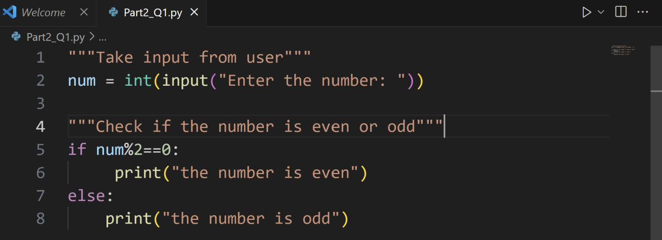

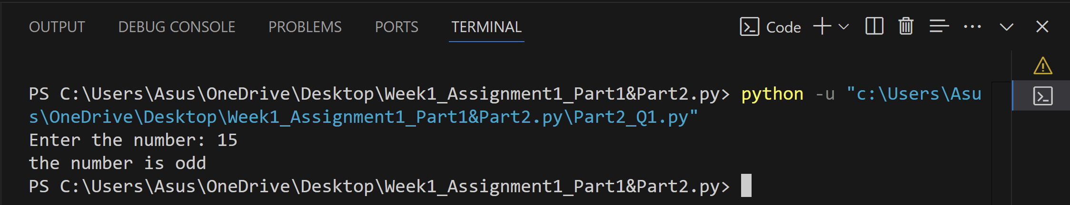

2. Write a program that prompts the user for two integer values and displays the results of the first number divided by the second, with exactly two decimal places displayed. **[5]**

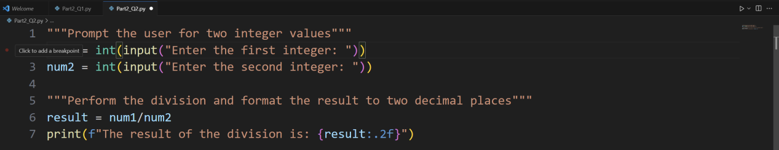

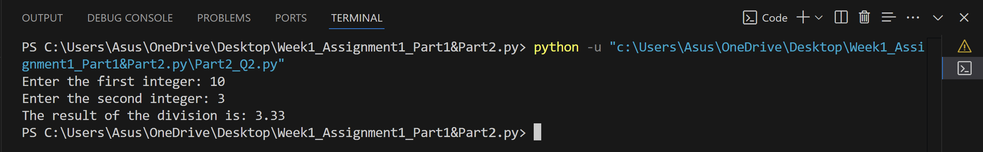

3. Write a program that will convert Celsius value to Fahrenheit.**[5]**

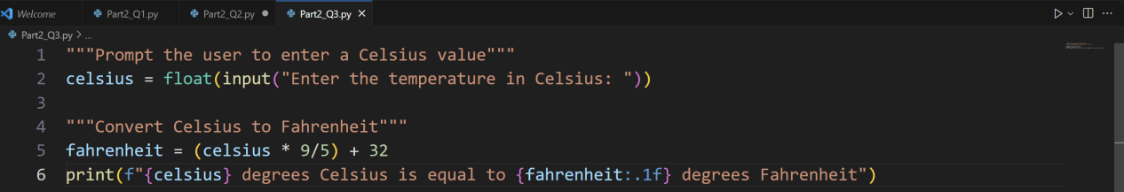

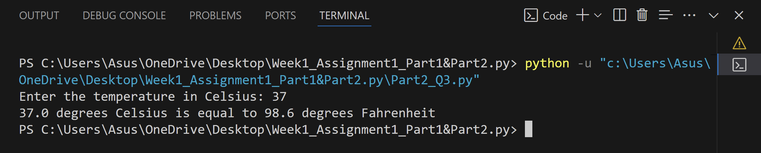

### Write a program to find the Euclidean distance between two coordinates. Take both the coordinates from the user as input.[5]

### 

### 

### Write a program to find the simple interest when the value of principle, rate of interest and time period is provided by the user.[5]

### 

### 

1. Write a Python program to find those numbers which are divisible by 7 and multiple of 5, between 1500 and 2000 (both included). **[5]**

### 

### 

7. Write a Python program that accepts a string and calculates the number of digits and letters.**[5]**

### 

### 

**8.** Write a program to create a number guessing game for the user. The program should ask the user to input a number. The program specifications are as mentioned below.

1. The program should generate a random number for the answer.**[2.5]**
2. The program should prompt the user for a number input.**[2.5]**
3. The program should provide the feedback to the user after each guesses (e.g. “Too high”, “Too low” or “Correct number”).**[2.5]**
4. The program should check the user input for 5 times and allow the users to guess for at most 5 times if their input don’t match the answer number.**[2.5]**
5. If the user is not able to guess the answer within 5 times, the program should display “Game Over” message and exit. **[5]**

