**Solutions**

1. Write a function that accepts a string and calculate the number of upper case letters and lower case letters. [10]

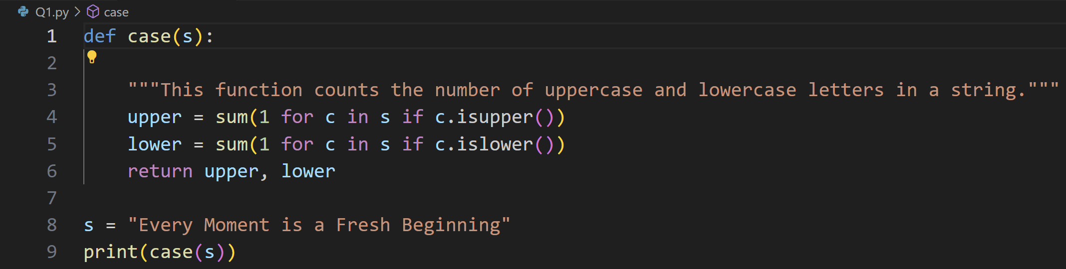



### 2. Write a function to check whether the given number is prime or not.[10]

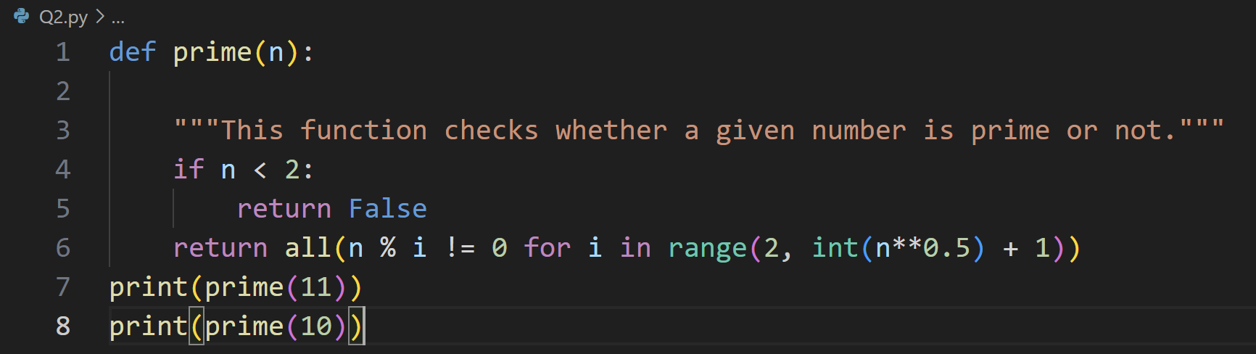

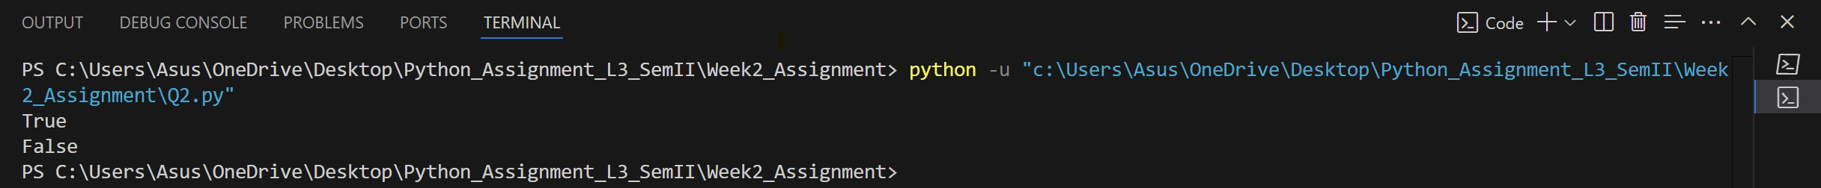

### 3. Write a function to check whether the given number is Armstrong or not.[10]

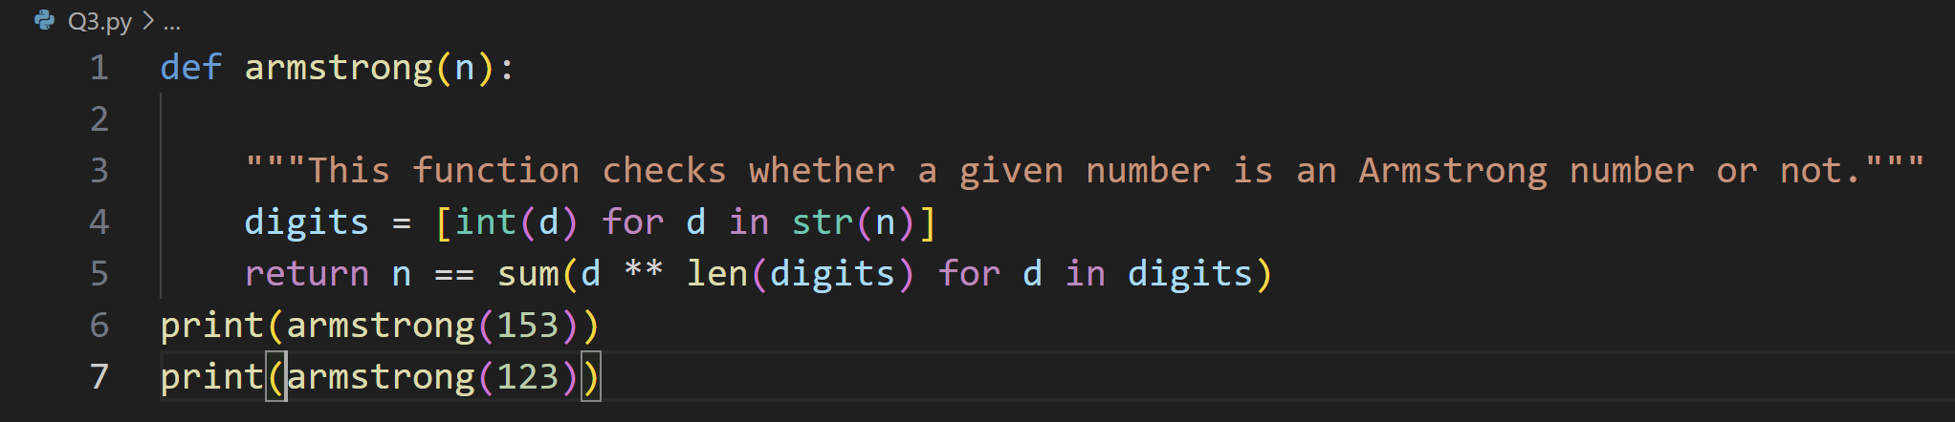

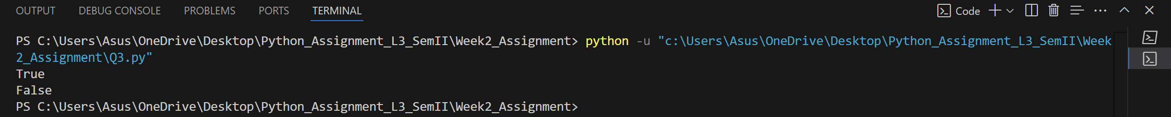

1. Write a function to accept a list of names and return the sorted order of names back.**[10]**

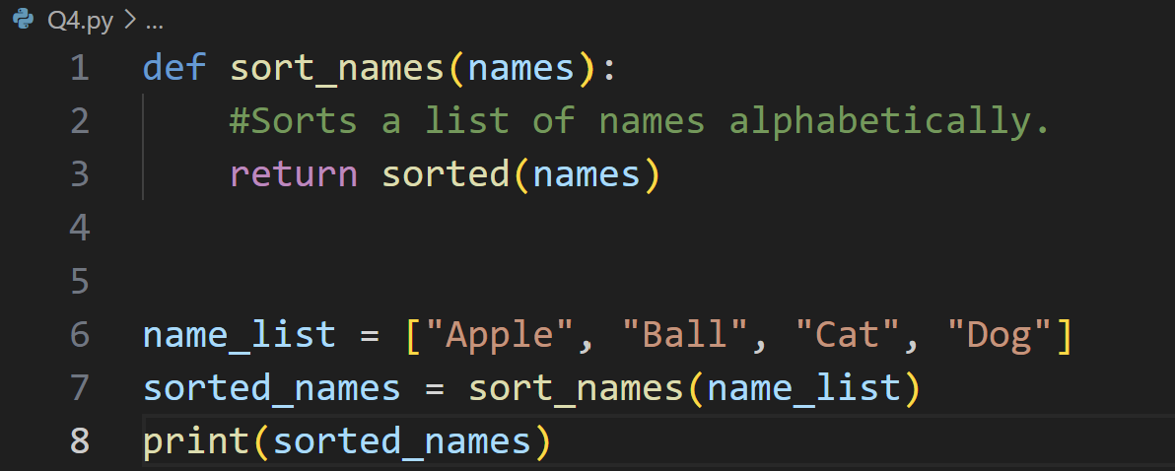



5. Create a program called calculator with functions to perform the following arithmetic calculations, each should take two decimal parameters and return the result of the arithmetic calculation in question.[**7**]

A. Addition

B. Subtraction

C. Multiplication

D. Division

E. Truncated division

F.Modulus

G. Exponentiation

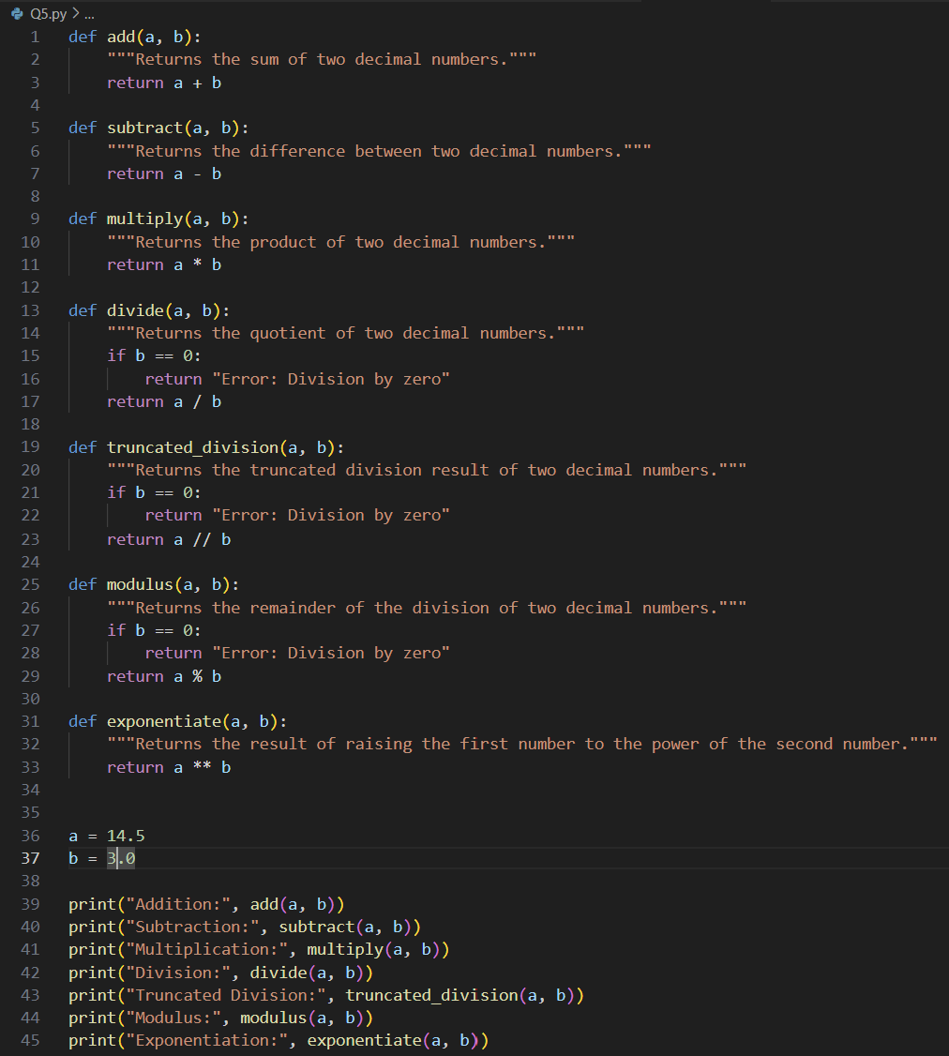

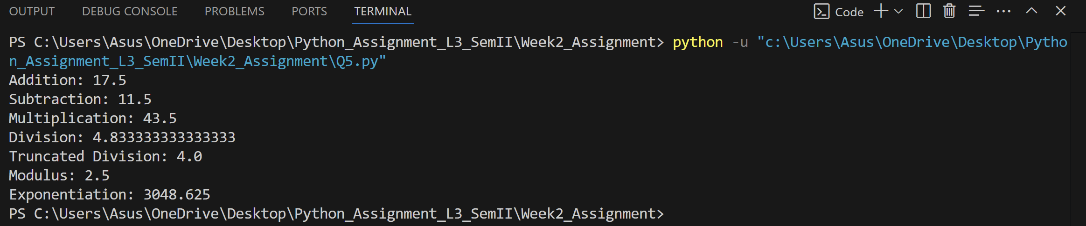

6. Write a program that prompts the user to enter a list of names and store them in a list. The program should display how many times the letter 'a appears within the list. **[10]**

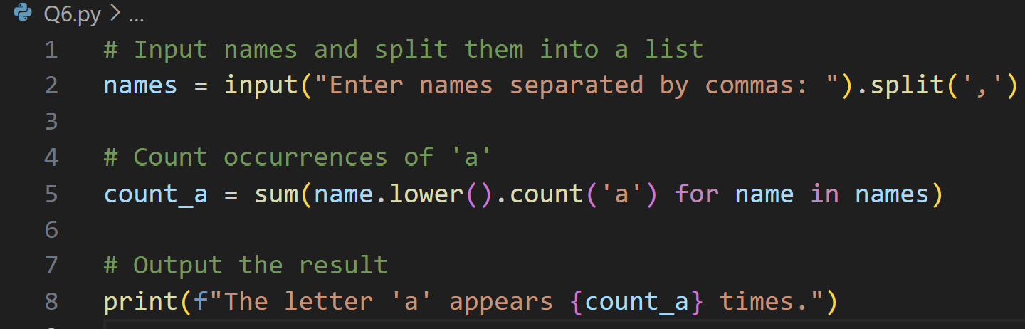

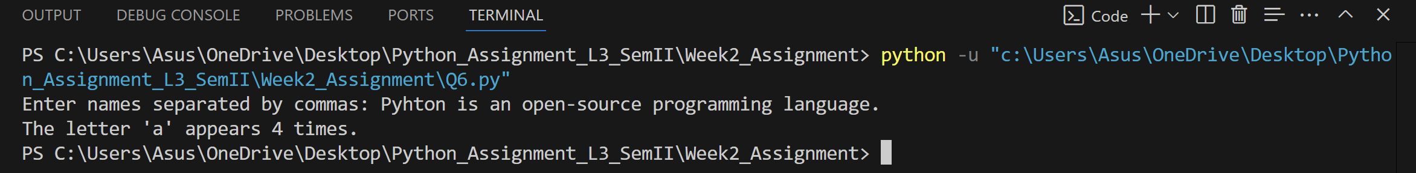

1. Write a program that prompts the user to enter integer values to populate two lists, then prints messages to determine the following: **[3]**

(a) Whether the lists are of the same length.

(b) Whether the elements in each list sum to the same value.

(c) Whether there are any values that occur in both lists.

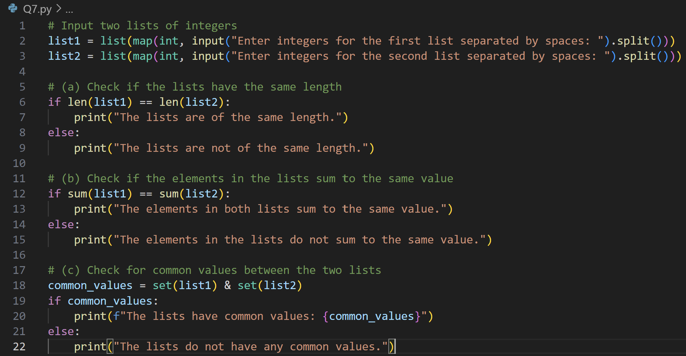

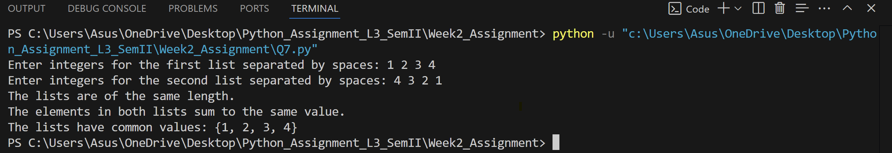

1. Write a function called add_daily_temp that is given a (possibly empty) dictionary meant to hold the average daily temperature for each day of the week, a temperature value, and the day of the week for the recorded temperature. The function should then add the temperature to the dictionary only if it does not already contain a temperature for that day. The function should return the resulting dictionary, whether it is updated or not.**[10]**

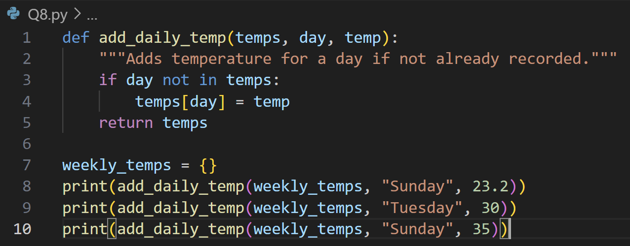

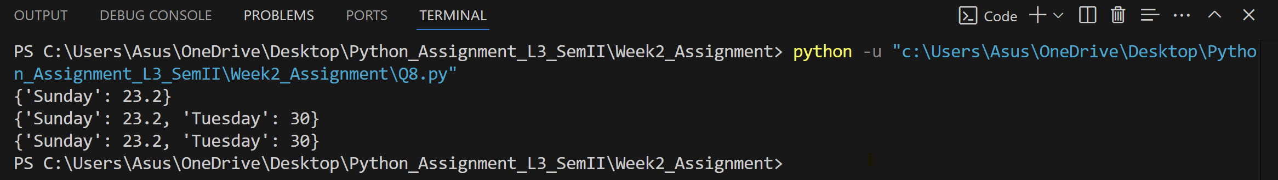

1. Write a function named get_daily_temps that prompts the user for the average temperature for each day of the week and returns a dictionary containing the information the user entered. **[5]**

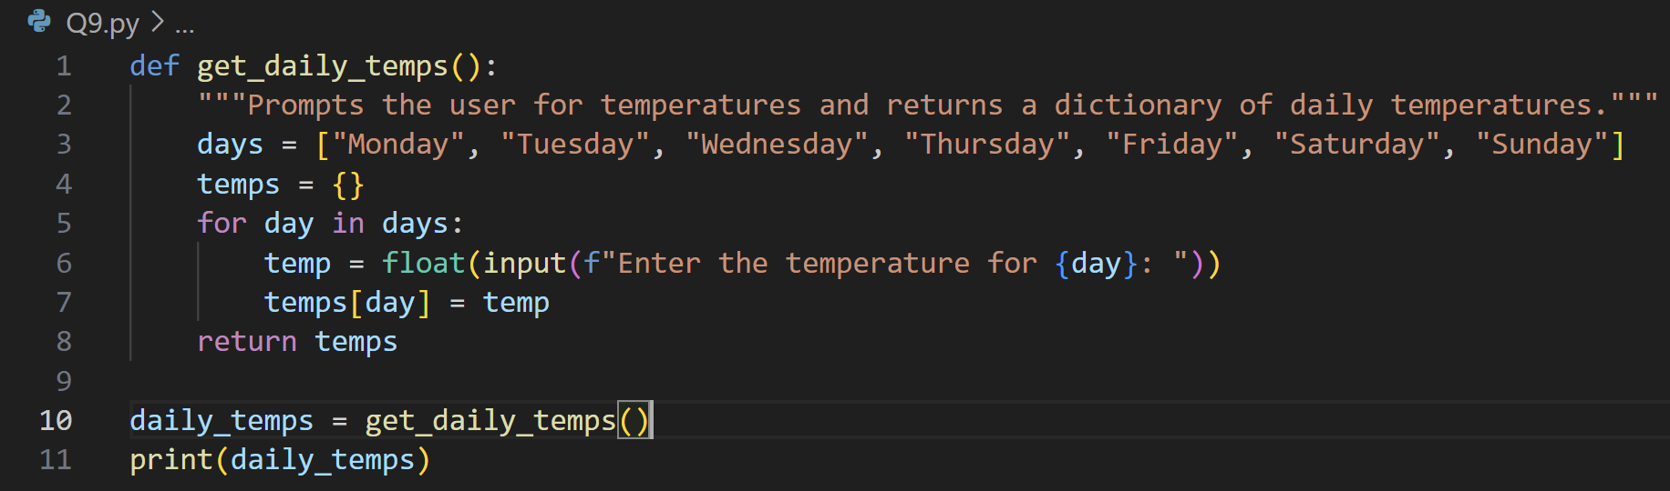

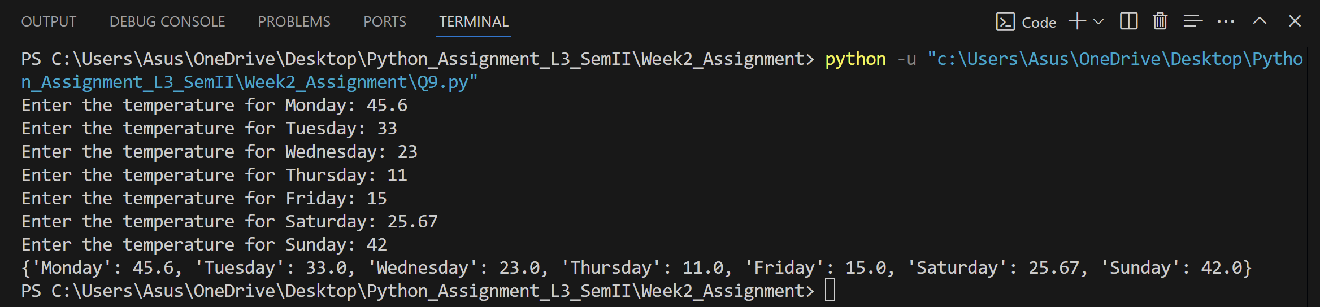

1. Create three dictionaries: **[7]**

dic1 = {1:10, 2:20}

dic2 = {3:30, 4:40}

dic3 = {5:50, 6:60}

(a) Write code to concatenate these dictionaries to create a new one. Create a variable called nums to store the resulting dictionary.

(b) Write code to add a new key/value pair to the dictionary nums: (7, 70)

(c) Write code to update the value of the item with key 3 in nums to 80

(d) Write code to remove the third item from dictionary nums.

(e) Write code to sum all the items in the dictionary nums

(f) Write code to multiply all the items in the dictionary nums

(g) Write code to retrieve the maximum and minimum values in nums.

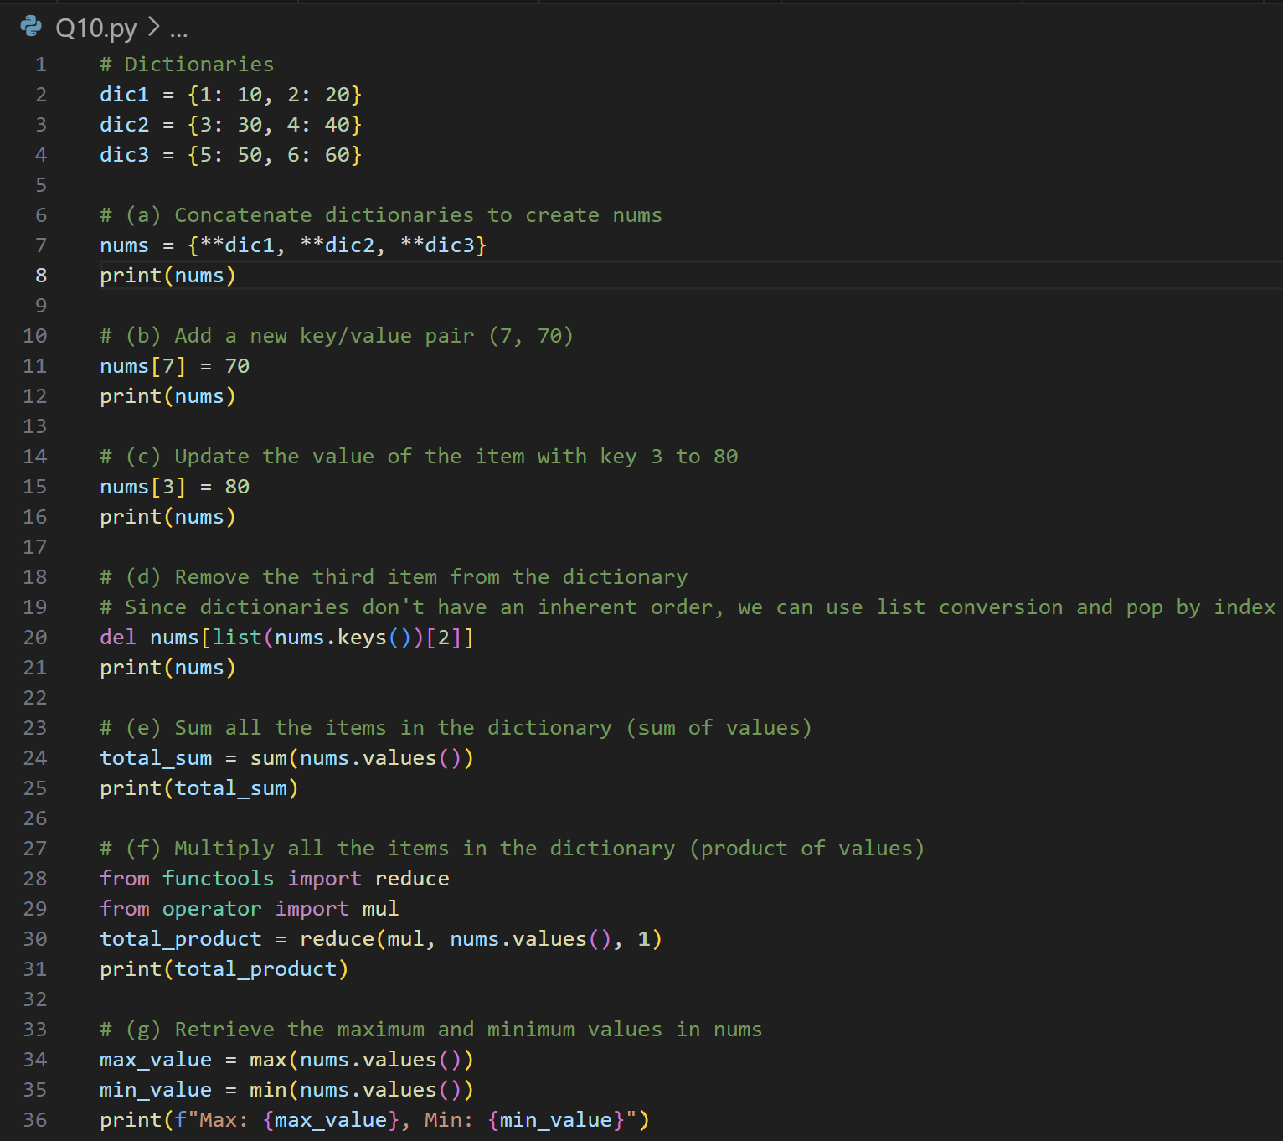

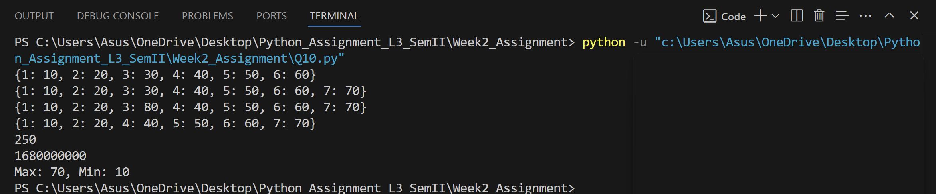

1. Create two sets: **[5]**

set1 = {20, 40, 60}

set2 = {10, 20, 30, 40, 50, 60}

(a) Write code to perform a union of these sets. Print the length of the resulting set.

(b) Write code to perform an intersection of set1 and set2.

(c) Write code to compute the symmetric difference between set1 and set2

(d) Write code to add the value 40 to set1, did the set change?

(e) Write code to remove value 20 from set2.

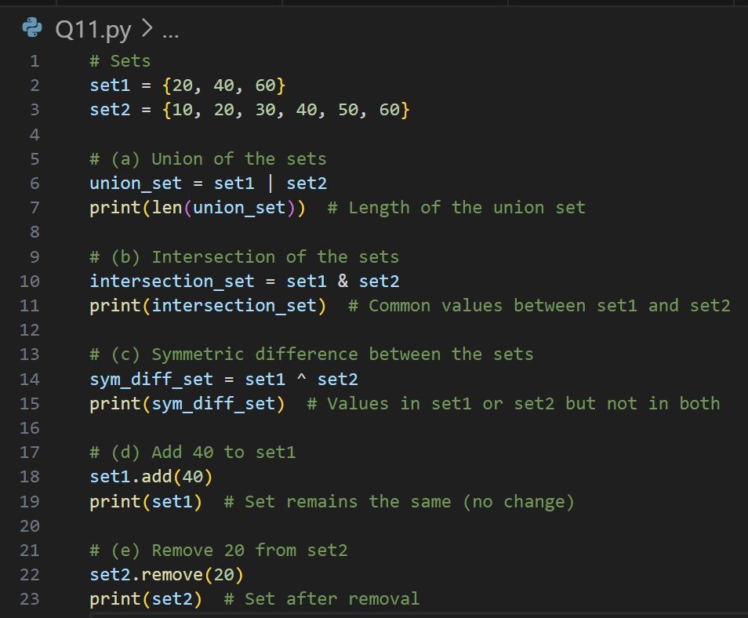

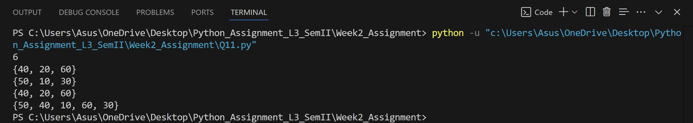

1. Create a function called word_intersection that prompts the user for two English words, and displays which letters the two words have in common. **[3]**

