**Solutions:**

1. Write a program to count the number of lines, words, and characters in a text file.**[10 marks]**

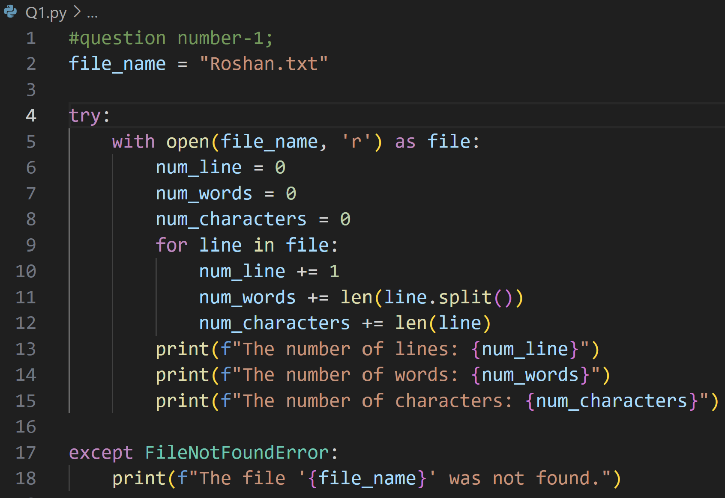

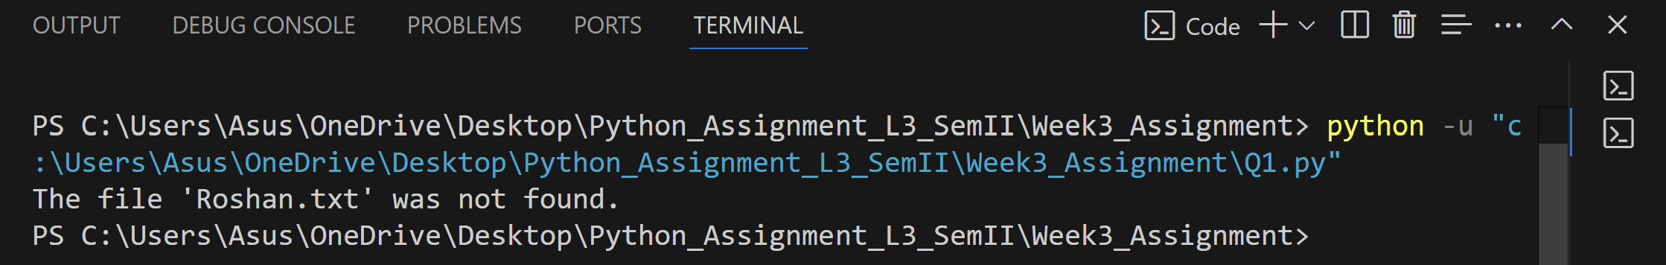

2. Write a program to copy the contents of one file to another.**[10 marks]**

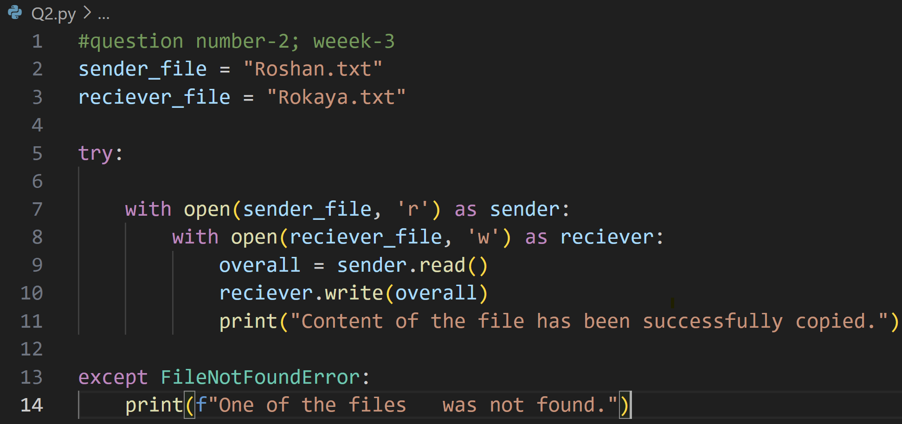

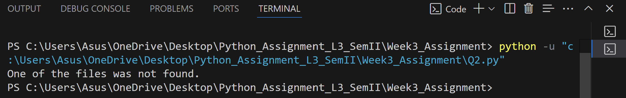

3. Write a program to find and replace a specific word in a file with another word.**[10 marks]**

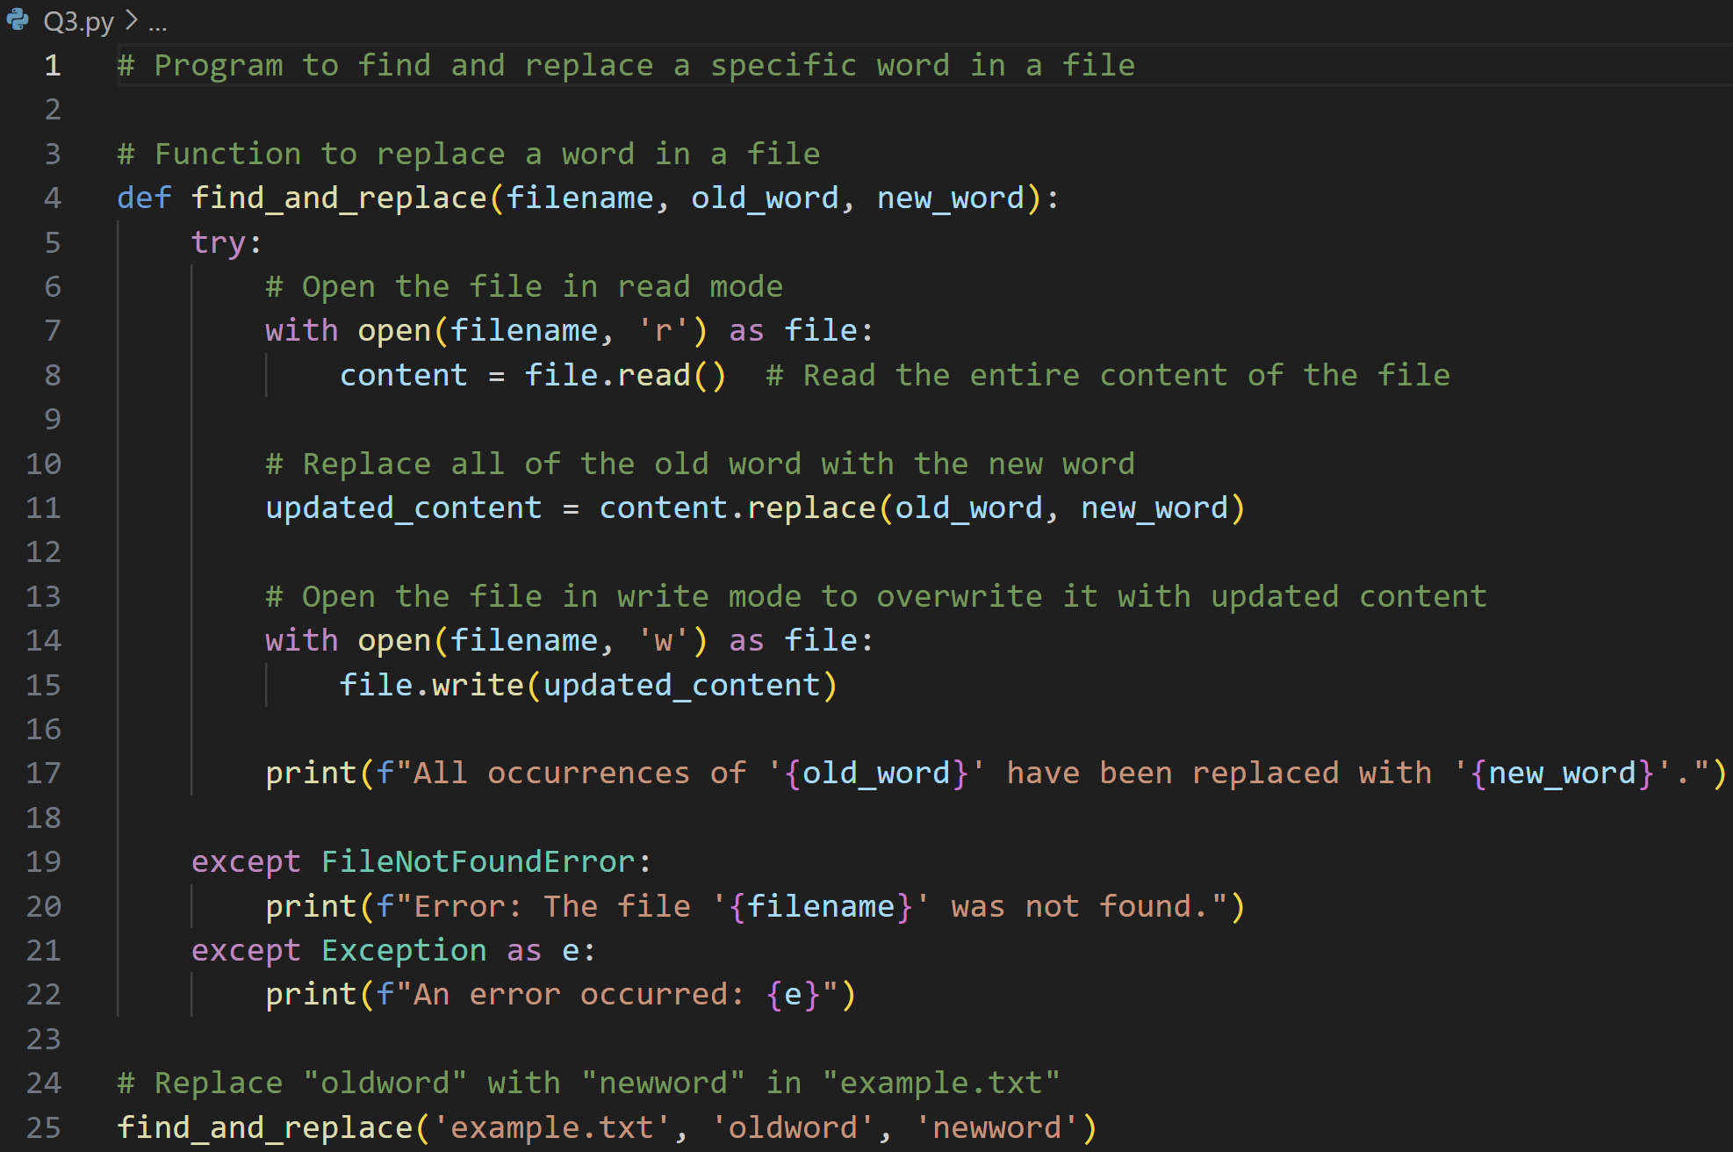

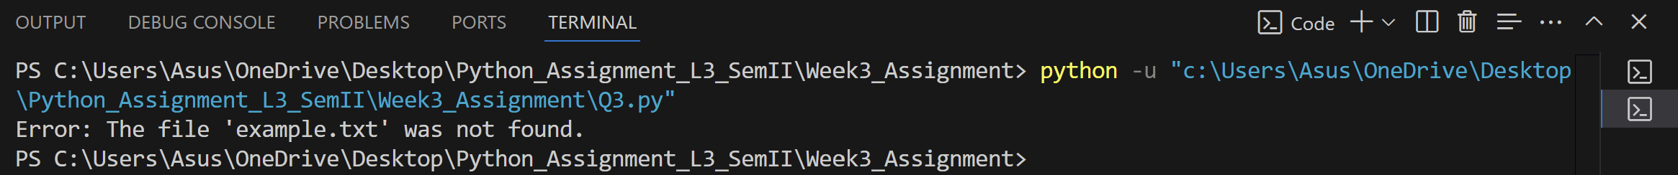

4. Implement a program to read a CSV file and display its contents in a tabular format.**[10 marks]**

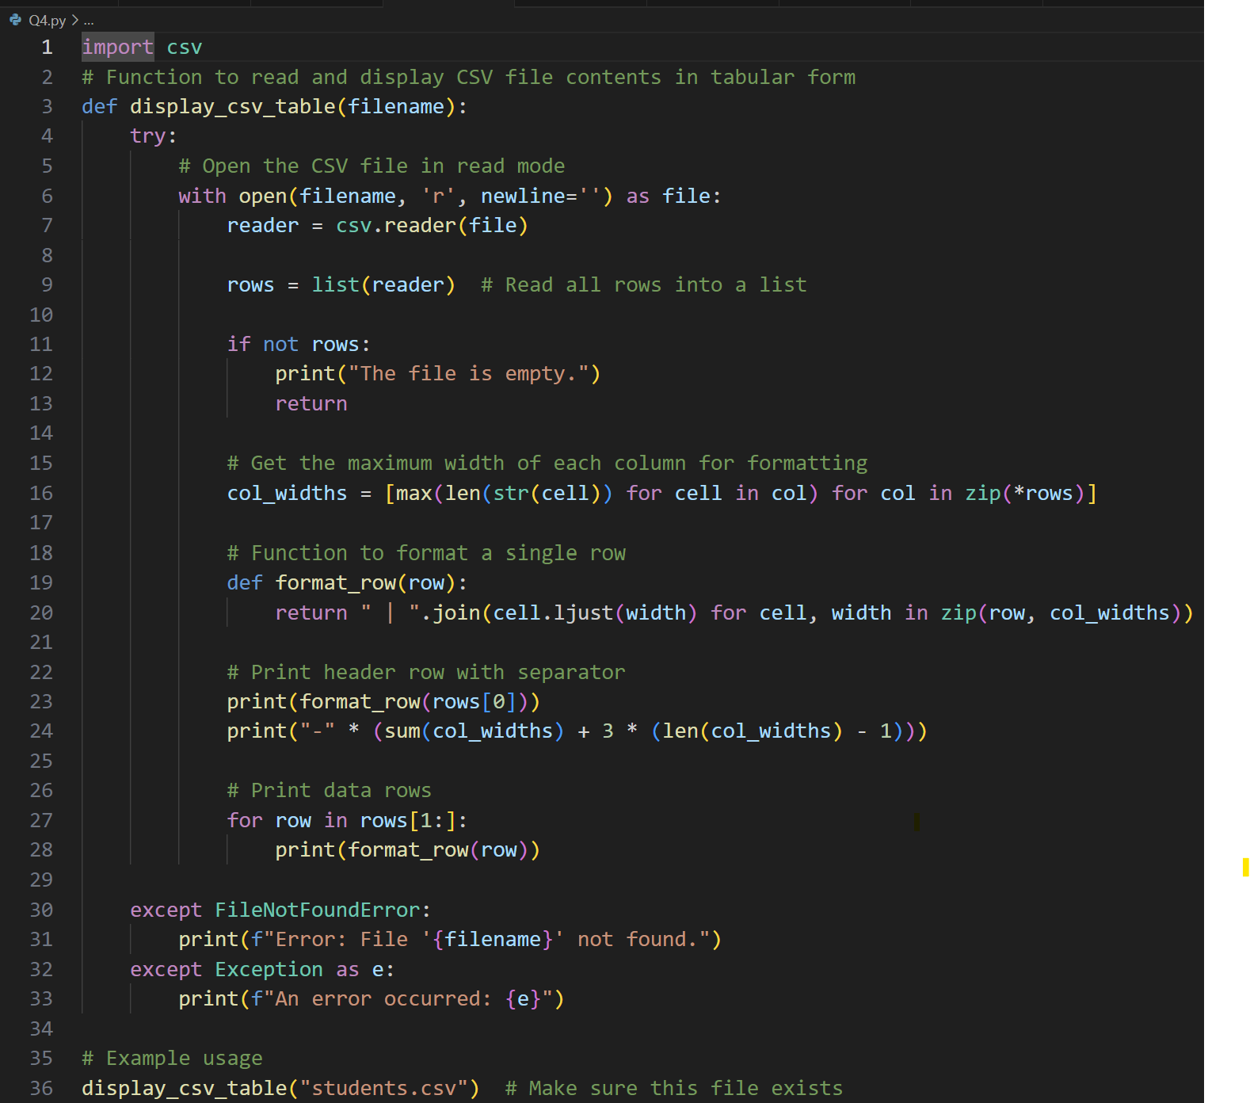



1. Develop a program that counts the occurrence of each word in a file.**[10 marks]**

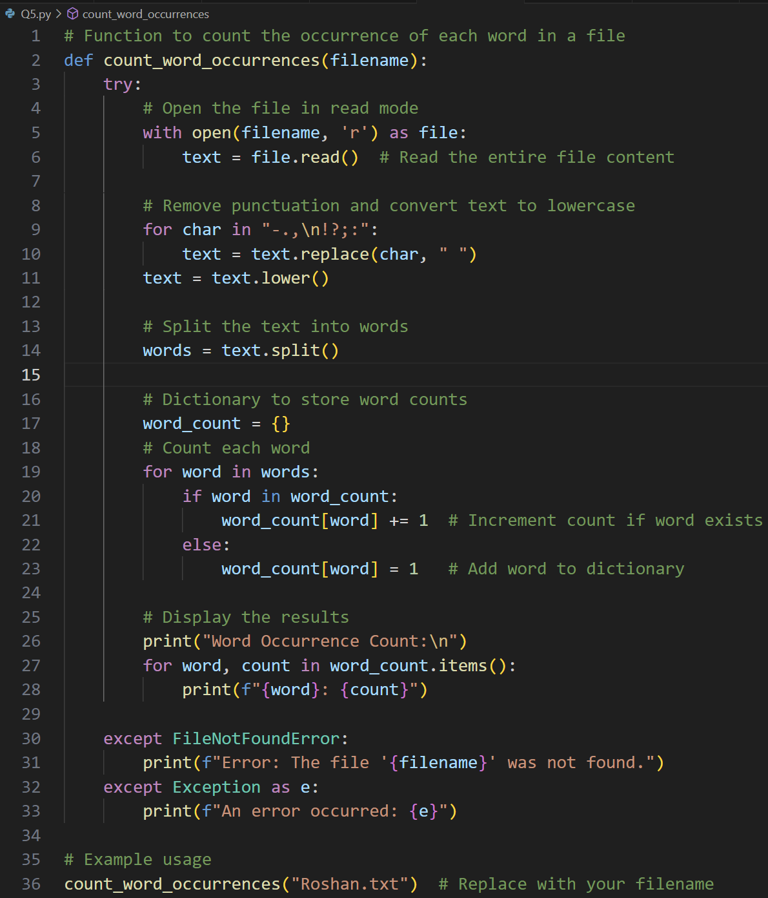



6. Create a class Student with the attributes such as id, name, address, admission year, level, section. Instantiate the object of class to take input for all the attributes and display the output. **[10 marks]**

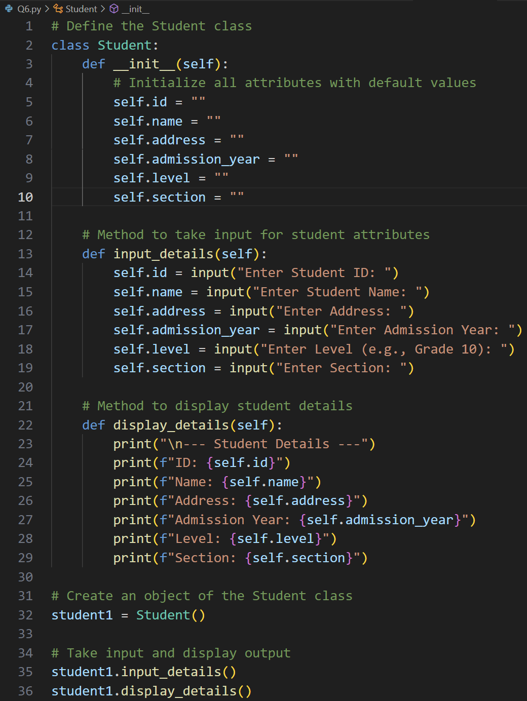

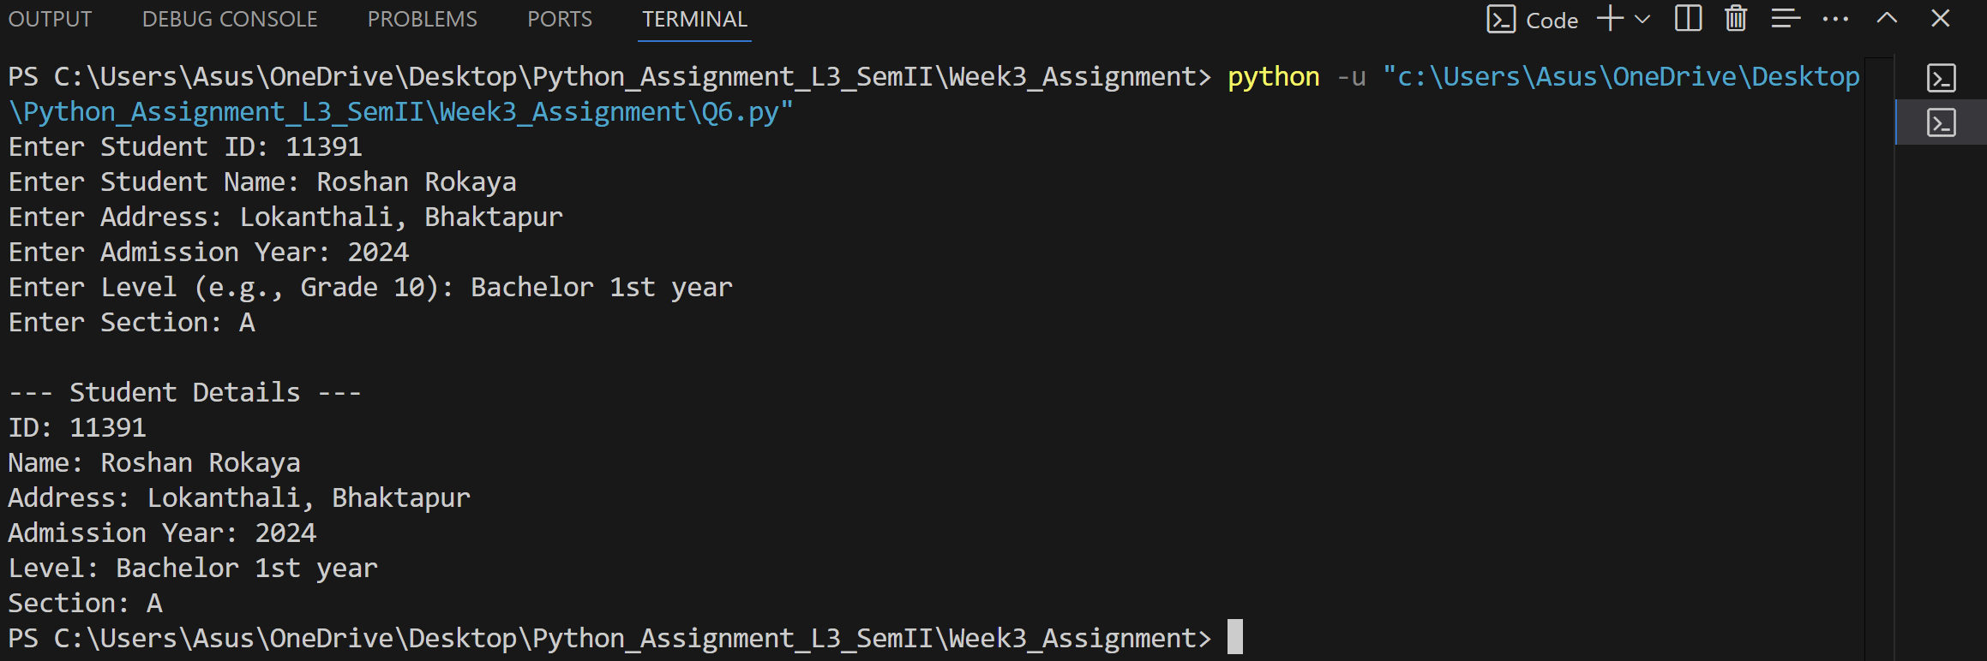

7. Write a program to implement a class called employee with attributes such as empid, name, address, contact_number, spouse name, number_of_child, salary. Instantiate this class to input the values for multiple employees and write it in a file “employees.csv”. Allow the user of your program to see the list of employees and their details as well. Try to use the concept of try/except too in the program. **[20 marks]**

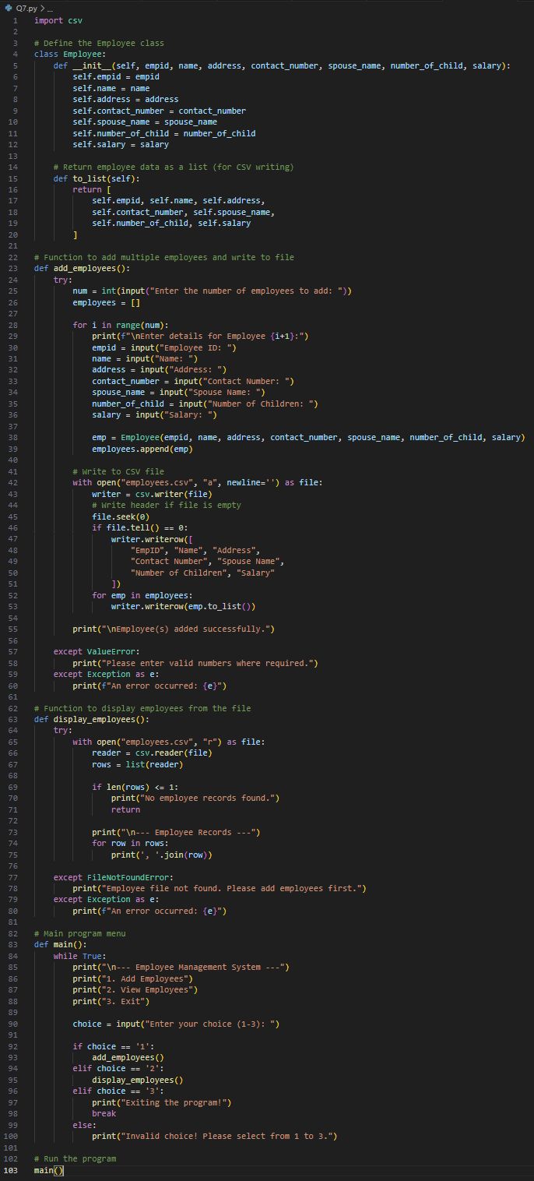

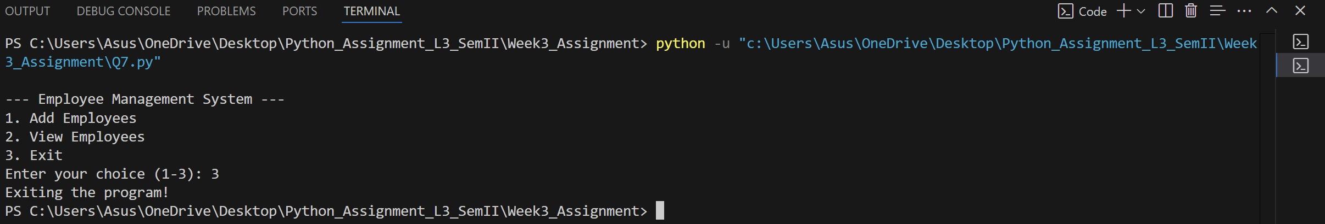

1. Write a program to implement a basic library book management with the functionalities such as issue the book, return the book and search the book. Use the concept of OOP to create the necessary classes on your own and implement the concept of other OOP features. For the storage of book details, use the file handling along with the exception handling. **[20 marks]**

